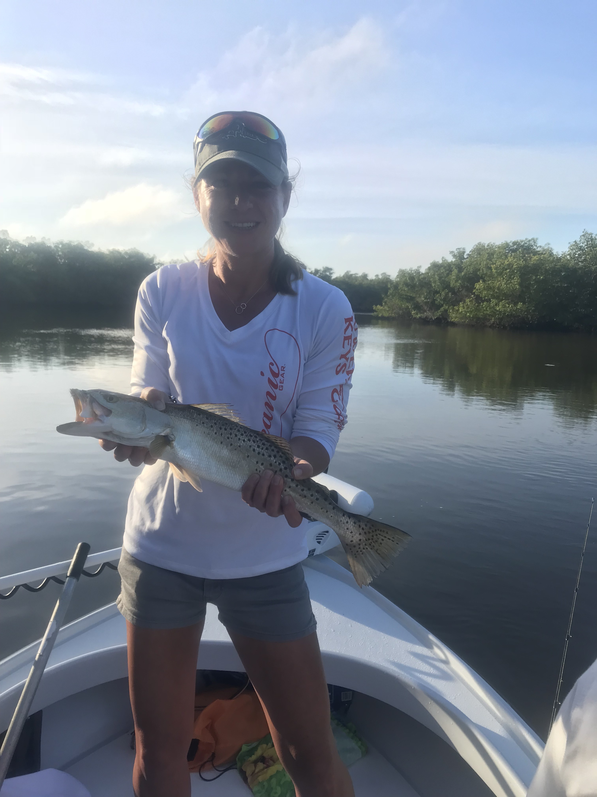
Picture: Mindy from Cape Coral with a big trout caught while shiner fishing with Capt Matt Mitchell this week.

Snook fishing turns on.

Warming water temperatures this week along with a great stretch of awesome weather finally fired up the catch and release Snook bite for the first time since early January. Along with the great Snook action trout and redfish became part of our daily catch too. Its just awesome to be back shiner fishing again after over a month of grinding it out catching Sheepshead on shrimp.

Once we got to 68 degree water temperature that was the magic number when our snook came out of the long winter hibernation and finally started feeding again. What a difference a few degree’s of water temperature made, it was like the switch got flipped to the on position. Mangrove creeks I have been catching Sheepshead in all winter blew up with a fantastic top water shiner bite. Trout, Jacks and mangrove snapper also exploded on live shiners making for a great visual bite.

Mangrove creek systems came alive again when chumming live shiners. Being able to throw free lined shiners at feeding snook as they blow up on the surface is one of my favorite ways to fish. The majority of these fish are in the mid 20 inch size range although we did catch a few this week right around 30 inches. With another warm week forecast this catch and release bite will only get better and better. Clean clear water in these creek systems only adds to enjoyment of this great wintertime fishery.

Out along the beaches the tripletail fishing keeps getting better and closer in to shore as the water continues to warm up. Fishing with some regular clients from St Louis early in the week they wanted to target tripletail, with a nice calm day we headed out around lighthouse point to run the crab pots. Pots in close to the beach did not produce so I kept pushing further and further out as I’h had a few reports from stone crabbers seeing fish out in the 40ft range. After making it out to 35ft we finally began to see and catch a few tripletail. All in all it was a pretty good trip, we saw 6 tripletail and landed 3. While running around offshore in the pretty clean water I was very surprised to not see any other life, no feeding birds, no bait or breaking fish. As our water continues to warm up this will quickly change.

Nothing makes me, or my clients happier this time of year than to be back throwing live shiners. I forget how much I missed this type of fishing until it totally shut down due to the crazy cold we experienced the whole month of January. For over a week I had caught shiners everyday and the Snook just would still not eat them. Once these Snook did decide to turn on it’s been a beautiful thing…

