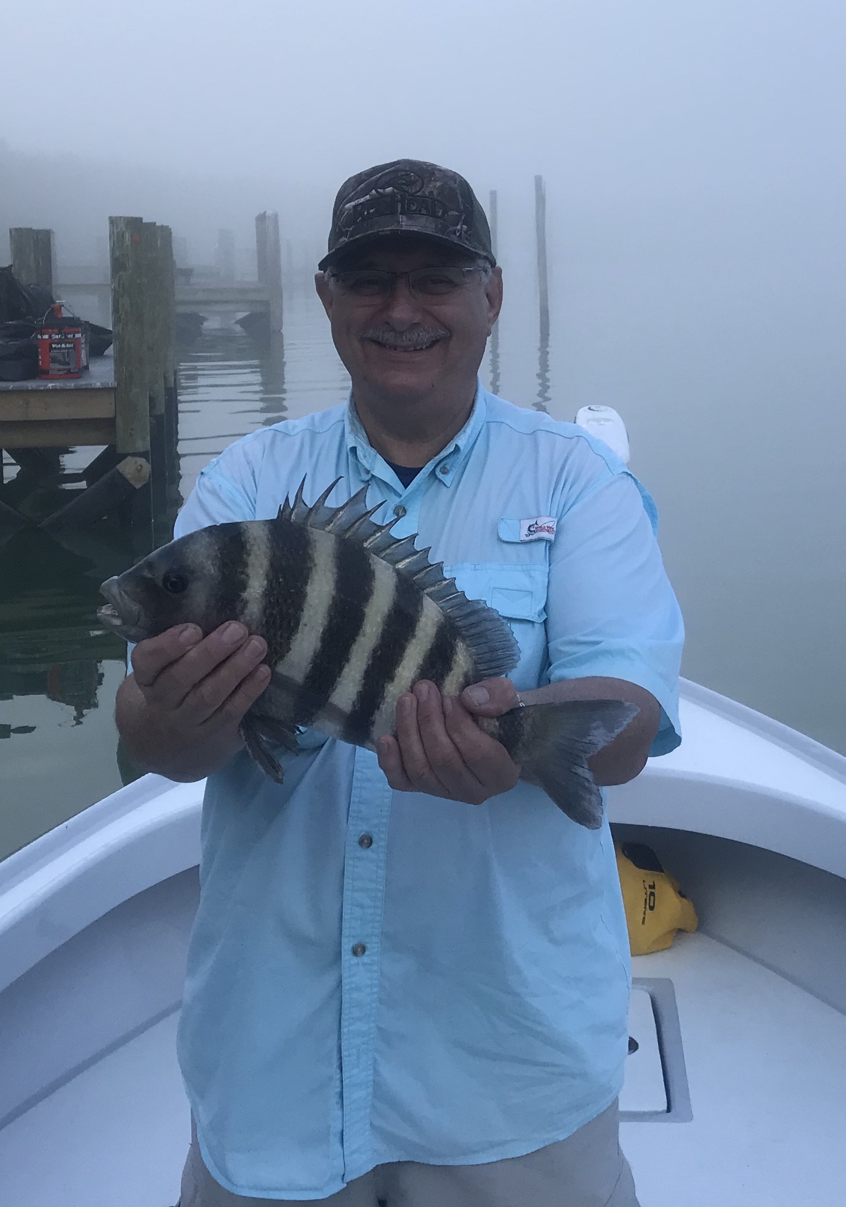
Picture: Joe from Sea Isle NJ with a Sheepshead caught in the fog this week with Capt Matt Mitchell.

Its Shrimp time.

Cold fronts will continue to push through for the next few months and are just a regular part of our winter fishing pattern. Getting out and catching fish during windy and cold periods requires one thing, the goto bait of winter live shrimp. Once our water temperatures drops below 60 the baitfish we fish with most of the year head out to deeper water that is less effected by colder temperatures.

Shrimp can be fished effectively a variety of ways for almost any type of fish you choose to target all winter long. When out on open flats during warmer winter weather use the shrimp live under a popping cork to catch trout. A sliding popping cork with 2-3ft of leader along with either a jig head or a hook and split shot will keep the bait down below the surface and is a hard to beat for anglers of all skill levels as it gives you a visual indicator of when you have a bite. Drift fish while popping the cork and the sound will attract the fish, once the float goes down simply reel tight and lift the rod. Hands down this rig catches more trout in our area than any other method.

During extreme cold periods or when specifically targeting sheepshead I like to use chunks of shrimp fished on a jig head. A 1/4oz Capt Hank Browns jig head with a 2/0 hook is my personal favorite. I remove the tail of the shrimp by pinching it off and then thread it on the hook then squeeze the head off. This small compact set up has very little drag in fast moving current and will quickly get to and stay on the bottom. It also makes it much harder for a sheepshead to steal your bait. Another advantage is that without a sliding sinker or split shot gives you a much better direct feel of the bite. When its cold and nothing else will get a bite this is the way to go.

Another option with the same Capt Hank Browns jig head is to rig it with a live shrimp. For this I hook the shrimp in the head going in the bottom of the head and bringing the hook out along the horn on the shrimps head. Make sure the hook goes through in front of the brain which is the black spot to insure your bait stays alive. This method is great for slow jig fishing while crawling the jig along the bottom. It also works well in deeper mangrove channels where the tide is fast enough to move the bait down the shoreline.
or catching redfish, snook and trout this is the way to go.

Free lining shrimp can also be a good method when fishing for spooky fish either in shallow clear water or around dock lights at night. Use a small light wire hook so the live shrimp can move naturally. Adding a small split shot a foot or more up from the hook will get the shrimp just up just off the bottom, slide the split shot all the way down to the hook and the bait will sit right on the bottom. Vary the size of the weight depending on depth and current.

Live shrimp are not only the universal bait of winter but easily available to everyone and don’t require much effort to keep them alive. At the end of the days fishing save any leftover shrimp in a ziplock bag on ice and they will stay firm for a few days. Since our big drop in water temperature a few weeks ago all my trips we have been fishing with shrimp. Not only is the variety of species you will catch on shrimp in the cold water endless at least a few weeks without throwing a cast net is never a bad thing either.

