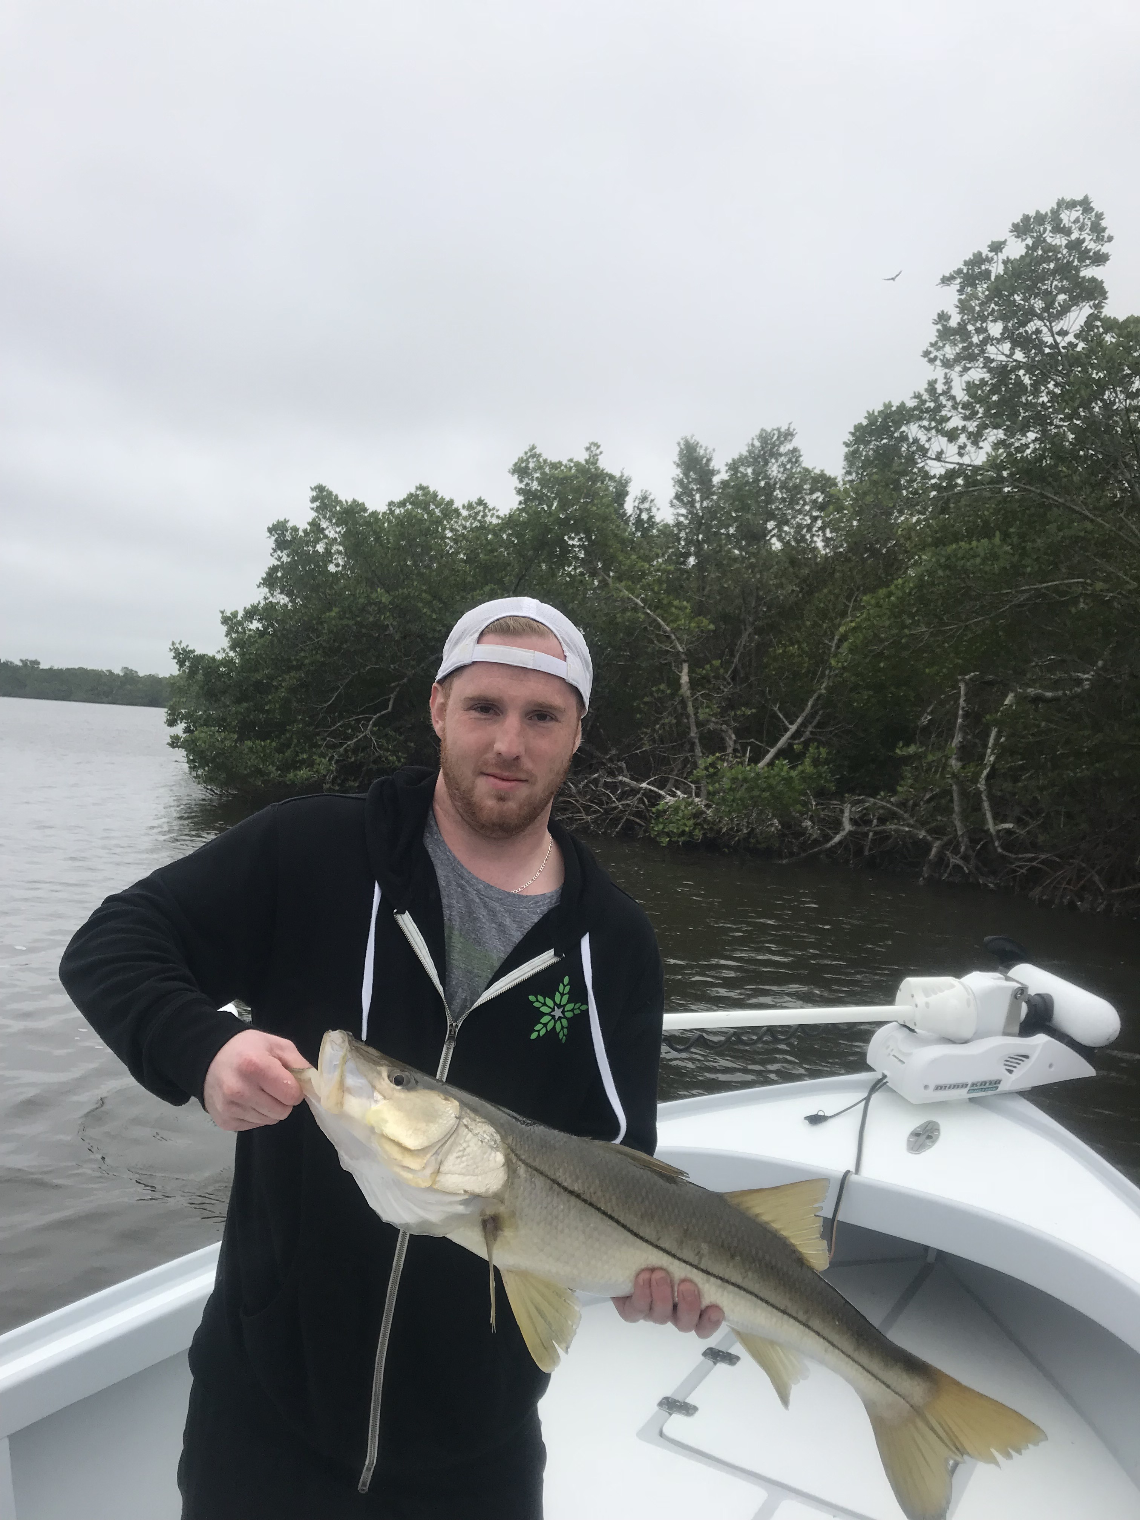
Picture: Gabe Bergman from Wisconsin with a 31 inch snook caught while fishing with Capt Matt Mitchell this week

Constantly changing conditions

The week from Christmas to New Years is always one of the busier weeks on the water. Among my local fishing guide friends we know it as “Hell week’ as it just not get any busier out on the water. This proved very true this years Christmas week with lots of people out on there boats while escaping the cold of the north and enjoying a southwest Florida Christmas. Dense fog, cold, wind and sunshine where all part of this weeks conditions that made both fishing and boating anywhere from really good to really challenging often all within a few hour period.

Tides were far from good this whole week with often anglers getting a period of little to non moving water making the bite just grind to a halt. When we did have moving water my anglers caught lots of snook along with a few redfish and some of the larger trout I have caught in the last few weeks There is nothing more frustrating as a guide than when you know you are set up in the fish and because of the lack of tide movement the fish will just not eat a bait. All my trips this week seemed to have a few hours of great hours of action once the tide finally began to move. During the periods of no tide it was like beating your head against a wall with little to no action at all.

During the periods of little to no tide I spent my time tucked back in narrow mangrove creeks that seemed to at least have a little water movement most of the time. Live shiners caught lots of snook along with many many mangrove snapper. As the water flow got better thats when we seemed to catch our redfish back in these same creeks along with lots and lots of snook. A few of these narrow mangrove creeks I frequent this time of year had schools of hungry roaming jack crevalle that once chummed up on live shiners blew up all over the surface and resulted in multiple hook ups and smiling faces.

With another cold blast in the forecast for early this week it will kick our sheepshead bite into high gear. On trips this week when I have shrimp fished targeting sheepshead we have managed to catch a few legal sized fish although the abundance of small mangrove snapper have made it tough going. Area’s in and around the passes will see the first big push of larger sheepshead as they move in from offshore to spawn as conditions get colder. If conditions stay cold we will see these fish on basically every dock and in ever deep mangrove creek and shoreline throughout the whole area or basically any structure that has barnacles on it for them to graze on.

