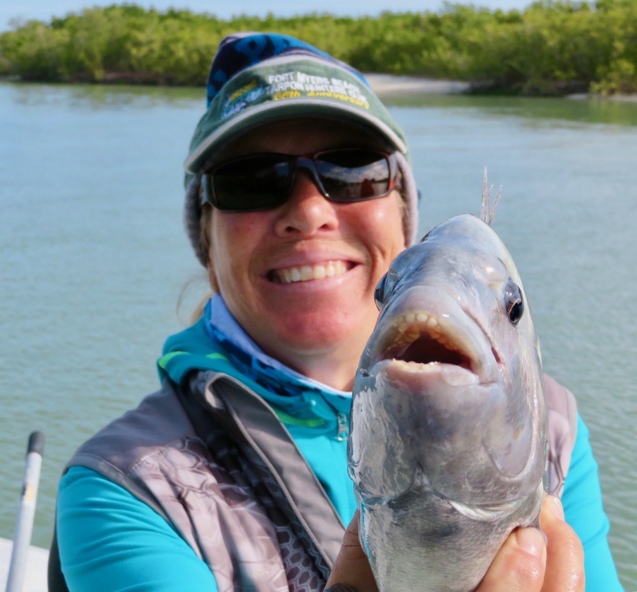

Cold water equals great Sheepshead fishing

Picture: Mary Laser with another smiling sheepshead

Falling water temperatures and more cold fronts made for another week of non stop sheepshead fishing. Some days locating these fish took more work than others though after a few moves the daily result was the same, my clients smiling and a cooler of sheepshead heading to the fillet table.

Any where close to the passes was a good place to start the sheepshead rodeo. Docks, pilings, sea wall and blow downs or basically any place with moving current that has barnacles growing on it held these fish. Often the difference between catching them and not catching them was getting the boat positioned so you could present your bait right next to the structure. After getting the boat set up in the right position then it all thats required is a accurate cast and its game on.

Down sizing the tackle to 2500 series spinning reels on medium light rods rigged with 10# braid makes the larger sheepshead a real tussle. This lighter tackle also makes for more accurate casting. I cannot stress enough how important it is to keep your bait close to the structure to be successful on these what I refer to as finesse fish. The bite is often very light as they nibble at a bait and knowing when to set the hook only comes with time spent. Its almost like you have to anticipate that the sheepshead is holding the bait to hook them.

Many of the places I’m catching the sheepshead are also giving up a few other species including redfish and black drum. Chunks of shrimp fished on a 1/4 jig head is our catch all set up during cold water times. Keep the bait on the bottom and don’t move it as these fish feed by scent.

With each passing cold front the average size of these fish continues to increase. With February and March the prime months for this fishery will just keep getting better and better. Its amazing how this species of fish take over our cold water months and become our main target species when its just too cold for many other species to cooperate. With more cold fronts forecast over the next 10 days our sheepshead fishing will only continue to get better.

