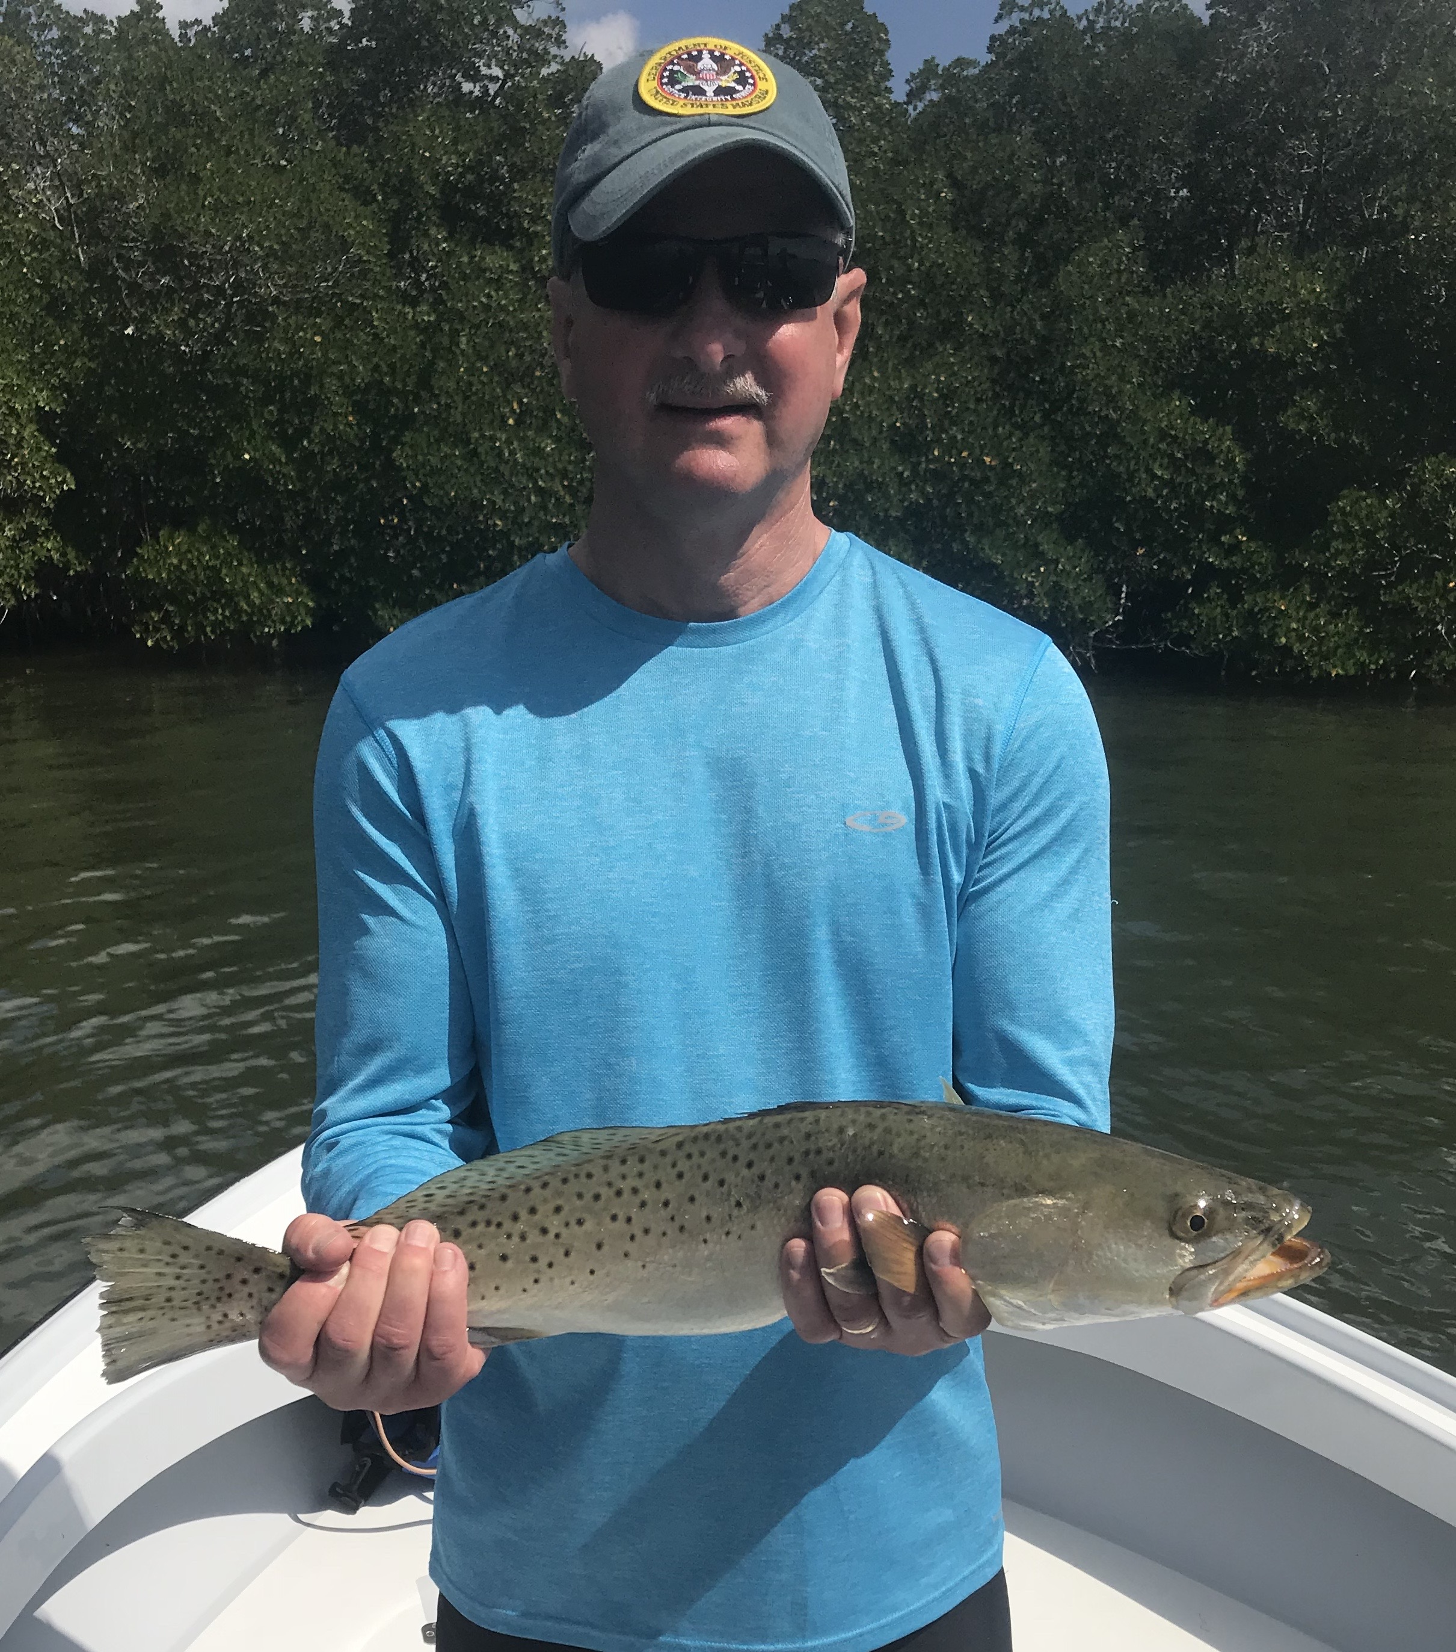
Picture: Mauri Sheer with a Gator trout caught this week while fishing with Capt Matt Mitchell.

A challenging yet gratifying week

So we thought we had dodged winter then the first week of March starts off with two cold fronts bringing us wind and cold like we have not had to deal with since January. With the warmest February on record behind us the jet stream has now dipped down lower as it usually does in March bringing us a weather pattern which I’m sure will include more cold and windy days. With the crazy February heat wave we went more than a month without a single weather caused trip cancellation, now only three days into March we have already started rescheduling and juggling trips due to the bad weather. When mother nature is your boss you just have to take the good with the bad.

This weeks fishing brought some of the slower action I have dealt with in months although we always ended up catching good fish. We avoided the passes all week to stay away from patchy red tide that would kill your live well full of bait then had constantly changing wind direction making us really work for every decent fish we caught. Days included going from spot to spot with only a few bites here and there then as soon as it got right we would catch all of our quality fish in basically one location and make the trip.

One such memorable day like that this week came after a few slow hours with only a handful of ladyfish and trout caught until we hit the lotto with 3 large Snook, a big Jack Crevalle and a small tarpon all within 15 minutes at one place. This was a great way to finish out a trip but its extremely frustrating when it goes down like this as a guide. If I could only spread out those quality fish over the length of the charter it would be a great day but you don’t get to pick when it happens and will happily take em when they choose to feed. Everyday this week it took lots of patience and persistence to get the job done.

Most of my weeks fishing was spent in the southern end of the sound on grass flats, oyster bars and deeper mangrove shorelines basically doing what ever type of fishing it took to bend the rods. We would often change up the target species when we struck out. We did manage to catch Snook, big gator trout, Ladyfish and an occasional redfish although the action at times was just slow. Every part of this week was just much more challenging than usual. When I reflect back at the weeks fishing trips we had some real quality fish including some of the largest trout I have caught in a while but changing wind and conditions just never allowed the fish to get into any kind of pattern, everyday was like starting from scratch when usually I can take clients to where I caught fish on the same set up the day before and have success.

After fishing the Ding Darling with great results all winter long the Snook and trout fishing in these mangrove creeks totally ground to a halt which I would guess was due to slight effects of red tide pushing into the Ding making the fish move out. For some reason this almost guaranteed winter fishery simply quit even when I chummed live shiners there was not a single blow up by even a mangrove Snapper which have been in here by the thousands. I did see a few dead mullet on the bottom in some of my favorite Ding Darling creek systems but schools of happy mullet along with Sheepshead swam by the boat in the clear water unaffected.

With a stronger secondary cold front forecast to come through later this week the big cool off will do wonders for the spawning Sheepshead bite and also push lots of Snook and trout back into the sheltered mangrove creek systems. Our winter fishery can be challenging and is all about adapting to what the days conditions are. This year has proved that with a extreme February heat wave moving the fish into a open water spring like pattern before pushing them back into the sheltered waters of winter as we get another major cool down. From tarpon fishing back to Sheepshead fishing all in a week, welcome to March.

