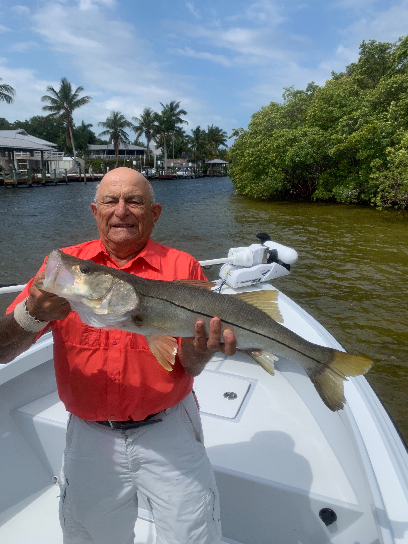

Pic: Nick Basilio from PA with his personal best snook this season, this 32 was caught and released with Capt Matt Mitchell

Yet another windy April

April always seems to play out as one of the windiest months of the year. This month brings constantly changing wind direction to deal with on a daily basis plus common late cold fronts with winds often strong enough to keep everyone off the water. Its a frustrating time for anglers as we all want to tarpon fish yet most days its just too windy and rough to make that a option even though the tarpon are here.

Snook remained my main target species most days this week. Although we were successful these fish have my guide buddies all rubbing their heads. I cannot remember a year that in late April our Snook had not crossed the sound to the passes in huge numbers. Our annual Snook spawn should be well underway. After a longer colder winter than normal our water temperatures are now in the high 70’s to low 80’s this weeks full moon should be what it takes for them to make this transition.

Catching Snook did not come that easy for us this week though with some work and perseverance we managed right around double digit numbers all week long. Most trips played out the same way with my clients catching quite a few in the mid 20 inch range then having at least one or two shots a trip at landing a much larger one. One very memorable lost fish this week we had all the way back to the boat. On the first run this rocket took off 50 yards of line and never jumped before being turned. Once finally back to the boat I was confident the battle was over as the roughly 40 inch fish laid up close the surface by the stern of the boat. In the few seconds it took me to grab the landing net this fish got a second wind and ran under the boat and back to the trees before the angler could get the rod around the bow to put any pressure back on the fish. This brief few seconds was all it took for it to part ways.

Spanish mackerel fishing provided good action close to home with a great bite going on between St James city and the power-lines. Diving pelicans and lots of small bait fish made this action easy to locate. Rigging up with a short piece of single strand wire assured these sharp fish would stay hooked up. Throwing handfuls of live shiners while anchored up had mackerel feeding right next to the boat. Seeing how many guide boats where anchored up doing this same fishing is a sure sign there is wasn't many options in the wind.

