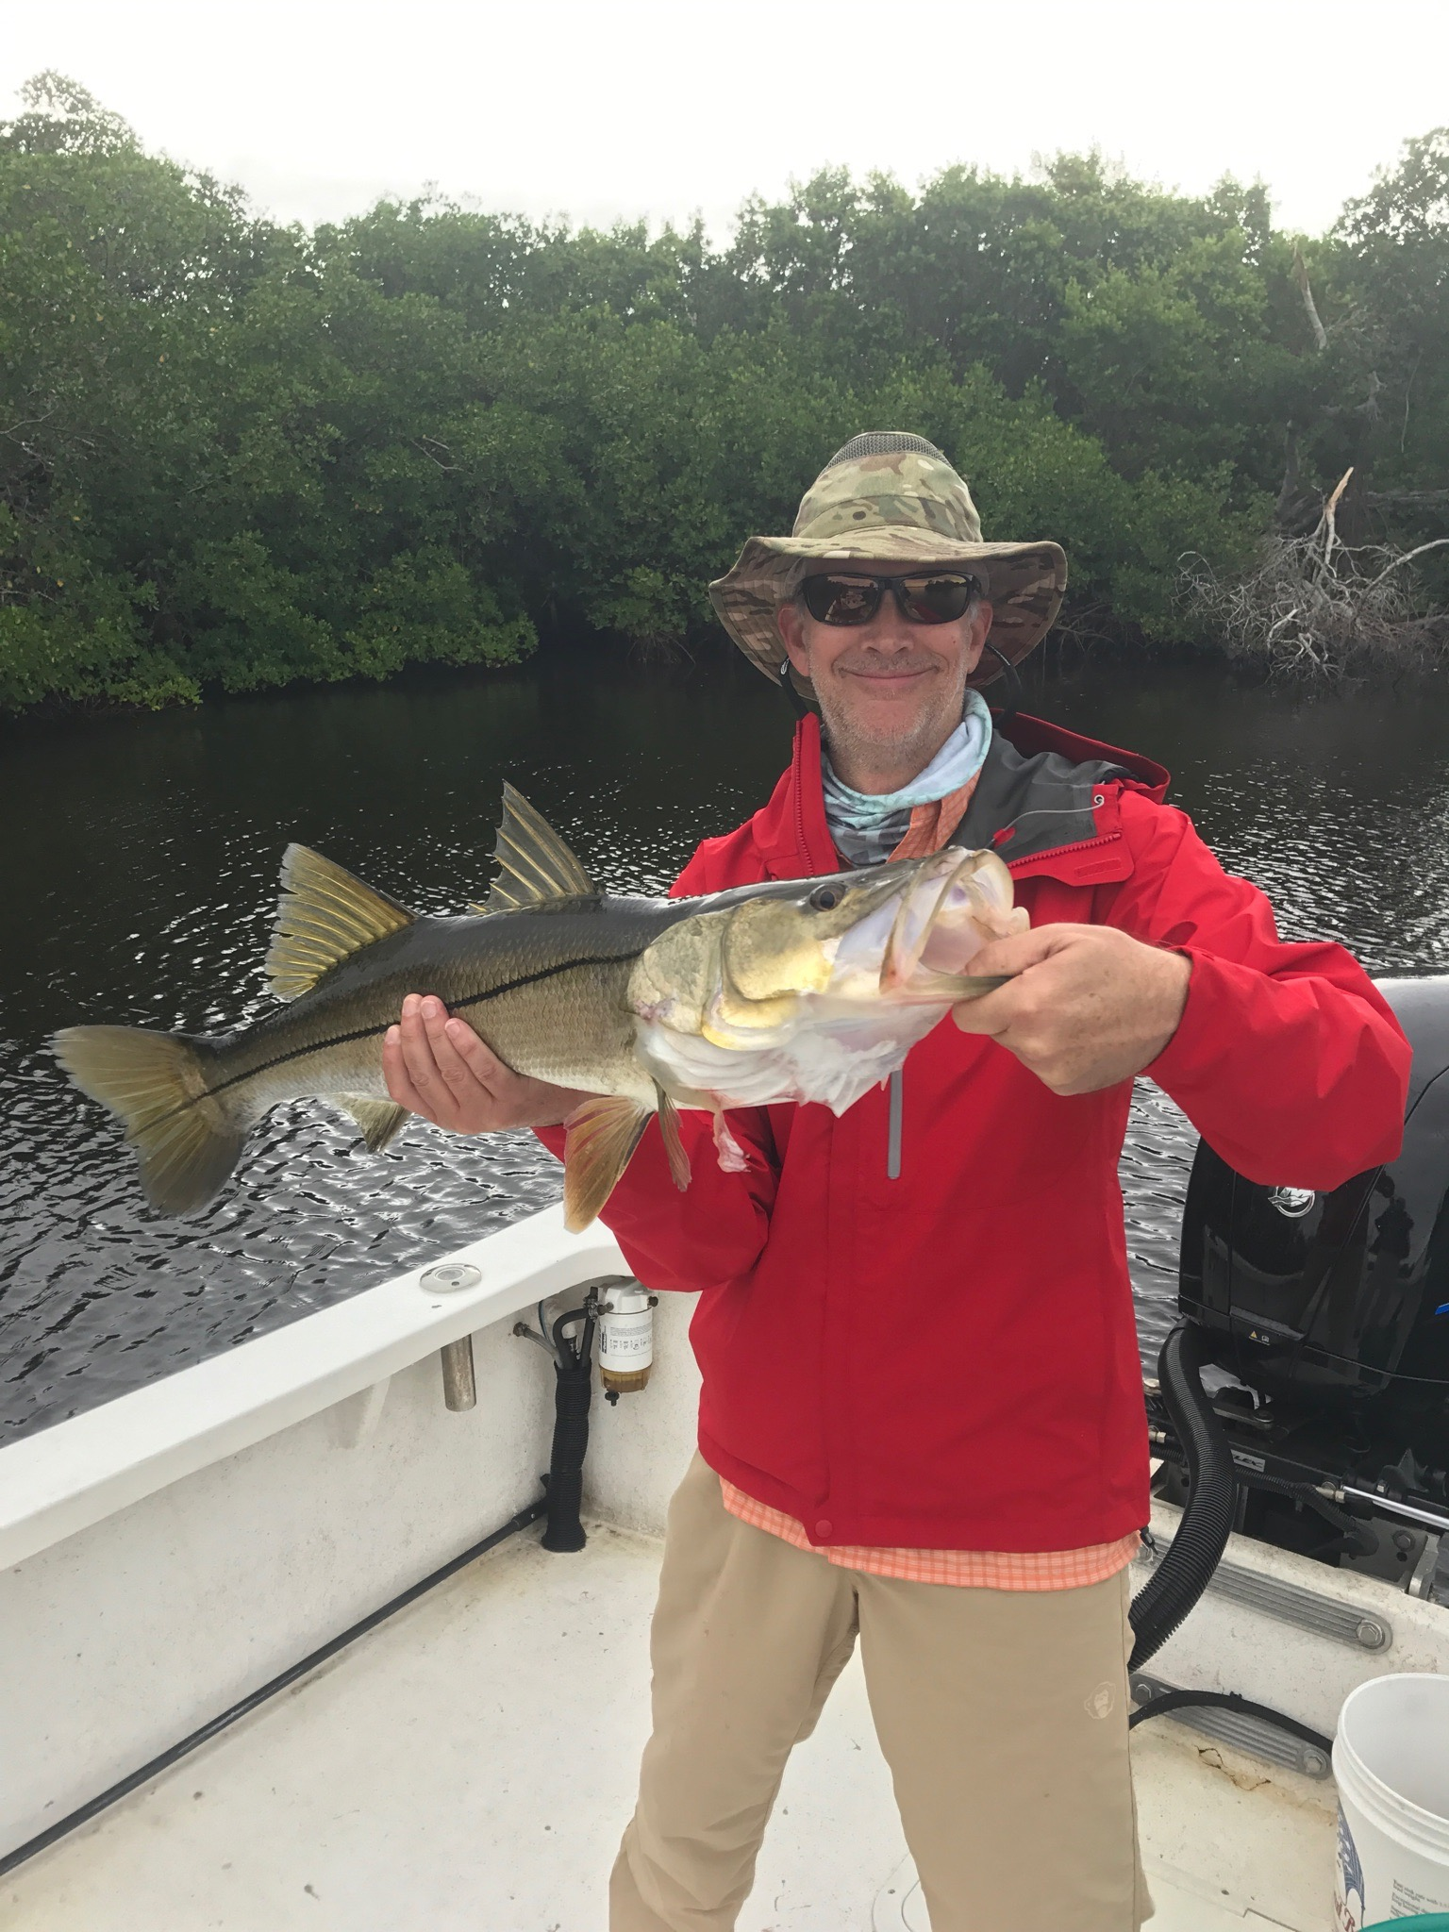

Picture: Steve King of Naples with a 30 inch Snook caught while fishing with Capt Matt Mitchell this week

Wintertime fishing pattern arrives over night

Our first cold front of Fall dropped morning low temperatures in the 50’s and brought breezy rough conditions for several days Expecting the fishing action to grind to a halt for at least a few days I was pleasantly surprised to find the fish had just moved what seemed like overnight to the usual winter time places. This early cold front brought us a quick 10 degree drop in water temperature basically over night pushing Snook deep into the mangrove creeks where they winter.

Fishing back in these Mangrove creeks was about the only option for a few days as we hid from extremely windy conditions. Most days going from creek to creek on different stages of the tide we found outstanding action on of snook of all sizes. It still amazes me how fast our fishing pattern changed this year from fall to winter in what seemed like one day. Live free lined shiners had these creek snook bouncing off the roots as we caught fish after fish. The average size of these snook is in the low 20 inch range but what they lack in size they make up for in sheer numbers and excitement as you watch them chase baits down.

For the next few months unless we experience a major warm up I spend most of my days with clients fishing back in tidal mangrove creeks all over the sound and Matlacha Pass. Learning where and what stage of the tide Snook set up in these creeks only comes from time spent in these waters. No matter what a days conditions throw at us I can almost always catch snook in these creek systems as long as I have shiners and the water temperature does not get down into the low 60’s. The amount of life in these mangroves creeks is amazing with lots of varieties of wading birds along with raptors, dolphins and manatees to look at while catching fish.

All of the creeks systems that I find the most productive share a few key factors: deeper water, strong moving current and natural channels.
From Shell creek in the river to St James Creek in Matlacha Pass then the many creeks of the Ding Darling and even Turner creek you don’t have to go far this time of year to catch lots of fish and stay out of the wind.

Although I’m not a fan of the cold weather I do really enjoy how close the fishing is to home this time of year. With another re enforcing cold front passing through early this week I only expect the fishing to get better in all these creek systems.

