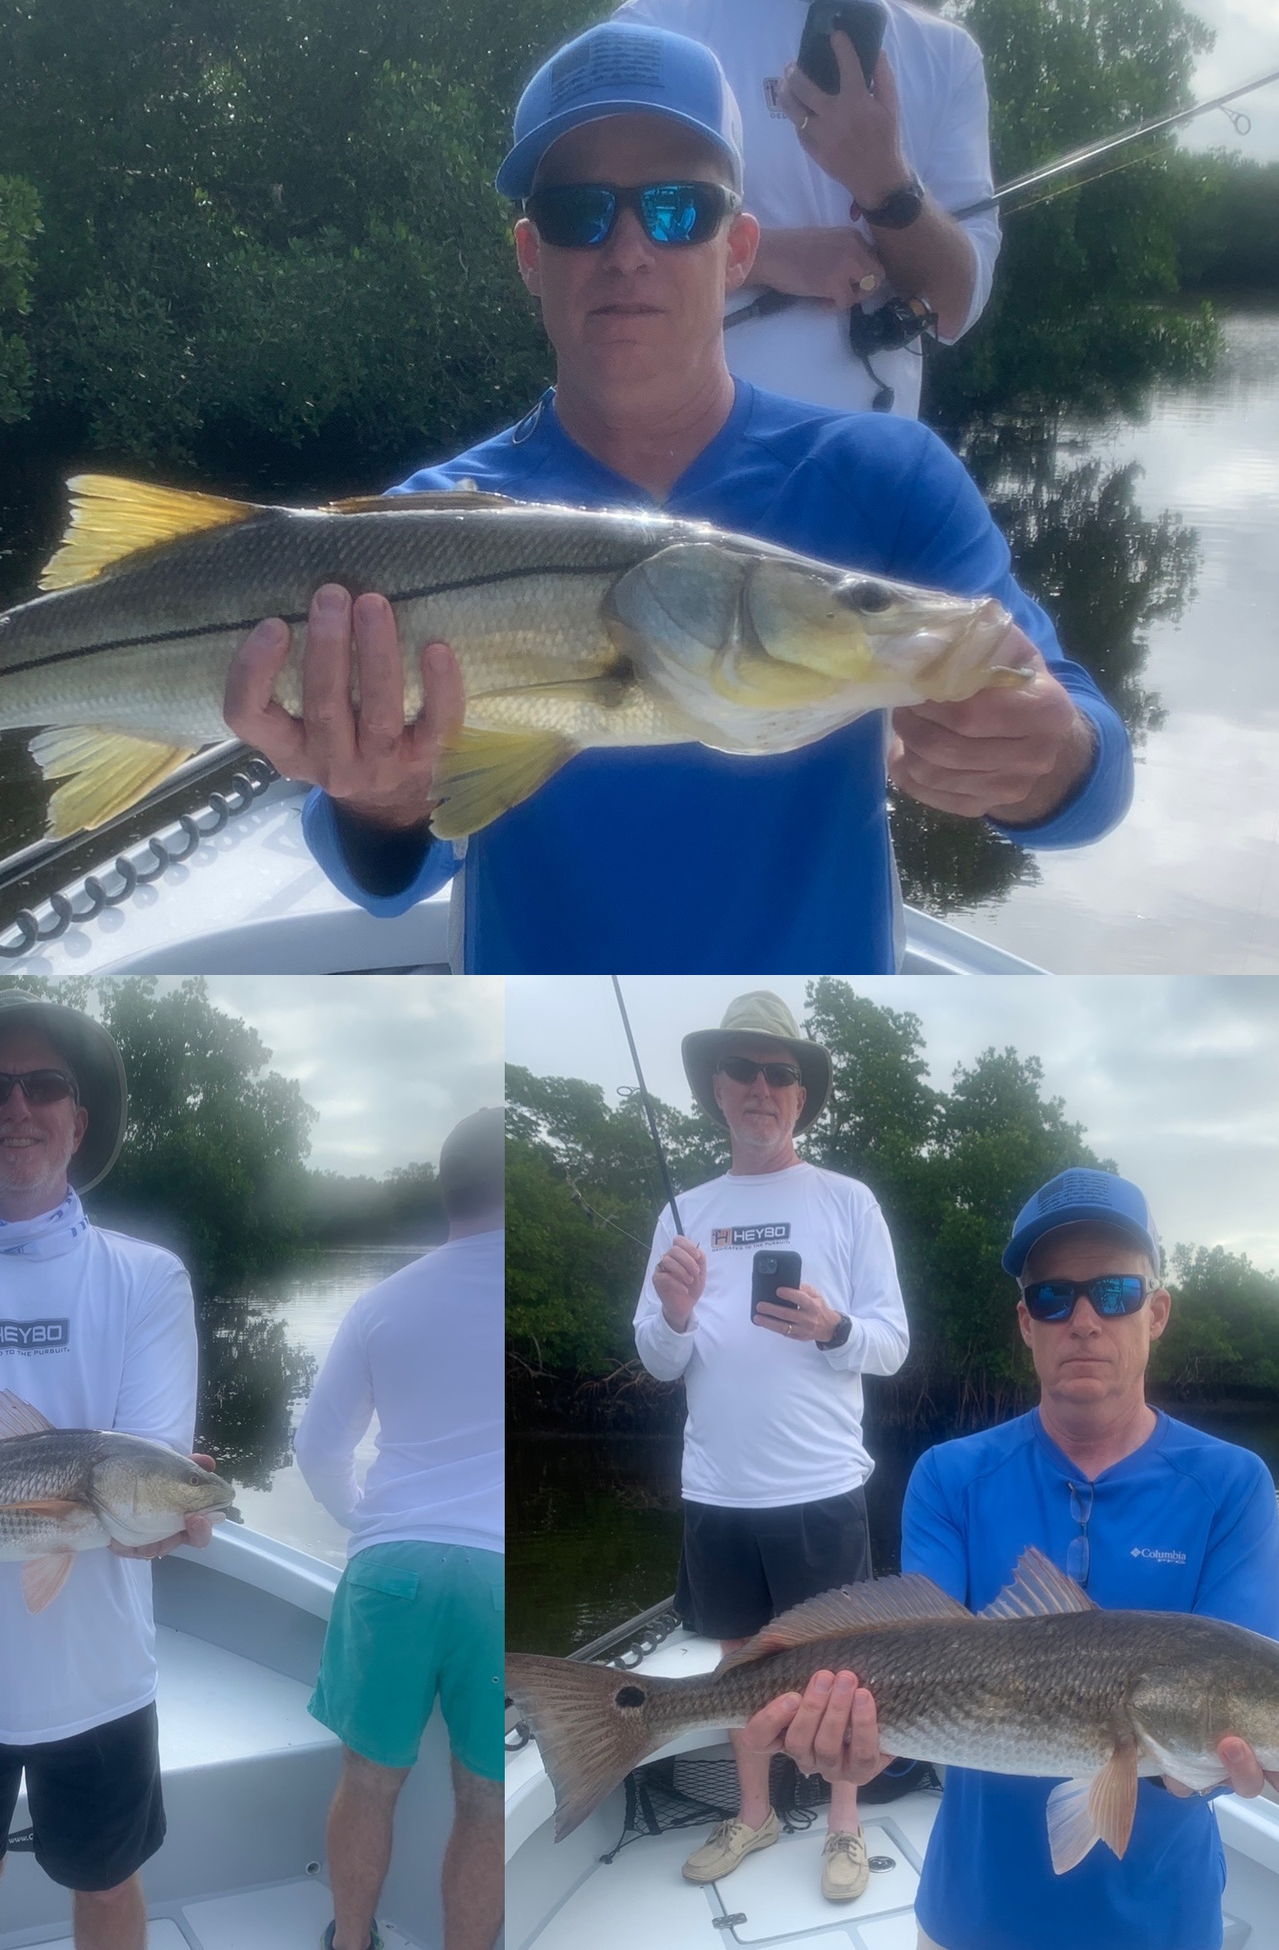

Winter weather rollercoaster
Pic: Highlights while fishing with Kemper and the boys this week all while fishing mangrove creeks.

Weather conditions kept anglers on there toes all week. Warm temperatures and shiner fishing quickly turned into cold water shrimp fishing. The ups and downs of winter fishing require you to change your game plan to get the most out of the days trip.

When we get these big drops in temperature along with super low minus tides the playing field of places to fish gets really small. Finding deep water that is some what out of the wind makes even the most frigid 60 degree day very fishable. The passes and docks around the passes fill up with boats. Deeper mangrove channels offer my favorite option during cold windy days.

Some creeks close to home that have offered great action in less than favorable conditions include tarpon bay, shell creek and jew fish creek.
Getting to know these creek systems and how to navigate in them only comes from doing it. Google earth is a great place to get started too. Find the deeper holes and channels to fish during even the lowest tides. Many of this 4ft or deeper water are the places the fish go during cold water periods.

Getting out right after the passing of our last cold front I opted to take only shrimp and had an amazing days action while hiding from a south Florida extreme cold day. Starting our trip deep in a mangrove creek system we caught snook, trout and redfish all in one favorite hole. Slow bouncing live shrimp on a jig head during a low incoming tide the bite was almost non stop. Though non of these fish where trophies there is simply not a better way to start off a charter than with everyone on board hooked up.

Changing it up later in the trip as the wind laid down I made the run further north down the sound heading to the pass. The plan was fishing shrimp chunks on a jig head to catch a few sheepshead for dinner. With the tide screaming in the pass I opted to target some of the many docks on the inside. After setting up on a open dock it did not take long to catch a few upper slot sized redfish. As we continued to cast to each individual piling on the dock we put a few respectable sheepshead into the box during the last hour of the trip.

Although we continue to hear about red tide I have only experienced a few small patches of low levels around the east end of Sanibel. Over the past week its had very little effect on where Ive been fishing. I did have a issue a few days ago while catching shiners on the causeway with the bait dying in the live well. With cooler water temperatures and a northerly wind pattern everyones fingers are crossed it will quickly continue its movement south breaking apart.

