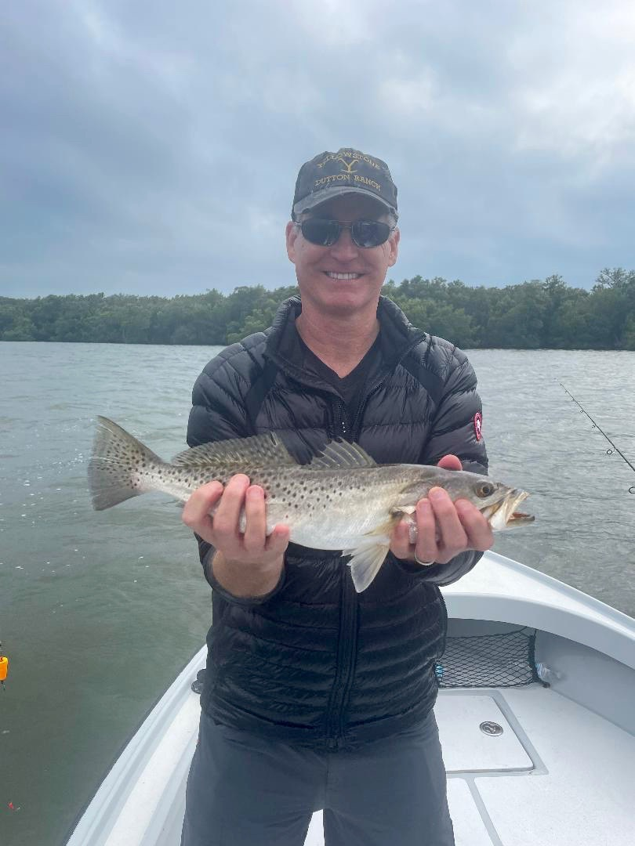

Winter fishing patterns in full swing

Pic: Jim from Iowa with one of many trout caught this week with Capt Matt Mitchell.

The ups and downs of this all we can call “Crazy Florida Winter” weather continued over this past week. Having frost on my boat and on the marina docks is certainly not a regular occurrence. During the warm up fishing was up and down with some days being much better than others. Even more than the water temperature being so cold moving water was the most important factor to getting on good action.

Trout fishing has become much more consistent over the past couple of months with these fish hanging out on shallow sand dotted grass flats. Protected bays that have been sheltered from the wind and have clean clear water have brought the best action. Popping cork rigs with a jig head and live shrimp caught fish after fish. The Fosters point flats on North Captiva along with the Buck key flats on Captiva both displayed the amazing rebound these fish have made since the 2017 devastating red tide we endured.

Popping cork rigs though very simple are incredibly effective when fishing the flats. The pre made sliding type of popping cork has a few metal beads that make a rattle when popped which attracts the fish. This rattle sounds like a shrimp or baitfish clicking or skipping on the surface. These float rigs are so much easier to fish than the old slip on popping corks which consistently tangled up. The weight of this pre made rig makes it easier for everyone to make long prospecting casts and better locate the fish.

Like I tell my clients a little pop of the concave float every 10-20 seconds draws the fish in. Just a little twitch of the rod tip when the line is tight makes this fish calling noise. When the float does go down, I like to reel just fast enough to create a bend in the rod. Trout have a extremely soft mouth so a strong hook set will rip their lips and pull the bait right out of their mouth. Once hooked keep the rod tip high and with constant pressure slowly bring the fish to the boat.

Although we often think of bobber fishing as kids fishing there are certain situations when there is not a more effective was to catch trout and shallow water fish. This rig not only gives the angler a visual indicator of a strike but also attracts fish with the noise it creates. When fishing shallow grass flats, it keeps the bait from hanging up in the bottom and allows it to drift covering lots of water. All winter long the main two set ups I carry rigged on my boat when shrimp fishing are popping cork rigs and jig head rigs. Between these two set ups you have it all covered.

