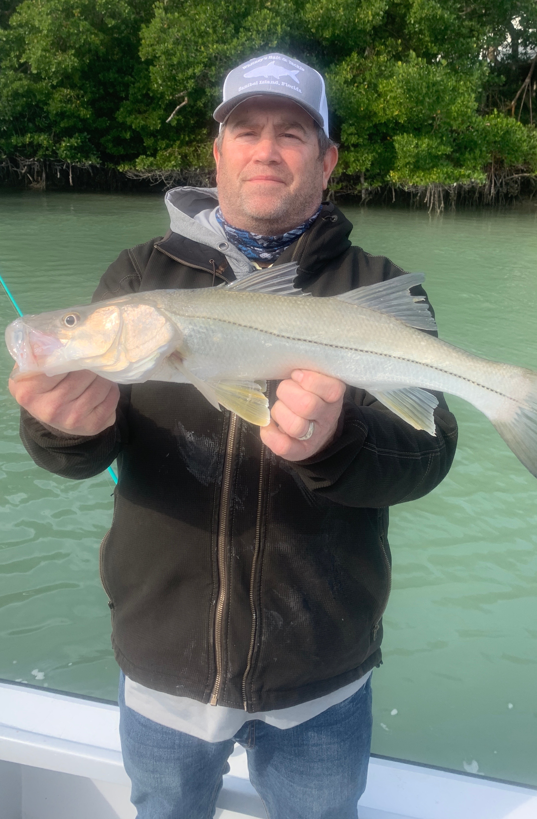

Where are the Sheepshead?
Pic: Rick from MN got in on the unbelievable snook action this week while fishing with Capt Matt Mitchell.

During our colder winter months Sheepshead are what many of my clients usually want to catch. Going home with a bag of tasty fillets has been relatively easy during our colder months. This has not been the case this year with very few being caught in all the usual places.

Everything I thought I knew about cold water fishing has been thrown out so far this winter. Water less than 60 degree’s usually requires chunks of shrimp fished slowly to catch fish. This year shiners are still plentiful and Snook are feeding like I have never seen in such cold conditions. Redfish of all sizes are also been caught in these same places. On most charters we have also caught a few trout to complete the slam.

Although I don’t know for sure what the difference is between this winter and winters past a few things come to mind. First off its been cold now for almost a month straight. Once the water temperature plummeted its basically stayed in the low 60’s. What seems to shut our snook fishing down is quick drops in temperature. It seems to me these fish have become acclimated to this cooler water and just have to eat.

Generally during these cold water periods our fishing switches over to shrimp and the shiners disappear moving offshore. This year shiners have stuck around being caught in the deeper water around the causeway bridges. Having a live well packed full and being able to chum with live shiners has the snook, redfish and trout fired up.

Deeper sheltered channels along with canal mouths have been fish havens. For the past month the fishing in these places can only be described as epic. During fast moving tide periods the bite is as good as it gets with close to a fish every cast. Once set up in one of these places its been hard to leave. I simply do not ever remember catching so many snook, redfish and trout during prolonged cold periods. Being able to share this amazing fishery with long time winter clients who are used to catching sheepshead is not a bad thing.

