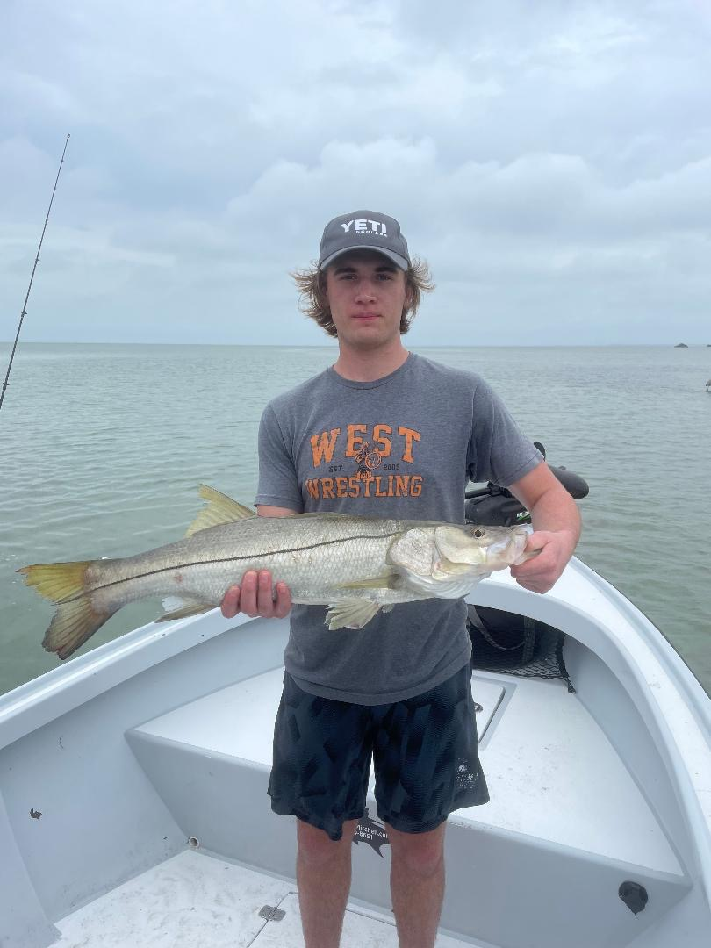

Pic: Mike from IL with an afternoon snook caught while fishing with Capt Matt Mitchell this week

Time of Day or Tide?

One of the questions we are often asked by clients is “What’s the best time of day to fish?”. The answer to this question is not as simple as you would think as there are lots of variables. Water temperature, time of year, wind and tide are just a few.

Over the past few months of high season, we do both morning and afternoon charters. Reading and reacting to the day’s conditions allow us to be in the places that set up best for success. No matter how good a certain place was on the previous day when the wind and tide are different it’s time to move on. Conditions are how and why we choose to fish a certain place and knowing which locations set up best on the days wind and tide are the major factor.

While our water temperature is in the mid 70’s like it currently is the tide is the most important factor. Morning low water has been the best trout bite along with snook in and around the passes. For sheer numbers of fish, the afternoon high water snook bite has been the better call and the high water has been most productive for redfish. Like always the wind speed and direction plays a major factor in how high or low the days tide will be.

During winter months while water temperatures are cold afternoons are when the water is warmest and often produce the day’s best snook bite. Summer is just the opposite with morning cooler water being when the fish are most active. During our spring and fall months while our water is in that perfect temperature zone it’s just not as important and the tide movement is the most important variable.

Another big part of the puzzle is weather. Like I often talk about approaching weather can really fire off the bite. Low pressure is a good thing while high pressure is generally not. Fishing the back side of a front during this high-pressure fishing can get tough. Something as simple as the afternoon sea breeze kicking up from the west opens up a other set of places to fish.

As a guide being on the water almost daily you learn how to get the most out of what the days conditions give you. Staying home and waiting on that perfect day to go fishing is not an option. Working out these patterns only comes with time served. The more time you spend on the water just like anything else the more success you will have.

