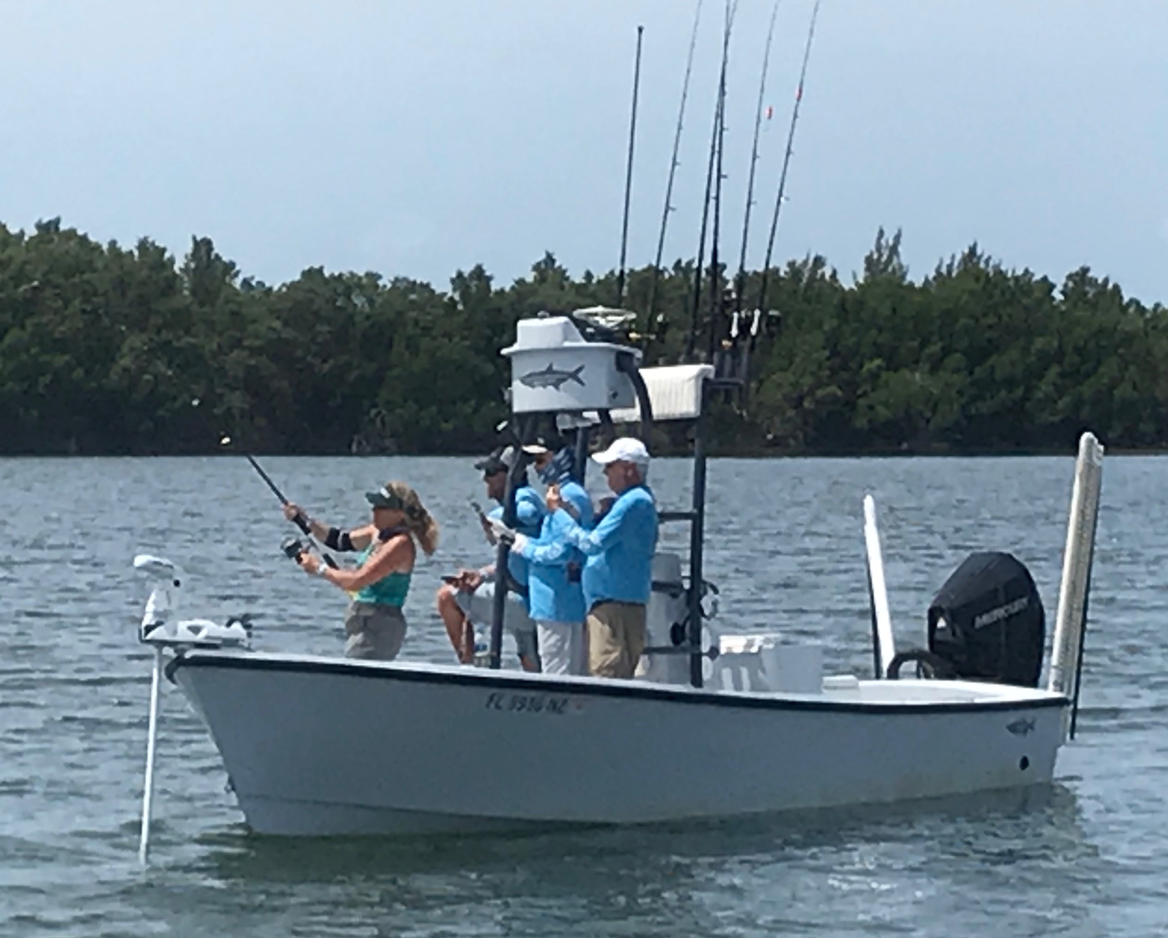

Picture: “Chasing Poon” hooked up while fishing the “Ding” Darling Doc Fords Tarpon Tournament.

The Tarpon have arrived!

Tarpon flooded into our waters this week in massive numbers both along the beaches and the bay. Seeing hundreds if not thousands of rolling tarpon during a morning charter is an amazing sight and gets everyone who see’s them fired up. Nothing I can think of is as majestic as rolling happy tarpon. Watching these fish do there thing is nothing that can be described and has to be seen to be believed.

Once you found these fish it was often just as easy as returning to the same location day after day. As with any tarpon trip some days these fish ate baits and some days they just would not. If your sat in rolling fish its getting a bite is out of your hands. As a guide all you can do is put your clients in these fish, beyond that its out of your hands

This week’s tarpon bites came on an assortment of baits including live crabs, pinfish, threadfins and cut baits. Beach fish seemed to prefer free lined threadfins and crabs while in the Sound the fish ate pinfish, crabs under floats along with cut baits. The days conditions dictated where you had the best chance of spotting fish and each day this week was a little different.

When fishing tarpon out on the beach its often about covering lots of ground to find the fish. These fish seem to move around more than the bay fish though once you do locate them they are usually in huge numbers. Beach fishing when the conditions are right can mean double digit hook ups if you find that right pod of fish that is feeding. Some days the right pod will eat bait after bait for as long as you can stay with them.

Bay fishing for tarpon is my personal favorite and usually my daily go to.
Tarpon return to the same places in the sound year after year and can be found some day’s busting the surface while feeding on baits. Fish in the bay seem to move slower and mill around more often giving anglers multiple shots. Cut bait in the bay is very productive along with live baits pitched to rolling fish.

There is just something very satisfying about pitching a live bait out to a pod of tarpon and getting a bite. The flash on the strike as the float goes down is more of a rush than the fight. So far this tarpon season we have more fish here and cleaner water than I have seen in almost a decade.

