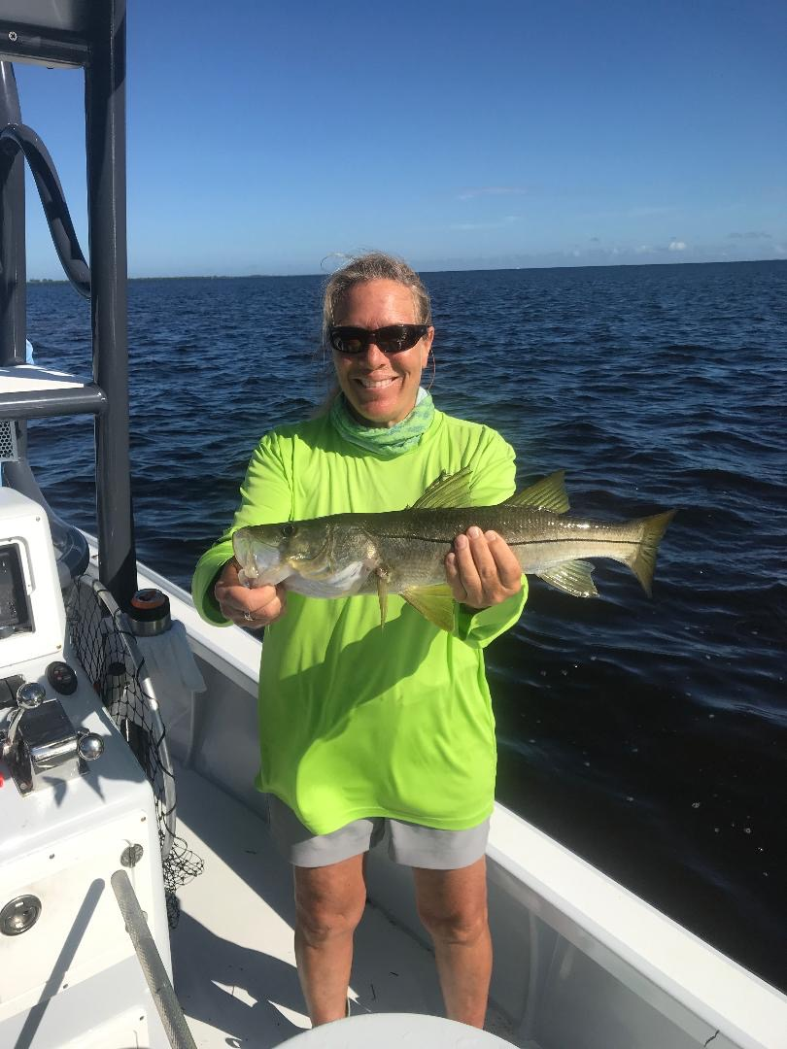

Thanks Gordon

Picture: Mary Laser of Sanibel with a Snook caught while fishing with Capt Matt Mitchell this week

Tropical storm Gordon proved to be just what we needed to break up and push more of the red tide out of our area. In the days immediately following the strong winds and heavy rain the sound was in amazing good shape and it was easy to see the vast improvement. Labor day weekend is usually the last busy weekend before the doldrums of September but with the red tide and a tropical storm it turned out to be the slowest holiday weekend anyone can remember.

Post Gordon fishing continues to keep getting better along with quality bait getting easier to catch. Keeping this pretty bait alive has generally been no problem though it only takes running through a patch of bad water and all your baitfish can die. Most days I had no issues with this but when returning to Punta Rassa to pick up clients one morning this week everything went belly up while between tarpon bay and the causeway. Later that day after a few hours of incoming tide this same area was fine and no bait died. While fishing a tournament this past weekend we ran the whole length of Pine Island sound and back down Matlacha Pass and did not see a single floating dead fish or have any baitfish die.

This week brought some crazy big high tides which proved to be the perfect set up for catching both Snook on oyster bars along with redfish under the mangroves. Oyster bars around Buck key held lots of smaller Snook and once you found them this bite was on fire. Redfish on the other hand where tough for me this week though I had reports from Matlacha Pass and the Bokeelia end of Pine Island where this bite went off. Mangrove snapper where in my fish of choice for my clients looking for fillets.

Waters around our area where a little busier this week which is a a good thing. I’m seeing people gradually getting back out on the water and they are being pleasantly surprised at the conditions they are finding. The middle northern sound and Matlacha Pass remain the cleanest water and the better area’s to fish. Area beaches are the cleanest they have been in a long time after the massive clean up operation. Don’t give up hope get out on our waters and enjoy.

