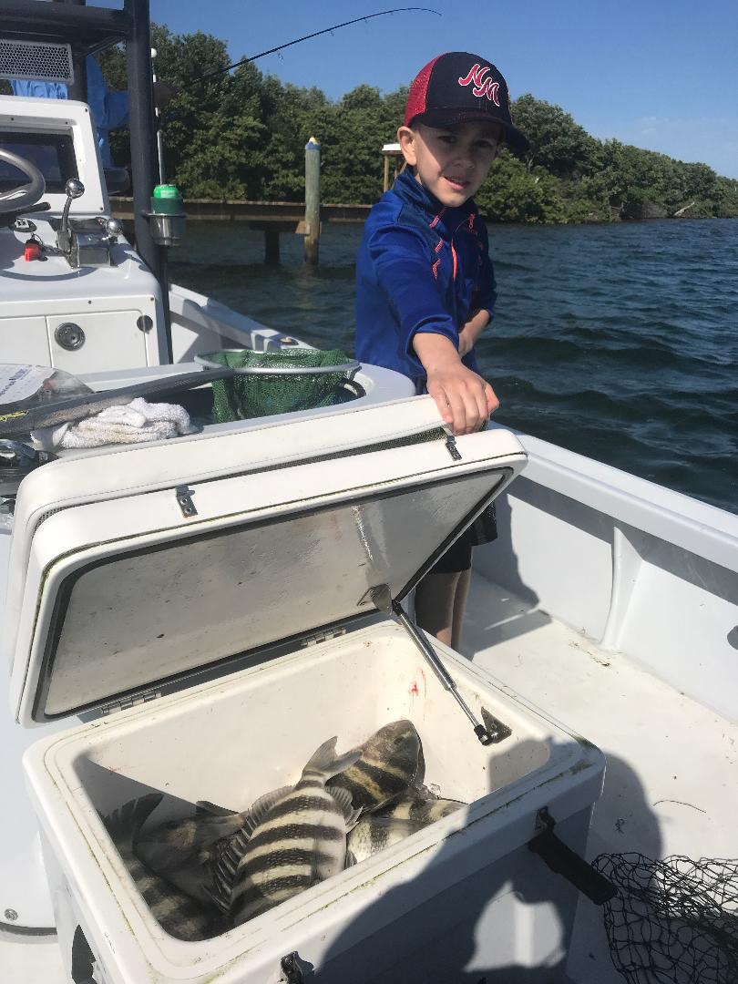

Picture: Coolers full of Sheepshead are childs play in the cold

Temperature ups and downs of winter fishing

We are now on what is that seasonal roller coaster of winter fishing. Cold fronts push through almost weekly bringing us either rising or falling temperatures. Knowing what species to target depends on which side of the cold front you are fishing and makes all the difference to your success. A general rule of thumb is the colder it is the smaller and slower the presentation needs to be.

This was extremely noticeable this week with a few mornings that temperatures fell into the high 40’s then in just a few days temperatures began to rebound . Since the sound is so shallow a few cold days is all it takes for our water temperature to plummet into the mid 60’s which was a major 10 degree drop almost over night. The snook bite before this front as expected was crazy good then after the front non existent for a few days.

The first day after the front the winds laid down just enough to get out for a afternoon charter, we wrapped up and went fishing. Heading up to the passes with a live well full of shrimp action on sheepshead and rat redfish was really good with my clients bringing home lots of keeper sized sheepshead.. Chunks of shrimp fished down on the bottom around docks and pilings in the deeper fast moving water is always a sure fire method to catch fish even during the coldest temperatures.

During this cold water fishing I switch up to my smaller winter size rod’s making catching these fish fun. A 2500 or 3000 series spinning reel on a light rod rigged with 10# braid and a 20# Fluorocarbon leaded makes casting shrimp easy and a 3-5pound fish a battle. Although many of the sheepshead and rat redfish we caught where on the small side at times the bite was non stop. Fishing with long time client Mike Bennet from Captiva we had a 100 plus fish trip which included 10 bigger sheepshead in the cooler to go home for dinner. Sheepshead regulations have changed for this year with the size remaining at 12 inches minimum thought the bag limit is now 8 per harvester reduced from what was 15 per harvester.

As cold front after cold front rolls through snook are making that move into the warm water hang outs of winter. Although action in my favorite Ding Darling creeks has not fired up quite yet it getting close to that time. Getting to go fishing with live shrimp and not have to throw the cast net is always a nice break although as conditions warm back up the snook bite on shiners will go off and it will be well worth catching shiners again. Usually this wide open snook bite happens within a few days of the next approaching cold front.

No matter how badly you want to fish for a specific species of fish its more productive to let the days conditions make that decision for you. Mother nature is in charge and learning what species and method to fish according to the day is never more important than during our winter pattern of cold fronts.

