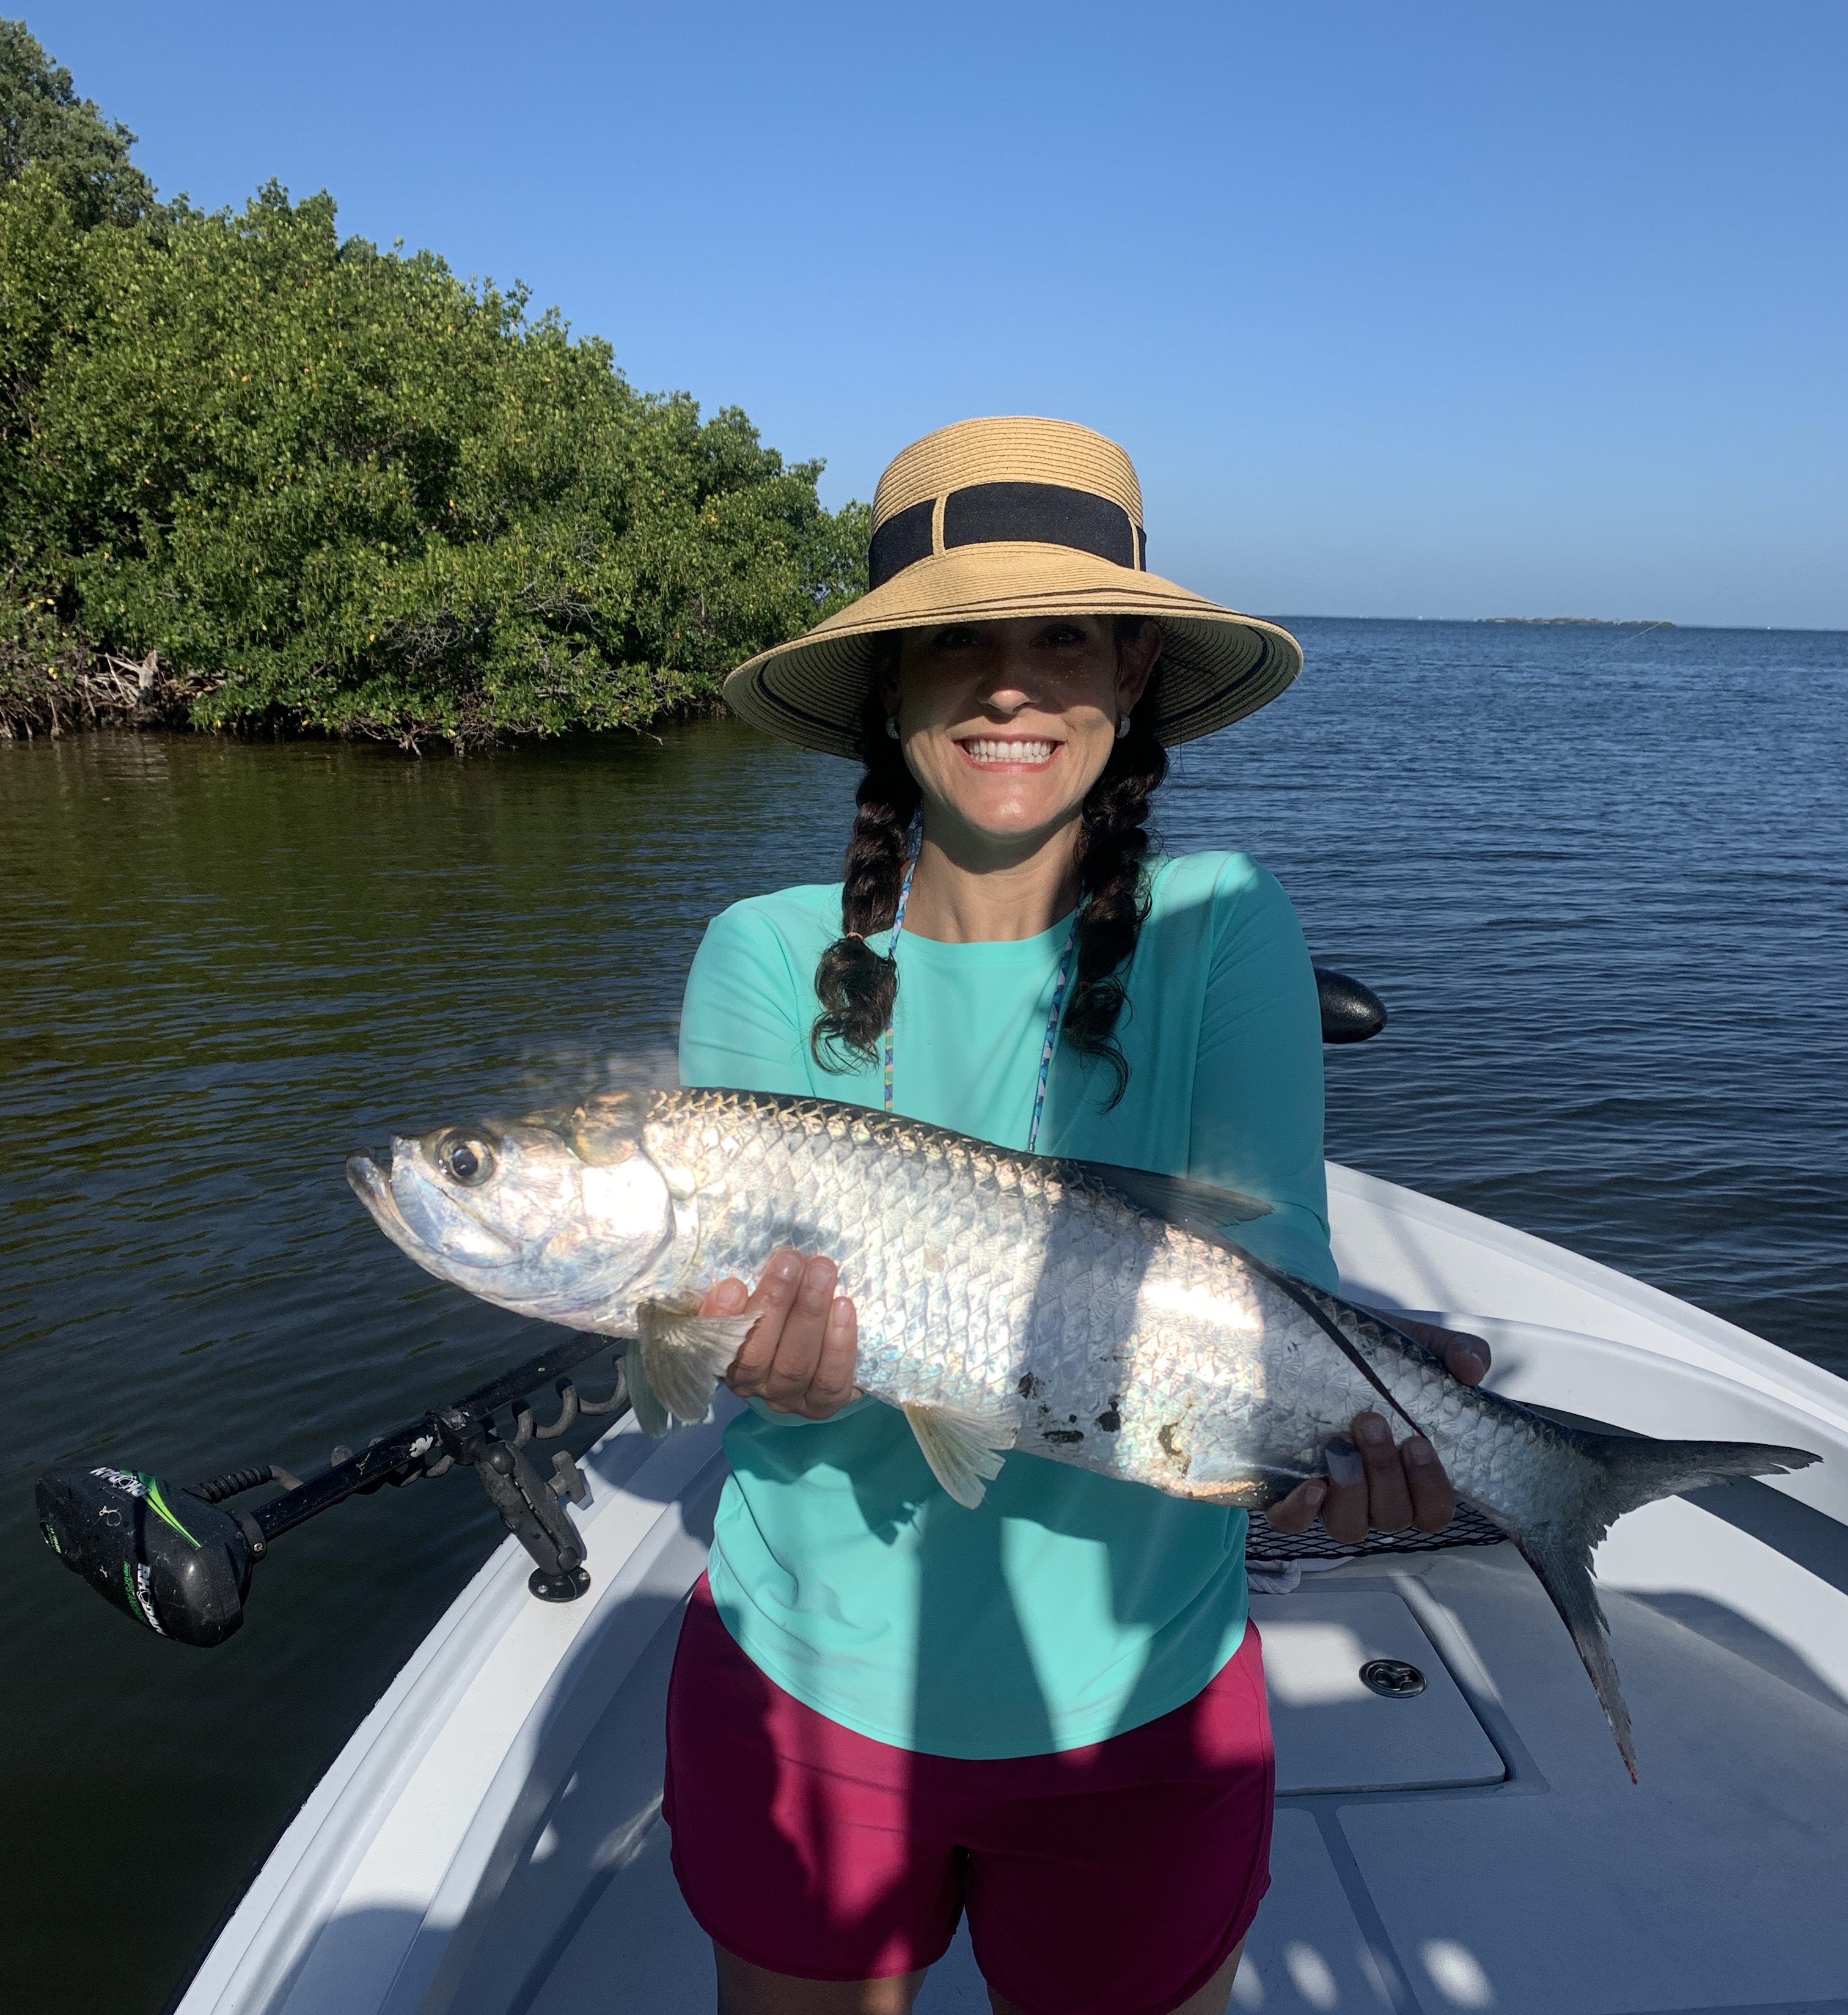

Tarpon time is here

Pic: This juvenile tarpon was caught while snook fishing this week.

So you want to catch a tarpon or be more proficient at it. There are as many ways to catch these game fish as there are ways to loose them. They can require an amazing amount of patience as the frustration level can often be off the charts. With great patience though comes great rewards.
Day in day out there are more tarpon caught in our area doing the old school style of soaking cut baits. Heavy conventional tackle is usually the go to rig consisting of a 4/0 reel on a 8ft boat rod. The reel is loaded with 40-80# mono along with a 80# or larger mono leader. Cut baits are put on a large 7/0-9/0 circle hook. When fishing deeper area’s a twist on rubber core sinker is a good idea to keep the bait on the bottom. Baits of choice include catfish tails, mullet, ladyfish and mackerel. When you see lots of boats anchored up tarpon fishing they have a spread of multiple rods out.

My personal favorite way to fish tarpon is sight fishing. Conditions for this method have to be calm enough to see these fish as they roll and gulp air. Moving around these fish on a trolling motor or even a push pole will give you more opportunities The tackle for this is a large spinning reel basically a 6000 series or larger that will hold over 200 yards of 30# braided line. A butter smooth drag is critical. For a rod a 8ft medium heavy spinning rod will cast a bait a long way. THe rig is simple, a float and roughly 5ft of 40-60# fluorocarbon leader along with a 5/0-7/0 Trokar circle hook. Sharp hooks should not be over looked. Live baits for this are threadfin herring, pinfish, crabs and large shiners.

Over the past few years I’ve really taken to throwing soft plastic baits at these fish when conditions are right. I like a little lighter set up for this. My go to is a long casting 8ft medium spinning rod loaded with 20# braid. Some favorite plastics for this are the DOA bait buster, 3D plastic mullet and Hogy’s. Look for plastics that are rigged with a single circle hook, they work best along. Tarpon shake there head so aggressively and have such a hard mouth they seem to throw almost anything else.

These migrating tarpon have returned to our waters for millions of years and frequent the same area’s over and over. Once you find them some where expect to find these fish here again and again. Waters within a mile or so of the passes both in the bay and out on the beaches are a good place to start your search. Keep your eyes peeled as all it takes is seeing rolling fish or even free jumpers to locate them.

