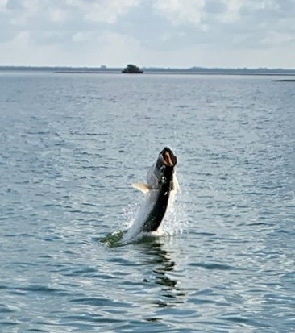

Tarpon anticipation is over

Pic: “Silver King” going airborne.

The full moon in April did wonders for our tarpon fishing. After only seeing a few scattered fish, it was like the starting gate had been opened and almost everywhere I looked for tarpon we found tarpon.
This big push of fish marks the start of the annual migration and some of the most amazing fishing of the year.

Switching gears to tarpon fishing is always a much anticipated time of year among both guides and anglers alike. Although I have heard of a few fish caught here and there over the past few weeks conditions until now just have not quite been right. Water temperature is a major factor in what seems like a little bit later start than in the past few years to get to that magic 76 degrees.

Everyone you talk to has a favourite place and method to target these fish. Growing up here it was all about setting up on a anchor at Knapps point with cut baits. We would buy shad and cut them to create a chum slick while we soaked baits on the bottom. This Knapps point area can be described as the tarpon triangle when you draw a line to Naples

It is a staging area for massive amounts of fish before they push up into the passes and bay. Although it’s a huge area most days, it’s about finding the threadfin herring and pretty water and the tarpon will be there. Wind conditions play a huge factor in being able to locate fish out in this exposed area. Drifting live threadfin is now the method of choice even though cut bait fishermen still get it done.

These tarpon will also be traveling up and down all our beaches. Getting out early to present live baits to these fish can be extremely productive. The beaches of Cayo Costa have extremely clear water and allow you to track these fish even while they are below the surface. Deep water close to the beaches of Captiva means these fish come in extremely close often being in casting distance of beach anglers.

Many anglers opt to fish the passes while drifting the outgoing tide with crabs. This method can be very effective at Boca grande, Captiva Pass, Redfish pass and even Point Ybel. It’s often very crowed though if everyone is on the same page can be very successful. This bite is more about the strong outgoing tide and the action can go on anytime of day. Over the past few years, I’m seeing more and more tarpon around the causeway bridges on this same tide pattern. Anglers setting up on a spot lock trolling motor and drifting baits back around the pilings have been getting it done.

Many areas in the sound are magnets for these fish which return to these same places year after year. Early season the deep hole south of Marker !8 is a popular cut bait spot along with Marker 4 between Picnic Island and the B span of the causeway. Further up the sound the whole back side of North Captiva will have traveling fish as they move between redfish and Captiva Pass. Deeper channels that travel both north and south from Captiva pass turn into tarpon highways.

No matter what method or where you choose to tarpon fish these fish are like nothing else that swims. Although this can be some of the most frustrating fishing you will ever do with patience comes great rewards. All it takes is hooking into one of these magnificent fish and the hype is totally understood. We are lucky enough to have a backyard that every Spring is where tarpon from all over the world migrate too.

