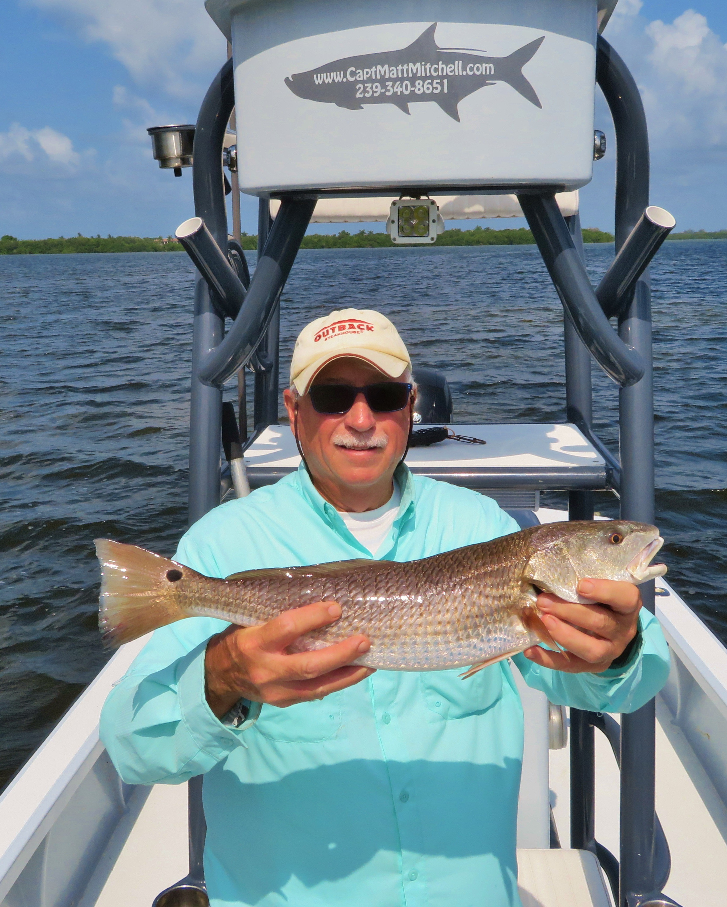

Picture: Gary Biltgen with a slot-sized redfish caught while fishing with Capt Matt Mitchell this week.

Summer snapper bite continues.

The stories of water woes continued this week with patchy red tide out Gulfside blowing dead fish up on the beaches. Just because there are dead fish on the beach does not mean the red tide is in the sound. In fact to the contrary fishing in the sound has been really consistent. A few mornings this week we did have issues with bait dying in the live well just inside redfish pass and lighthouse point. Moving away from these passes we re caught bait and had great days catching lots of fish. What’s really strange to me is the fishing in the mouth of the river and southern Matlacha Pass has been some of the hottest action around on a crazy variety of fish.

Small shiners remained the daily bait of choice with fish blowing up on them when chummed. With our shallow water mangrove snapper bite in high gear its been relatively easy to catch a limit of good sized snapper up to a respectable 14 inches. Some of my favorite and most productive places to catch these fish has been in the southern end of Matlacha pass and mouth of the river. At first glance this water looks really black but on closer inspection its pretty clear, tannin stained and full of life.

Canal and creek mouths along with oysters bars have been my go to when fishing this area in the southern sound. A strong high incoming tide proved the most successful time to fish these places. Along with the snapper we have also been catching a mixed bag including big trout, snook, Spanish mackerel, jacks and even a few redfish. A few scoops of these small shiners has been all its taken to have these places light up with more surface action than you would have ever thought possible.

With some perfect mid morning high tides to go after redfish I am starting to catch a few. The best redfish day came while fishing with Mary Laser and Gary Biltgen as we managed to put 3 slot sized redfish in the boat. Every redfish caught this week ate the same little fry bait I have been using to catch all the species mentioned. Seems with the water just so hot most fish just prefer a bite sized snack than a full meal larger bait. Wind blown shorelines from Buck Key to Wulfert keys were all good places to target these redfish.

If you are planning on going on a fishing trip in the next few weeks remember the last thing any guide wants is to take clients out and not catch them fish. If fishing is bad due to red tide any respectable guide will be the first one to tell the client that its not worth going When you have a new client from out of town that has seen all the dead fish all over the beach they are often apprehensive about going fishing or just don’t even book a trip. Ask your guide how the red tide has been and if it’s effecting where they fish. Over the past few weeks many of my guide friends, me included have had cancellations because of the amount of dead fish showing up on the beach and them hearing all the negative reports on the news. In reality fishing in the sound has been really good despite the red tide in the Gulf.

