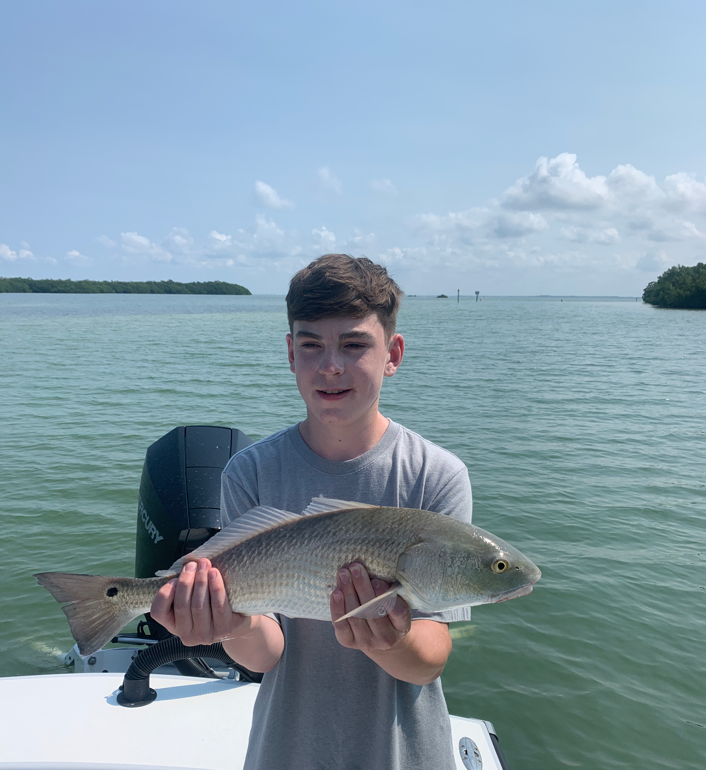

Pic: Matt while visiting from WV completed an inshore slam on his first SWFL fishing trip.

Summer has arrived

Fishing during these hot sticky summer days requires either getting out early or later after the afternoon thunderstorms are done. These often fast moving strong storms will be part of our daily pattern for at least the next few months. As our water temperature has crept up to what can only be described as hot fish are most active during the first few hours after sunrise and then again after the afternoon rain cools things off. Big fish are what summer fishing is all about. Not only is our tarpon fishing going on big snook and redfish are also a great option.

When targeting tarpon getting to the fish at first light can make all the difference. Being in the tarpon as the sun slowly lights things up will give you the best shots at these fish. Area’s in the northern sound were the most productive this week with North Captiva and Cayo Costa being the hot spots. Both pitching live baits at laid up fish and soaking cut baits did the trick this. By mid morning even though the tarpon are often still showing this bite shut down.

Pass fishing offers anglers lots of options with not only tarpon moving through these area’s but huge amounts of Snook stacking up on any structure. Docks and snags in the passes where great places to fish. Big redfish also crashed the party this week with many over 30 inches being caught within close proximity to the passes. During clear water conditions the herds of snook that can be sight fished can only be described as impressive. Riding down the beaches any downed tree’s, flat rock and snags have also been a good bet for not only for snook but some really big trout to complete that inshore slam.

Shiners are slowly disappearing as the seasonal change over to fishing with pinfish and grunts has begun. Setting bait traps to catch these pinfish is a great option and doesn't require much effort to have plenty of live bait. I bait my traps daily with Spanish sardines and set them in grassy area’s in 5-7ft of water. These traps catch a wide variety of bait often including crabs for tarpon fishing. Although I’m currently still throwing a cast net for shiners the traps are insurance that I always have live bait.

