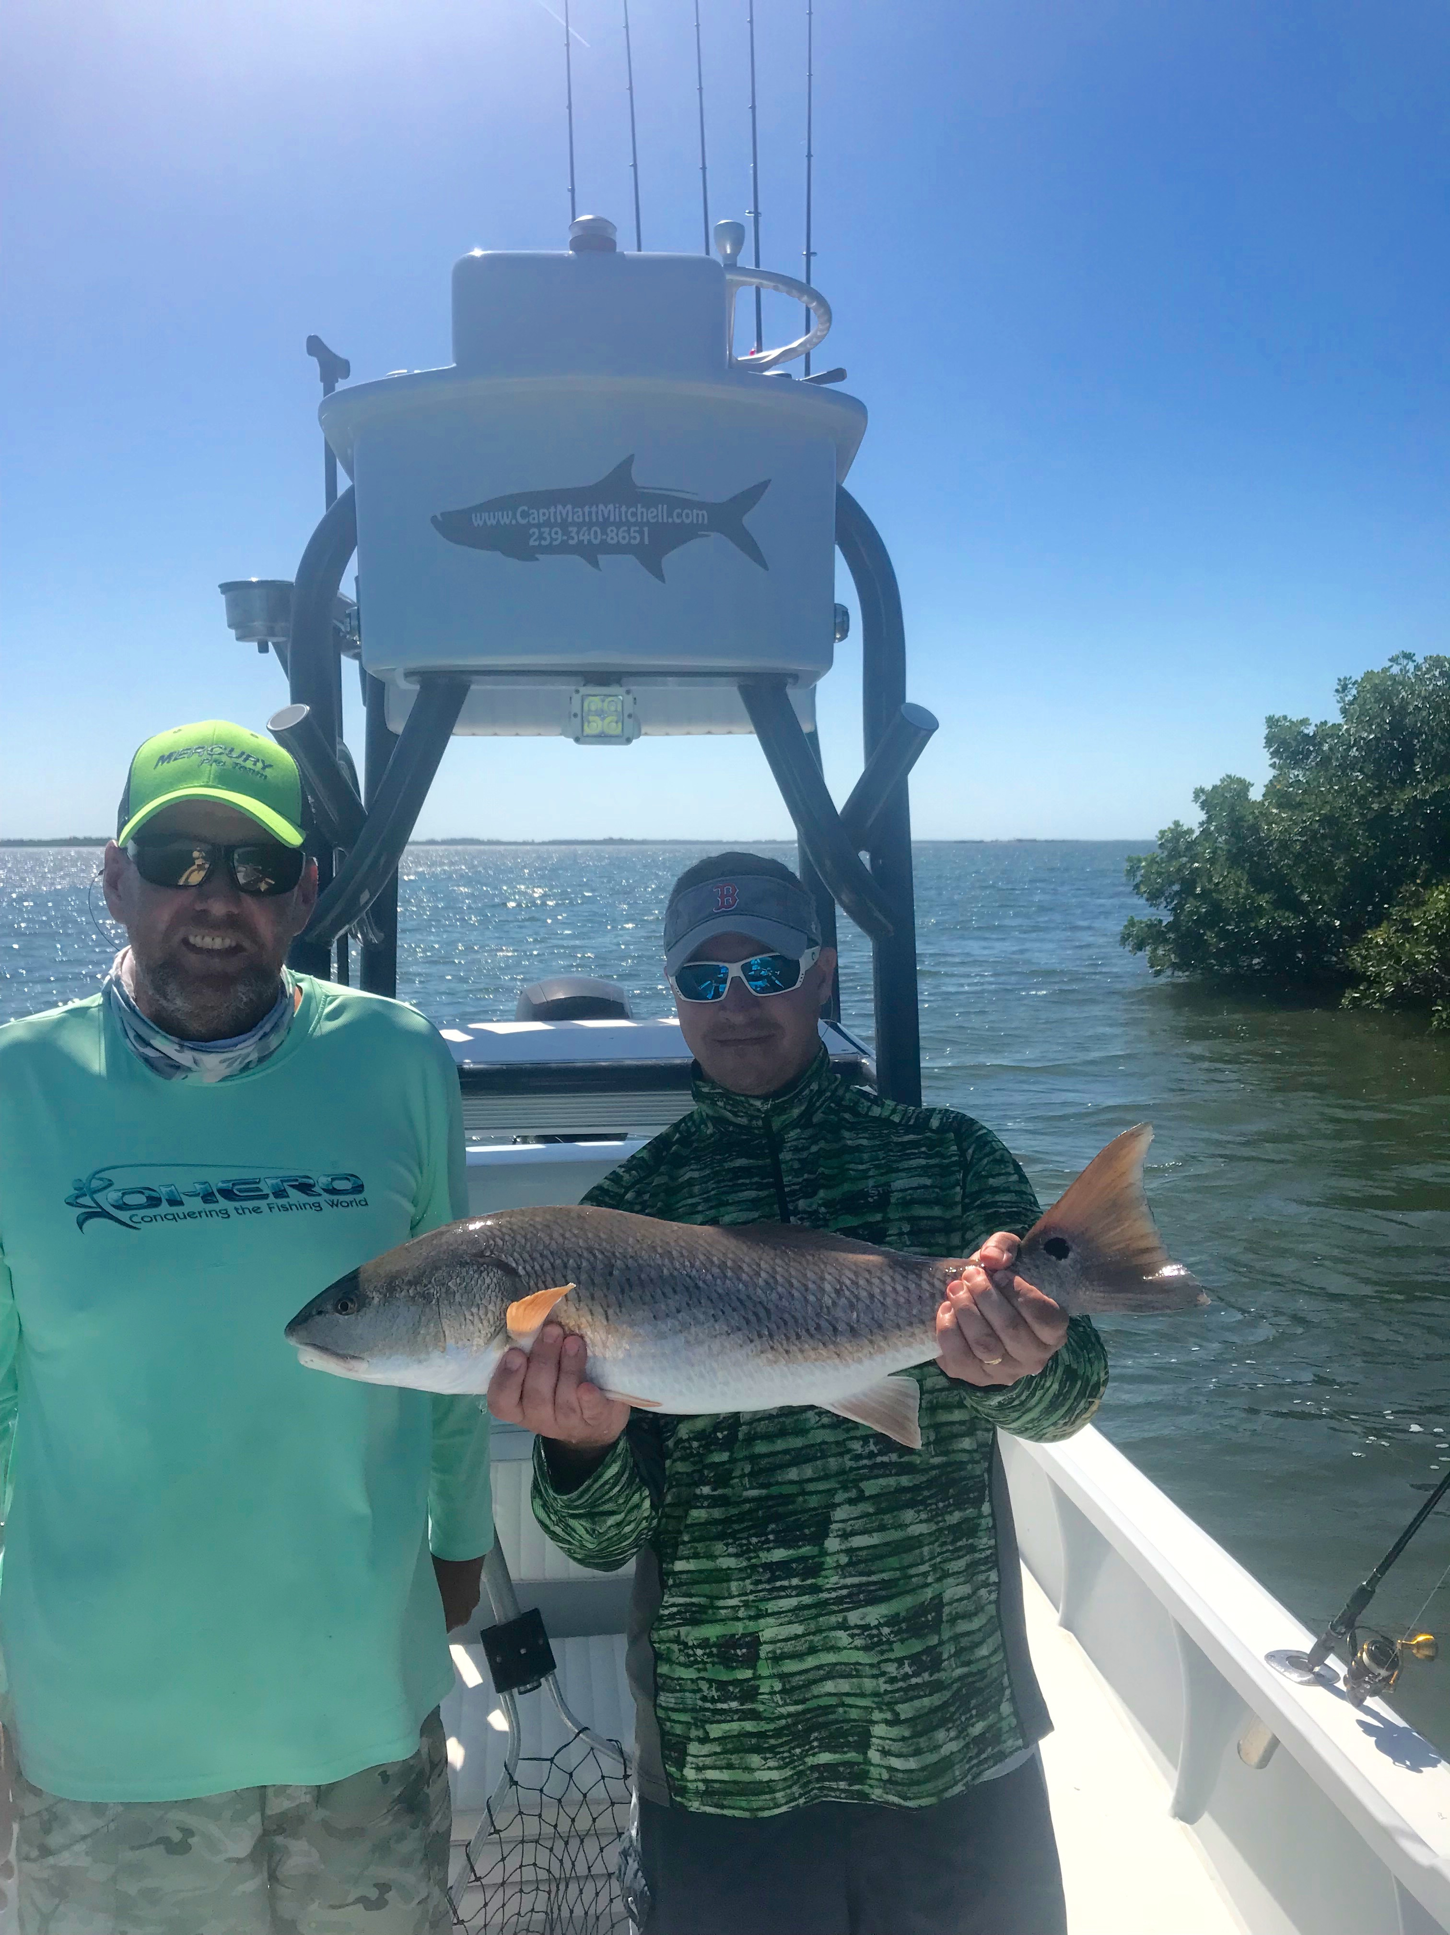

Pic: Alex from ABC liquors with a 29 inch redfish caught while fishing with Capt Matt Mitchell.

Struggling for that Snook.

Great tides and great bait don’t always mean great fishing. This week proved to be a struggle when fishing for Snook and redfish although I did catch some of each the bite was just never on fire and every single fish we caught took work. The best action continues to be our big trout fishing that has been outstanding with lots of fish over the 20-inch mark. Tarpon fishing was beat up a little by more strong winds although anglers who where willing to put the time in soaking cut baits continue to hook them in the southern sound. Along with tarpon lots more sharks are starting to show up along with Spanish mackerel, ladyfish and jacks of Spring.

This week I had the pleasure of fishing with one of my favourite groups all year Diageo and ABC Liquors during their 3 night stay on Captiva. These clients have done this annual business strategy meeting and fishing tournament for the last 10 years.. This year was no different with 5 boats booked for 2 days and them wanting to only fish for Snook with the big Snook each day being the winner. Day one Snook fishing was tough with big high pressure on us but we did manage to catch 4 slot-sized fish on the 5 boats.

Day one after running all over the sound to the places I had seen Snook laid up all week we had very little success only catching a variety of other species until the last hour of the tournament. As the tide got up higher during late morning I made the run to a favourite oyster bar looking to catch one good fish. First cast on the oyster bar and the bait was not in the water 10 seconds and we where hooked up on a nice 29 inch Snook that we landed. Continuing fishing the other oyster bars in the same area we also managed a monster 24 inch trout before time ran out on us. My friend Capt Travis won day one with a Snook, which measured 31.5 inches.

Day two I had a different game plan planning to run north and sight fish some Snook on the bay side of Cayo Costa in the clear water. Idling down a favourite shoreline I located lots of larger Snook but could just not get them to eat even a live chum. After a couple more frustrating hours working down this shoreline without even a bite I made the run back to the south to fish a island by rocky channel in the north-eastern sound now that the tide was finally high enough to reach it. Idling around this mangrove island every sand pothole had Snook laid in it. Setting up way out and making long casts we had Snook blowing up on live shiners and it looked like it was going to happen. On the 2nd or 3rd cast we finally did catch our 1st small Snook of the day and then it just quit.

Motoring around to the next deeper shoreline I spotted about 20 over sized redfish laid up under the mangroves along with a 1/2 dozen big Snook sat out in the deeper sand hole. After throwing baits to these Snook without a bite we did hook three big redfish and landed one 29 inches before time ran out on us. Day 2 proved tough for all the Captains with the largest Snook caught only measuring 26 inches.The winner day 2 was caught by Capt Jason Marsh who operates my 2nd boat.

After probing Jason a little bit he gave up the fact that after struggling all morning Snook fishing he had gone back to our home Marina in St James city and caught one of our pet Snook we feed everyday right in my boat slip for the win. If my morning wasn’t frustrating enough to have the winning fish be one of your pets and worse yet why didn’t I think of it 1st. All in all it was a great two days spent on the water with very generous clients that have become my friends over the past 10 years. Add in some friendly competition amongst fishing guides and I can’t wait until next year when I hopefully get to redeem myself.

