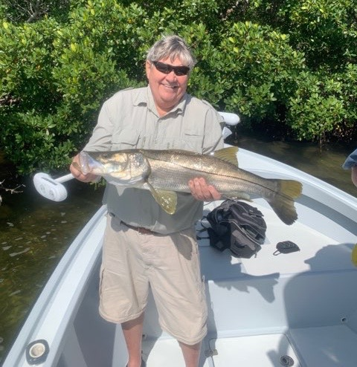

Pic: Pete with a 36 inch Snook caught on the last cast of the charter while fishing with Capt Matt Mitchell

Spring like variety

Yet another fabulous week of outstanding weather made for excellent fishing on what continues to be a crazy wide variety of fish. No matter what kind of fishing you are into there is something out there for you. Not having just one single target species in mind has kept things interesting and the rods bent. My clients have enjoyed what the day has given us as dealing with some really slow to no tide periods we had to mix it up to catch any fish. I’m very happy to see the better tide pattern for this week as a few trips this week the tide simply did not move.

Catch and release Snook fishing continued to be my main staple with the action being very consistent while the tide was moving. These Snook are in a transition period as they are moving from the back country to the passes with water temperatures warming. I’m managing to stay on these fish for a few days at a time then they move closer to the beaches where they will be in the summer. Oyster bars and islands in the middle sound have been the hot spots. Chumming live shiners in these places will let you know if the Snook are there and feeding. This week we did catch a few Snook in and around the passes as during the slower tides we where hunting moving water as much as Snook.

Spanish Mackerel fishing has also been been heating up with the best bite coming around the passes and out along the beaches. Sandbar drop offs in Redfish and Captiva passes had some real giant Mac’s this week with a few almost King Mackerel size. Light single strand wire leader was critical to landing these larger Mackerel without getting bit off. Tide rips around these shallow bars in the passes has also produced ladyfish, jacks and even a few bluefish.

More and more tarpon are being sighted along with some of the first catches of this year reported. These early season fish have been very random with them popping up all over. This week I ran into a few rolling fish at Fosters point on North Captiva and then again a few days later on the clam leases in the middle sound. There are not close to as many fish here as when the migration is in full swing like it will be in another month or so though seeing the early season tarpon being active is very cool. Its certainly worth taking some tarpon tackle on your next outing with just in case your lucky enough to run into these fish.

The shark bite has also been strong with them being caught both out on the beaches and in the bay. Soaking cut baits in rocky channel and inside the passes in the deeper natural channels has been a good bet. Blacktip’s and Bull sharks have been the majority of the species and are a blast to catch. With all the Ladyfish in the sound right now its just a matter of catching a cooler of fresh Ladyfish and working your way up the food chain.

Yet another cold front is forecast for mid week as I’m writing this. Things will get messed up again for at least a few days until conditions gradually improve. Though this cold front is not forecast to be very cold it will bring strong winds and small craft advisories keeping anglers home for a day or two. As we are approaching April we should be just about done with any more cold fronts that temporally stall our quickly improving fishing.

