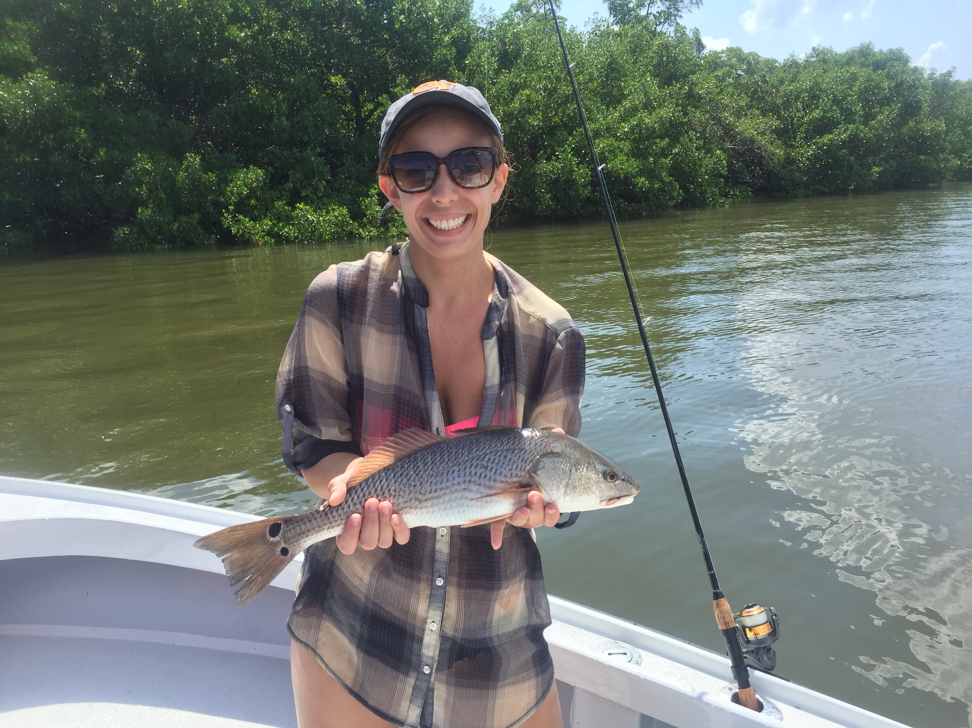

Snook and Redfish closed to harvest.

Picture: Still catching a few redfish though now they are all catch and release

Usually the 1st week of September I would be writing about the opening of Snook season but on August 30th the FWC temporarily made both Snook and redfish catch and release from Manatee county to Collier County. This executive order is in response to the red tide we have experienced and is in effect until at least the next FWC meeting Sept 26th.

The fact that these fisheries are closed to harvest is a good thing. Both Snook and Redfish fisheries have taken a hit by this never ending red tide. These iconic species of fish need protection and are way too valuable to be seen as just a plate of food. On the down side though this news making closure will only bring another wave of negative press and more miss information further grinding our tourism to even more of a halt than we have already experienced.

Getting out on the water this week I’m finally seeing a few more boats out than in the past several weeks. Conditions have rebounded and although there is little to no work for any of our area fishing guides or basically any water based business fishing was good. After catching shiners in the middle sound we easily caught limits of large mangrove snapper and also released a dozen or so Snook while just out playing around. Jacks and Grouper also bent the rods while bouncing spot to spot.

Bait and bird life is slowly getting back to normal with certain places just alive with life. In the northern sound once you make the turn north past the powerlines the sound was free of dead fish. Area’s inside the Sanibel light house are still a little littered with a few floating fish which I think is more due to the east winds and strong tides pushing floating fish in and out. With 140 miles of our coastline experiencing effects of this supercharged red tide its just going to take time to clear out.

Cancellations have been the normal for both hotels and every fishing guide as northern and European clients who normally get us through the summer have been lead to believe the red tide is of Biblical proportions and will make them sick. Miss information is all over with people believing there is no sea life left. When I have got clients out on the water they are amazed how good our fishing and eco system is after reading and watching the shocking news reports. After the slowest August and Labour day weekend for business anyone can remember September bookings are thankfully up.

Government along with the FWC need to come to the realization that a red tide bloom of this size is not naturally occurring and making the levy’s around lake O stronger to hold more water is not the solution as it will only allow them to hold more water for farm interests and increase the nutrient rich water releases. Something really drastic needs to happen before all the sea life in our beloved estuary is destroyed for future generations.

