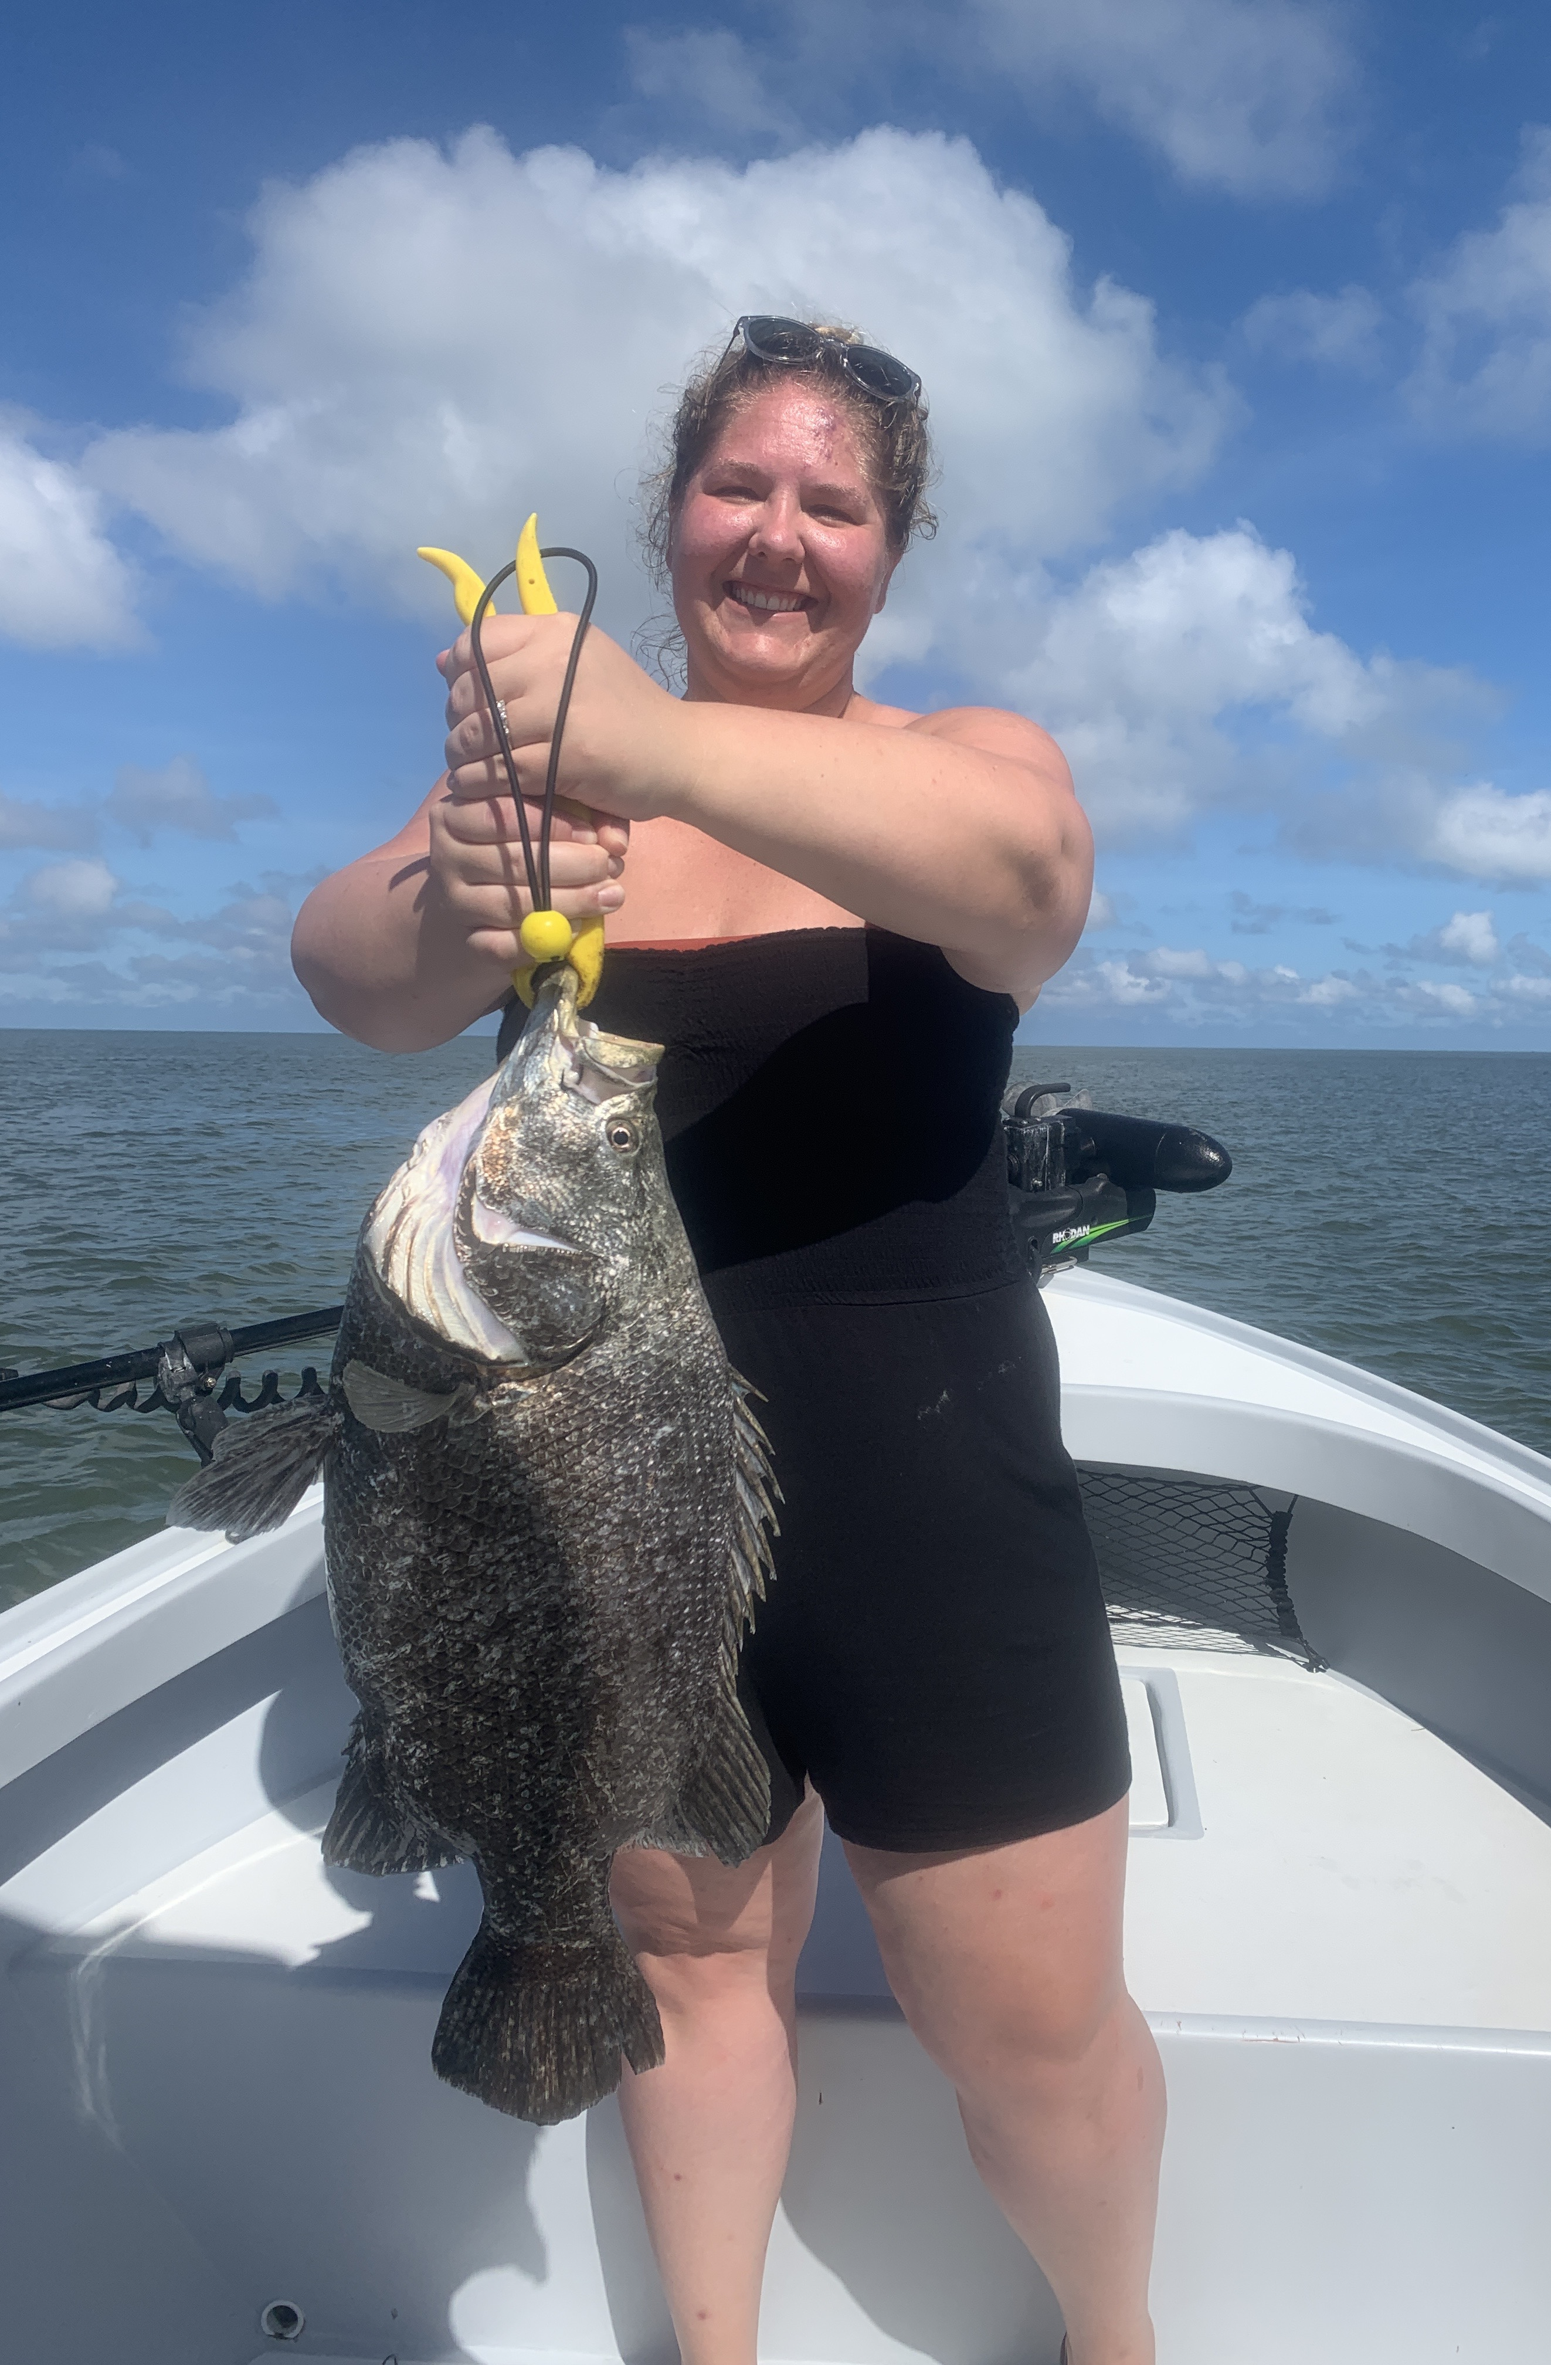

Picture: Alex from Cincinnati with one of the triple she caught while out with Capt Matt Mitchell this week.

Sight fishing the beaches

With light east winds all week until the Tropical Depression blew us out for the weekend I’ve been spending lots of time out on the beach side of the islands. The massive amount of bait gives anglers a wide variety of species to target. From Spanish mackerel and sharks to tripletail and tarpon all have been within a mile of the beach.

Spanish Mackerel have been the easiest to locate with waters just out from blind pass alive with these fun fish. its just a matter of finding birds and surface feeding Mackerel are right under them. Cast small glass minnow jigs or spoons through these fish making a fast retrieve to hook up time and time again. This bite will only get better as the bait migration kicks up. Jacks, ladyfish and sharks are often in this same mix.

While riding the beaches keep your eyes open for large mudded areas. These clouds of stirred up water are the places to find feeding tarpon. I’m not exactly sure what causes these muds though all I can assume is its fish clouding the water by digging in the bottom. I really think they do it intensionally to confuse the bait fish. Use a live pinfish rigged under a float and cast to these rolling tarpon. Some days these tarpon are right in the muds while other days they are working the edges.

While traveling out on the beaches crab pots and no wake buoys have been consistently giving us quality tripletail. September seems to be the time larger spawning fish are showing up on any floating structure both on the beaches and in the sound. Seems almost every time while out hunting tarpon we come across at least a few 10 pound plus tripletail. Some days without any small bait on board I’ve been cutting a strip bait off a pinfish and catching them on that. Certain fish you locate simply will not eat while others charge the bait on the first cast.

Locating fish out on the beach is really visual. Often its about learning the signs of when to slow down.. Anyplace you locate schools of bait fish and birds its always worth a more in depth luck. Beach fishing encompasses such a huge area you have to rely on your eyes. Once you do locate a good area its often possible to return to this same place for a few days before the fish move on following the bait.

