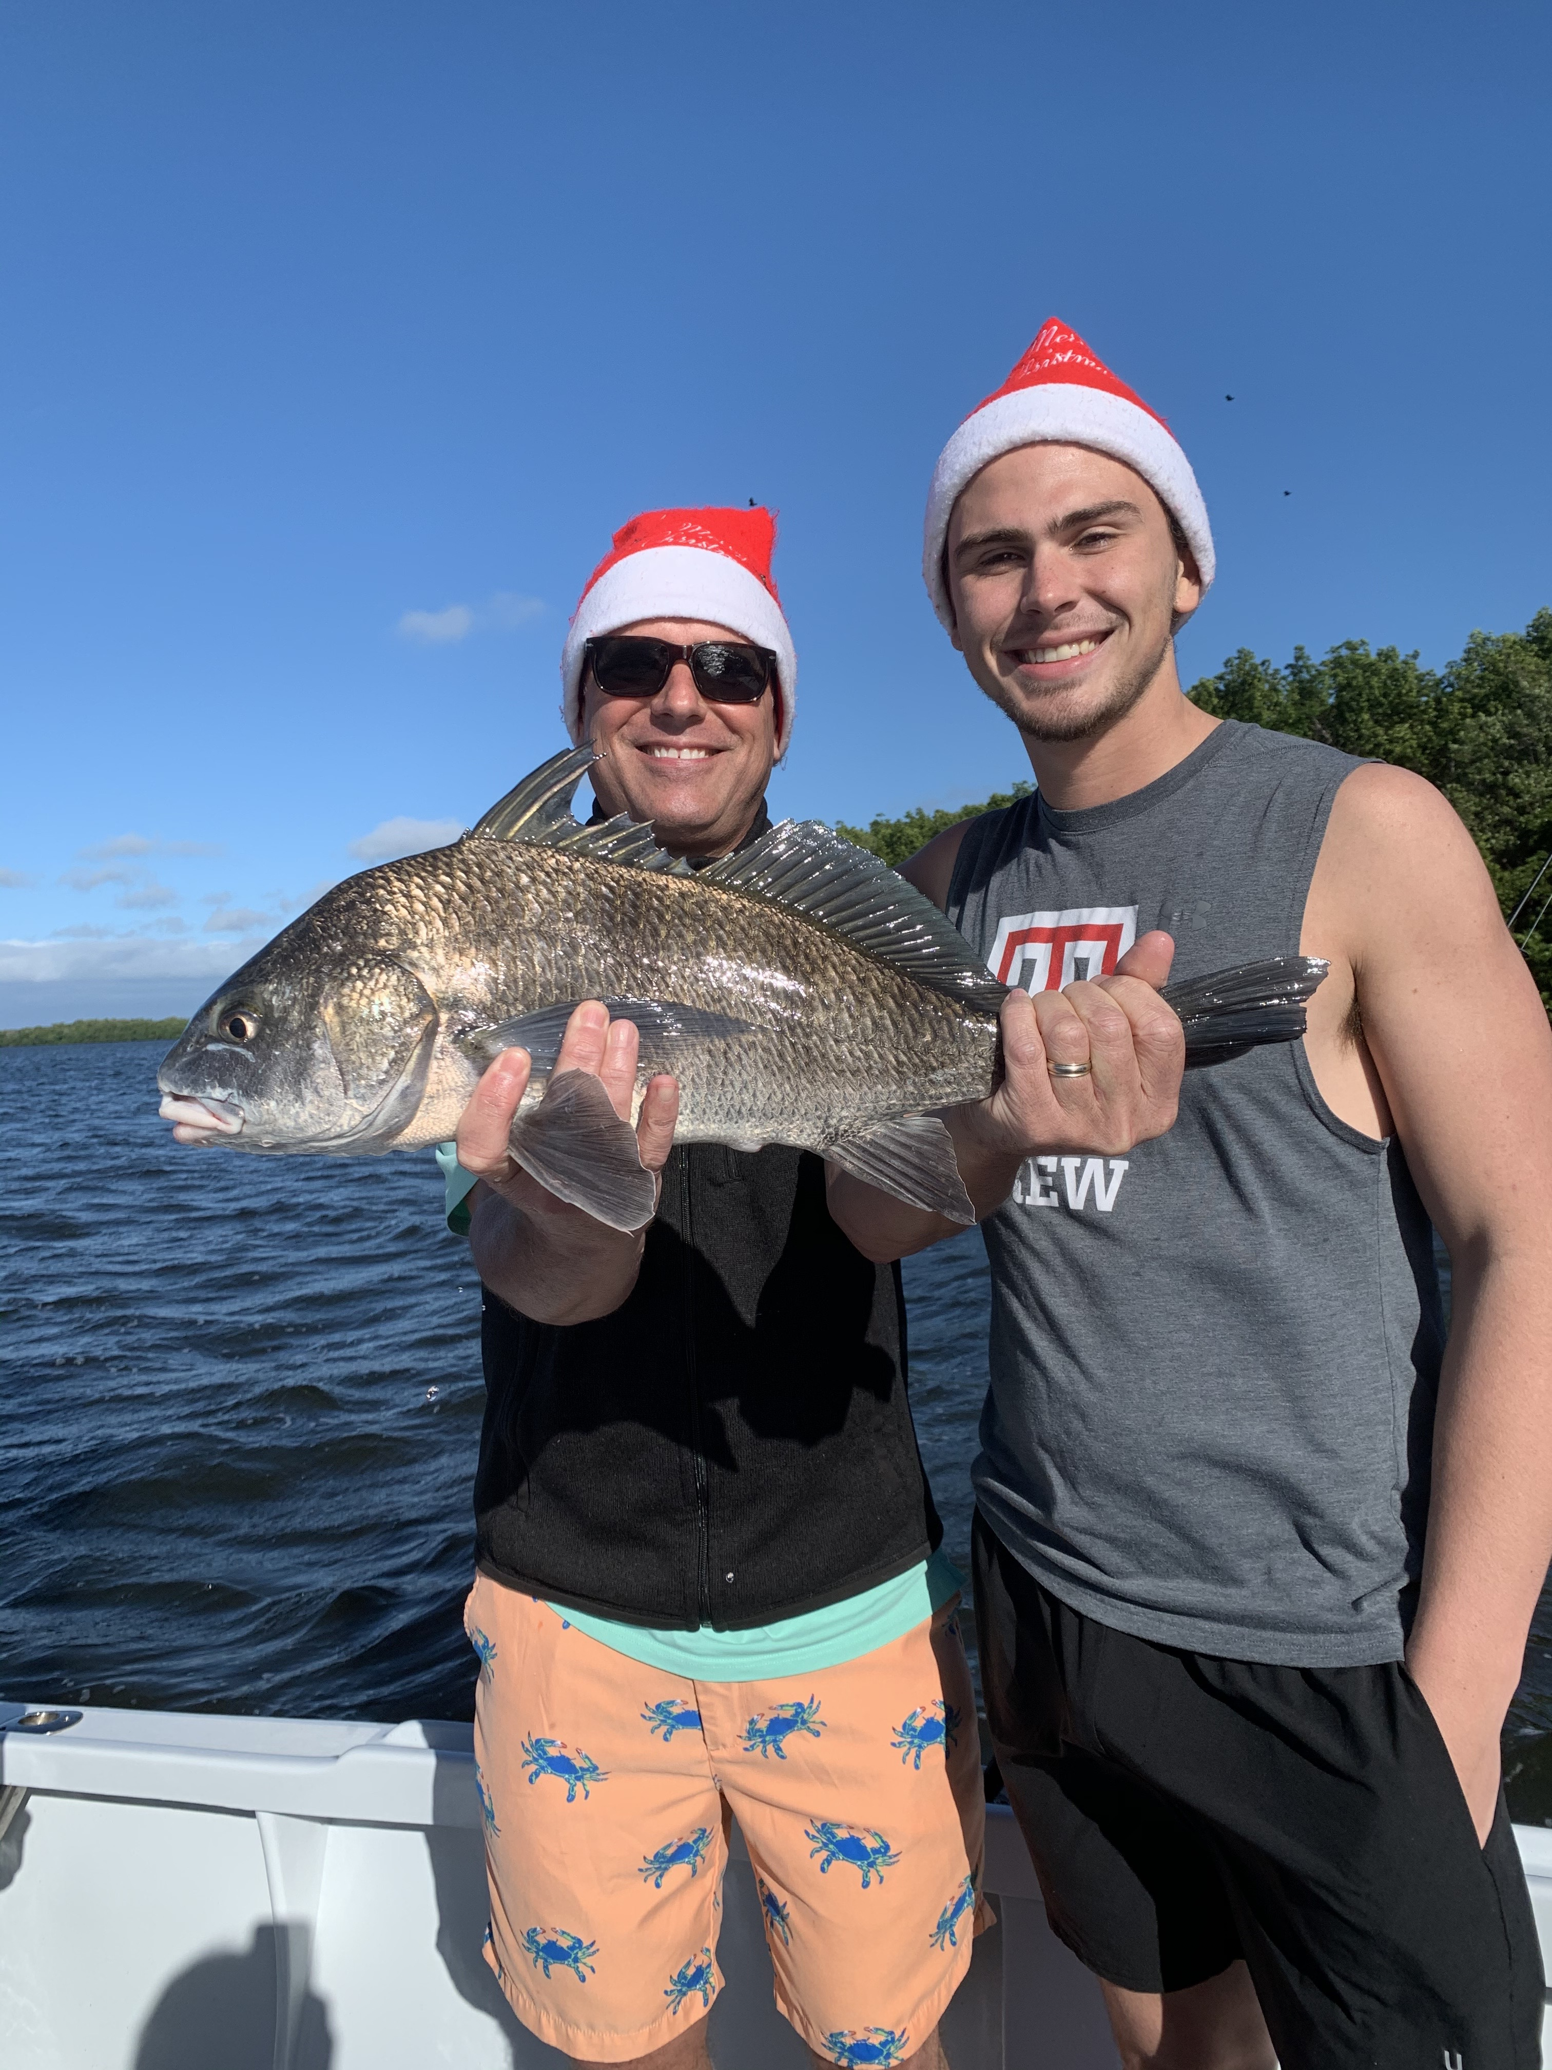

Pic: /John and Joe Adams got in on a crazy black drum bite Christmas Eve fishing with Capt Matt Mitchell

Shiners finally paid off

As usual Christmas to New Years was a crazy busy time on the water. With boats running around all over I rode back in some mangrove creeks this week to get away from the traffic. Some of these less traveled places where crystal clear and aquarium like. Once deep back in the mangrove creeks we rarely saw another boat.

Watching fish swim under the boat and even seeing them dart out from the trees to take your shrimp was awesome. We experienced some amazing redfish action at times with clients hooking fish after fish. The frustrating part of this creek fishing was the amount of snook we saw yet they would just not eat. Live chumming laid up snook with shiners and not having a single fish blow up was driving me crazy. Once in a while we would catch a snook although those bites all came on shrimp.

Knowing that any day the water temperature would get right and these snook would eat I continued to catch shiners. Three days in a row I did not catch a single fish on a shiner. By the weekend it finally happened and we got the snook to eat. This still did not happen in the creeks where we had been watching them all week. Mangrove islands in the open bay with dirty water and moving current seemed to be the places these snook would eat. After a few days it was a relief to catch snook after putting in the work to catch the shiners with zero payoff.

Docks and downed trees around the passes still held some keeper sheepshead, redfish and even a few black drum. During the weekend it was hard to get a spot at any of these places due to the boat traffic.
Both live shrimp and chunks of shrimp fished on the bottom caught these fish. Until we get another cold front the sheepshead in these places have been pretty well picked over.

Black drum are a species I don’t really target but usually catch them while I’m targeting sheepshead and redfish. Several times this week the black drum bite was on fire with fish between 14-26 inches being common. These smaller black drum up to roughly 20 inches are one of the most under rated eating fish around. Black drum have a slot size of 14-24 inches with 5 fish allowed per harvester You can keep one fish over 24 inches though its better to release these bigger fish as they are going to be wormy and desirable. Season on black drum is open year round though we only generally catch these fish in the winter time.

