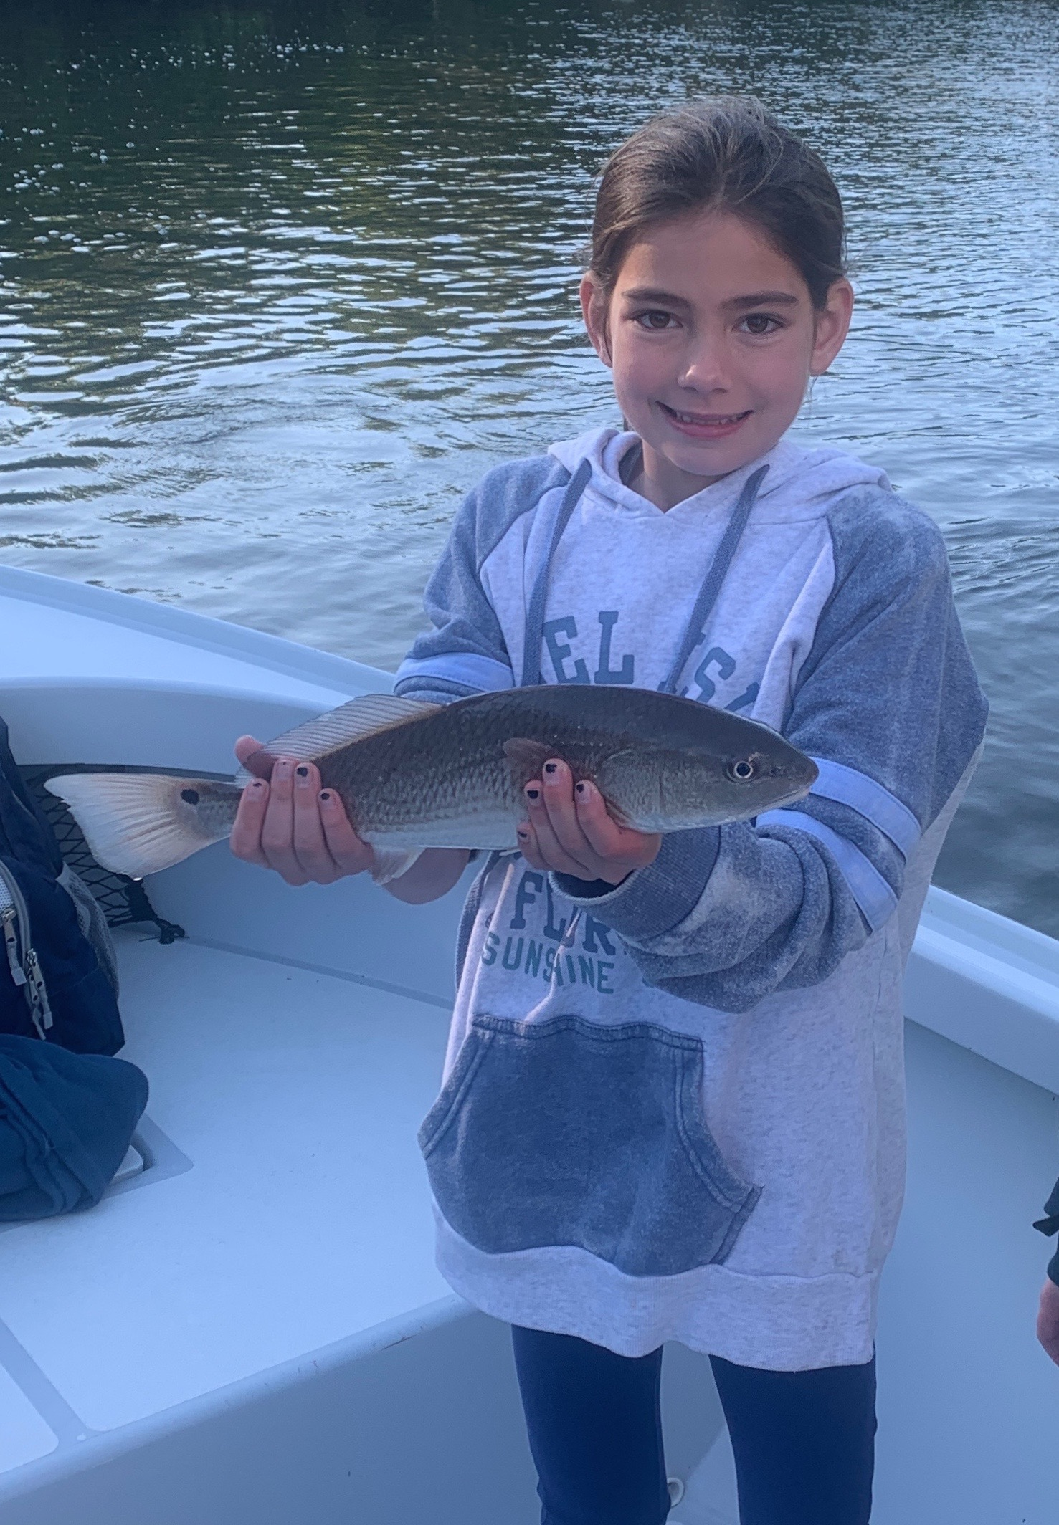

Pic: Maggie got in on some fast paced redfish action while fishing with Capt Matt Mitchell this week.

Sheepshead season has arrived.

As I sit writing this weekly fishing report conditions have already changed from the fishing we experienced all this week. Sneaking out as this strong cold front approached this morning we were greeted with dense fog before sunrise along with strong south winds. This pre front period will always bring some of the best fishing as the barometer is falling.

With this latest cold period forecast to stick around water temperatures will plummet as mornings are forecast to drop into the low 50’s. Seeing a almost 10 degree water temperature drop in the shallow waters of the sound basically over night is not that unusual. For the first few days’ water in and around the passes will be warmer than the sound. This is due to the less fluctuating temperatures of the deeper Gulf waters moving in and out of our passes. The great Snook bite we enjoyed while shiner fishing will quickly grind to a halt as the water drops into the mid 60’s.

Shrimp fishing will now be the method of choice to target sheepshead, redfish and black drum. Look for another much awaited wave of larger spawning sheepshead to move in from the Gulf. This always amazes me how fast this happens after we get a major cold front like this one. Structure just inside the passes will be the first places these hungry cold water loving fish show up. Then within a few days they will be found on docks in the intercoastal and what seems like every mangrove creek in the sound.

Switching gears to shrimp fishing has been a little longer in coming than in the past few years. Although we have had a few cold fronts temperatures have quickly rebounded until now. The fact that we have still been shiner fishing during the first week of January is quite rare.

Embrace the cold as you can now put that cast net away for a while, sleep late and go shrimp fishing. Its also time to downsize the gear to the lighter spinning rods rigged up with a piece of 20# fluorocarbon leader and that trusty 1/4oz jig head. While your switching it up you might as well sharpen up that fillet knife as sheepshead season is upon us.

