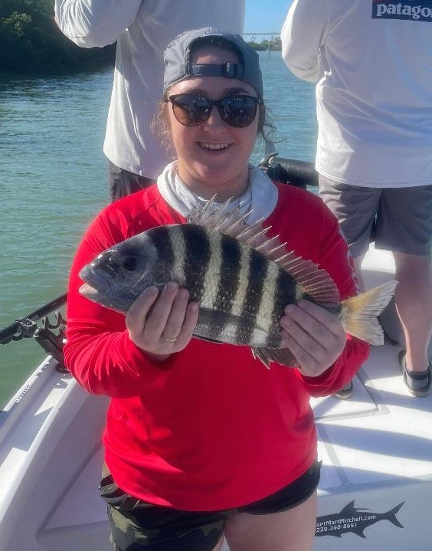

Pic: Sydney from MN with a sheepshead caught while fishing with Capt Matt Mitchell this week

Sheepshead its what’s for dinner.

Enjoying the warmest December in a long time is great for anglers looking to catch snook though until this point it hasn’t been great for sheepshead. Many of my winter clients love to target these fish both to take home a fresh fish dinner. This week it seemed we finally turned the corner and the sheepshead bit became much better. With water temperatures still at a warm 72 degree’s another cold front will really fire this bite up.

Docks and structure in and close to the passes are some of the first places these sheepshead show up as they come in from the Gulf to spawn every winter. Look for them on basically any structure that has barnacles on it. Throw in fast moving current and you are in the right place. All winter long every dock both around the passes and in deeper water is a pretty good bet to catch them. Some of my favourite places also include deeper mangrove channels with shell and oysters on the bottom.

Another option which will be a lot less pressured are the many deeper creeks both in both Matlacha pass and Pine Island sound. Often the best fishing in these creeks is right in the middle of the channels as the sheepshead are on the bottom eating shells and crustaceans. The many deep entrances into St James creek and on the Sword point side of Matlacha pass although hard to access can be amazing sheepshead fishing.

Most of my sheepshead fishing is done on a little lighter tackle, I prefer 10# braid with a 20# fluorocarbon leader. For a rod a 6-6 or 7ft 8-15# medium light with a 2500 series spinning reel makes catching these fish a battle. Chunks of fresh shrimp threaded on a 1/4oz jig head give you the most feel of this quick bite and make it harder for them to steal the bait. These fish are difficult to hook as they have mouth full of teeth and gnaw on a bait like we eat a chicken wing. I tell clients to gradually lift the rod as the fish nibbles until you feel the weight of the fish load the rod tip. While the rod tip os loaded make one quick strike straight up then while the rod is still bent pop them again. This usually ensures the barb gets in the hard mouth.

Sheepshead offer some of the mildest firmest meat of any of our fish. The trick to filleting them is to start the tip of the knife in the groove that the dorsal fins fold down into. Once you get through the skin let the tip of the knife do the work. I always avoid cutting through the rib cage bones as there is no meat over the ribs. For the size of the fish there is not as much yield as you would expect which is why we don’t keep any less than 14 inches even though the regulations are 12 inch minimum. The more of these fish you fillet the better you will get at it.

Although sheepshead is not one of our more glamorous species there is something I really enjoy about catching them each winter. Not only do these fish require patience it’s a totally different technique than we use for any other fish. Once you get this bite dialled in they pull hard and taste even better.

