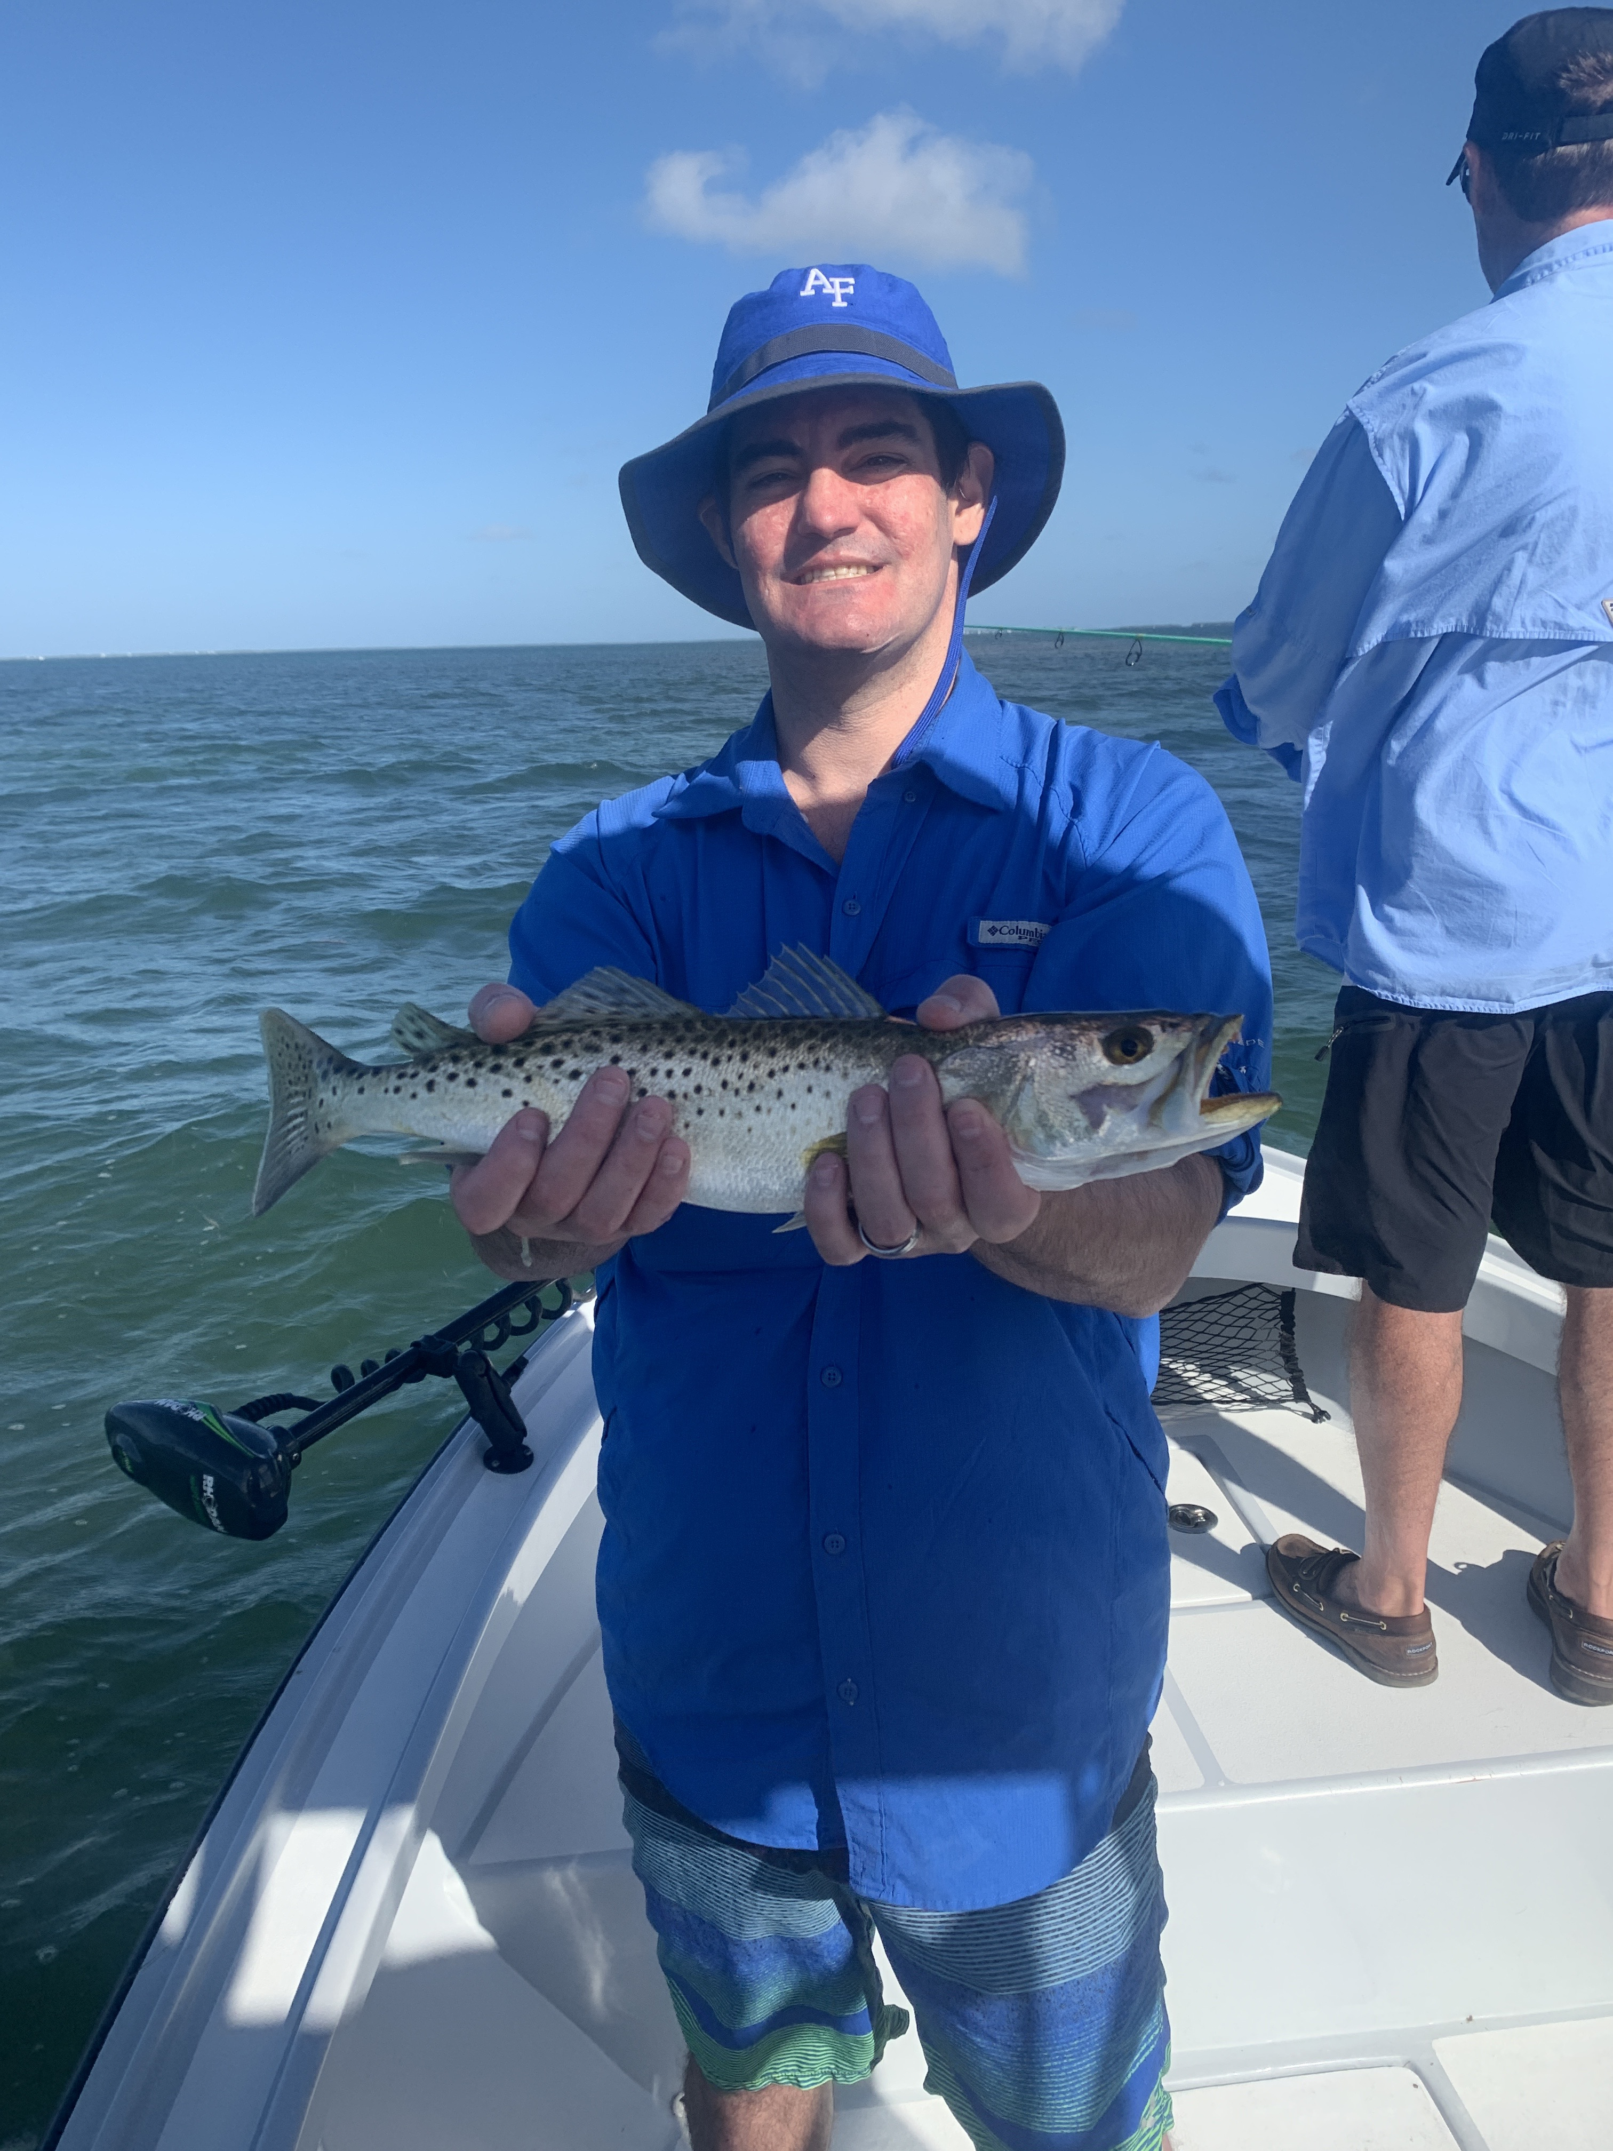

Pic: Grant got in on the big trout bite this week with Capt Matt Mitchell

Self quarantine with the fish

Over the past few weeks COVID-19 has changed everyone on the planets life in ways we could not have imagined. Fortunately I work in a environment that gets me well away from the crowds. My job encourages social distancing and being out in the sun and open air has to be about the safest place anyone could be. Even with a huge drop in our business we are lucky enough as fishing guides to be in that small percentage that can still go to work. For this I consider myself very fortunate. This is not the season anyone expected but we are making the most of it.

A exceptionally warm March has kicked our fishing into high gear with Tarpon already being caught throughout the sound. With a extremely noticeable lack of boat traffic on the water often we have these fish all to ourselves. Locating these tarpon in clear water has been amazing. We watch them swim through white bottomed sand holes in numbers we don’t usual encounter till May. Cut baiting these fish has been the most effective method for me as I just cannot get them to eat a live bait.

Most days this week I have started of my trips by bouncing live shrimp on a jig head to catch a awesome variety of fish. In the passes the Spanish Mackerel bite has been on fire while out on the flats trout, ladyfish and jacks have kept the rods bent. We save some of the ladyfish to do a hour or so of cut bait fishing for tarpon and sharks at the end of the trip. Most days we have either hooked a tarpon or caught a big shark to finish up the day with a bang. Its always good to start a trip with some great non stop action before having to exercise some patience while giving the tarpon a go.

Some days you just need a break from all of the bad news out there. There is not a better way to escape the madness for a few hours than with family and friends out on the water fishing. I cant think of anywhere else id preferred to be quarantined.

