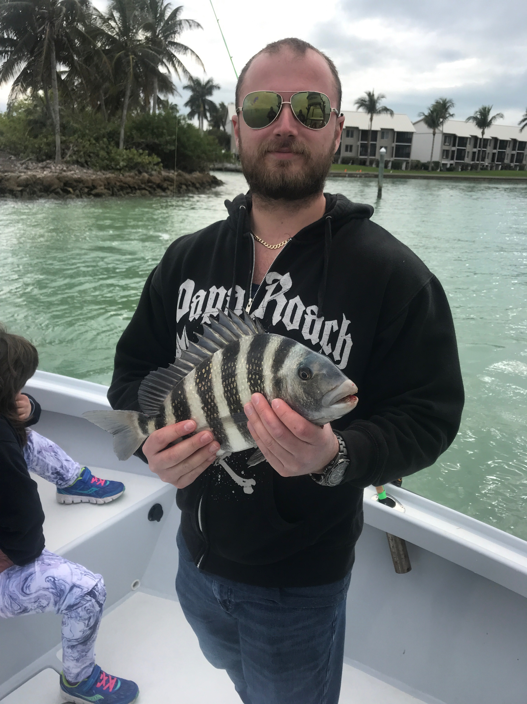

Scout about

Pic: Nick from CT with a sheepshead caught while fishing with Capt Matt Mitchell this week.

It feels so good to be finally getting back to a much more normal Florida winter weather pattern. I am glad to report I have put up the thermals for now and have really been enjoying the bright sunshine and light wind days that are associated with February. Water temperatures have begun to slowly creep back to normal levels after bottoming out in the high 50’s last week.

This week I took a morning on the water to go out and scout some area’s that have been very productive in years past. Often when fishing with clients you simply cannot try these areas. if you do not know if they are holding fish. Its just as important to know where the fish are not as well as where they are. Due to time restraints on a four hour charter I need to fish in the most productive areas.

On this scouting trip I needed to check out some places in the south end of Matlacha Pass along with favorite Ding Darling Creeks that require a idle to reach. Getting away from my daily routine of bouncing in and around the passes only let me know I’m fishing in the right places as these other areas had very few fish and where a bust.

Our fishing has been very different this winter than in previous winters with many places in the southern sound being just void of fish. Ding Darling creeks that I often fish with great success are holding very few fish. Though these creeks have mullet and a few sheepshead in them they are just not stacked up with the Sheepshead and Snook like in years past. The water in these creeks is crystal clear so spotting fish and getting an accurate read is easy.

Other places like the docks and canals in the southern sound from the lighthouse to the powerlines have almost zero sheepshead in them when in previous years these areas had thousands of fish on them. All I can speculate is that the barnacles that these fish feed on in these places are covered up with a mossy like substance and possibly dead.

Once I get north of the powerlines I’m finding lots of fish in all the usual places I would get them any other winter. Sheepshead, Black drum and rat redfish made up the majority of our fish again this week. With a few hour flat spot of very little tide movement the bite would slow then as expected as the tide picked up speed the action would pick up too.

No matter how long you fish a place you are always learning something new about it. This has proved very true this winter with our fish being in different places than in years past. Area’s in the southern sound have just not had the abundance of life like they had in years past while area’s from the middle sound north are better fishing than I can remember. If you are not catching fish in your usual places its time to do what I did this week and take a day to go scout.

