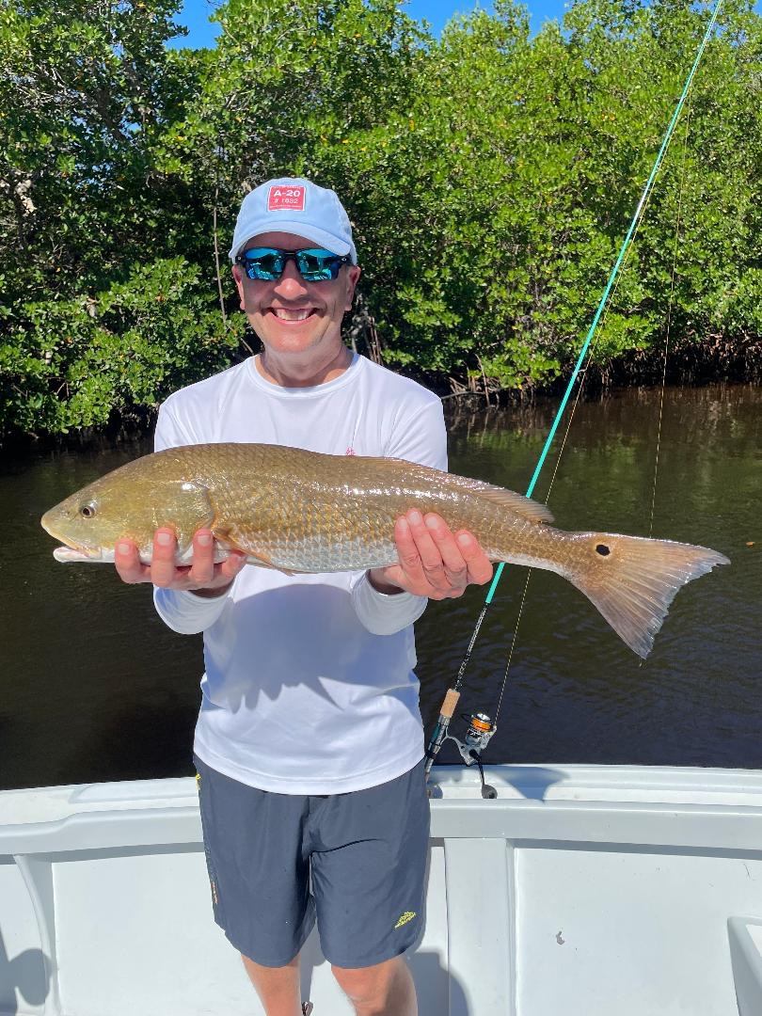

Roll with it in October

Pic: Dr Larry with a Redfish caught while fishing with Capt Matt Mitchell

Now that October is just right around the corner, we can already feel the change of season has begun. Both in the Spring and again in the Fall we experience big transition times for our fishery. Throw in the annual bait migration which happens north bound in Spring and south bound in Fall and fishermen have insane amounts of species options.

When clients ask me what’s the best time to fish without a hesitation October immediately come to mind. Although Spring is amazing too its generally windy which makes it tough to target all the available options. What also makes October outstanding is the lack of boat traffic and pressure on these fish.

Fall when conditions are right gives us the best tarpon fishing of the year. Light east winds will put lots of these tarpon out along the beaches gorging on the massive schools of fry bait. Yes, there are more tarpon here in the Spring but these fish just feed better in the Fall. Multiple hook up mornings once you locate the fish are common. All the fish that seem to refuse a well-presented bait pitched to them in the Spring simply feed in the Fall. Last year an early cold front late October put an end to what was the most wide-open tarpon bite of the year. In years past this big cold front generally does not happen until at least Thanksgiving.

Out along the beaches also expect to find King Mackerel, Spanish Mackerel and Bonita feeding on the mass bait migration. The amount of food and life that will move up and down our beaches is crazy. Feeding birds mark the way to this non-stop action. The larger the areas of bait and life you find the more diverse the species can be with Cobia, Sharks, Blackfin tuna and big Jacks all apt to show up at the buffet. These all out feeding blitzes can happen from within casting distance of the beach out past a few miles.

In the sound schools of Redfish will be the main target the entire month of October. Schools of bait will also move through the sound and spotting feeding birds can also lead to a crazy mixed bag of species. Though the birds usually mark Spanish mackerel, trout and ladyfish it’s not unusual that a school of hungry redfish are in these same places. Snook will also start to start the move from the beaches and passes slowly to the backcountry for the winter months.

To fully take advantage of what mother nature will give you have a variety of tackle and rigs set up when heading out. A spinning rod with a long casting spoon or soft plastic is a must as fish will disappear as fast as they show up. What I think I like the most about our Fall fishing is being able to switch it up and take advantage of what species pops up.

