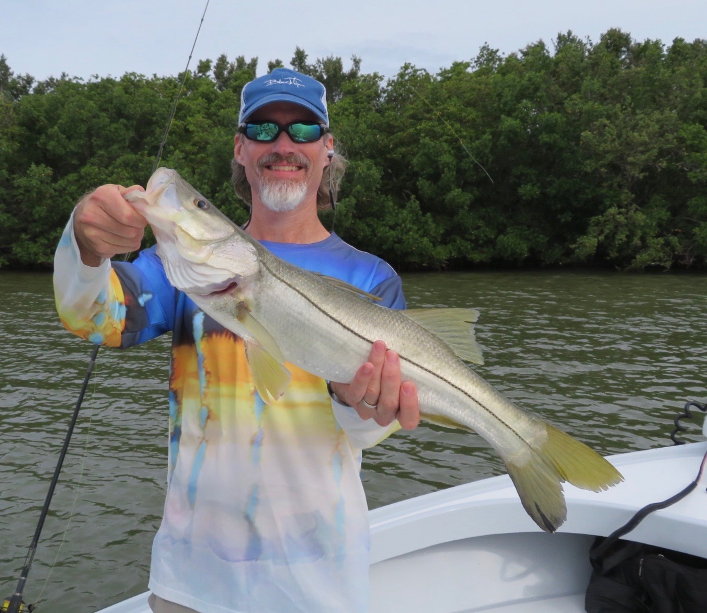

Picture: Dr Dan from Sanibel with a quality Snook caught while fishing with Capt Matt Mitchell this week

Rainy season has begun.

We have now had a low pressure weather system sit right on top of us for more than a week. It has brought rain daily coming both day and night. With lots more moisture funnelling in lots of tropical moisture from the south dodging rain has become part of the game if you want to get out and go fishing. These prevailing south winds did bring some higher than normal tides and some good mangrove and oyster bar redfish action, catch and release Snook fishing in and around the passes is finally getting fired up although tarpon fishing unfortunately has not been great most days this week due to gusty south winds that made locating fish tough if not impossible at times.

The upcoming full moon at the end of May traditionally marks the best time of year to catch Snook and Trout out on the beaches. These fish are now making that annual move out through the passes to the beaches bringing anglers some of the most outstanding action of the year as they stack up in huge numbers to spawn. Dirty stirred up water in the passes from all the rain is just what we have been waiting on for our catch and release Snook bite to go off. Target these Snook in all the local passes until you work out which tide they are feeding better on. Pinfish and Grunts are becoming the bait of choice now in the passes as we get closer to our summer months.

Fishing for the next few days will bring some challenging slow to no tide patterns. My go to during lousy tides is to target the passes, as these will be the only places that we may see at least a little water movement. Another option during bad tide days is to target channel markers with structure to catch both Gag grouper and a few Triple Tail. During these slow tides its also possible to fish the rocky structure in our deeper passes as you can hold the boat right on top of it. Although Gag grouper season is closed these hard hitting fish are still a challenge to catch. Use just enough weight to get a live pinfish to the bottom and try to fish straight up and down to increase your chances of getting them away from the structure.

If we do get a few calmer wind days it should still be relatively easy to locate Tarpon both out along the beaches and in the sound. Weather is the biggest factor in this fishery as options get less and less the harder the wind blows. Running and covering lots of water this week looking I did manage to locate some rolling Tarpon in the middle and northern sound but where unsuccessful in getting them to take a bait even though they rolled and circled our live crabs several times. Once you do find tarpon that’s half the battle, the other half is getting them to bite. Some days they do it some days they just don’t.

