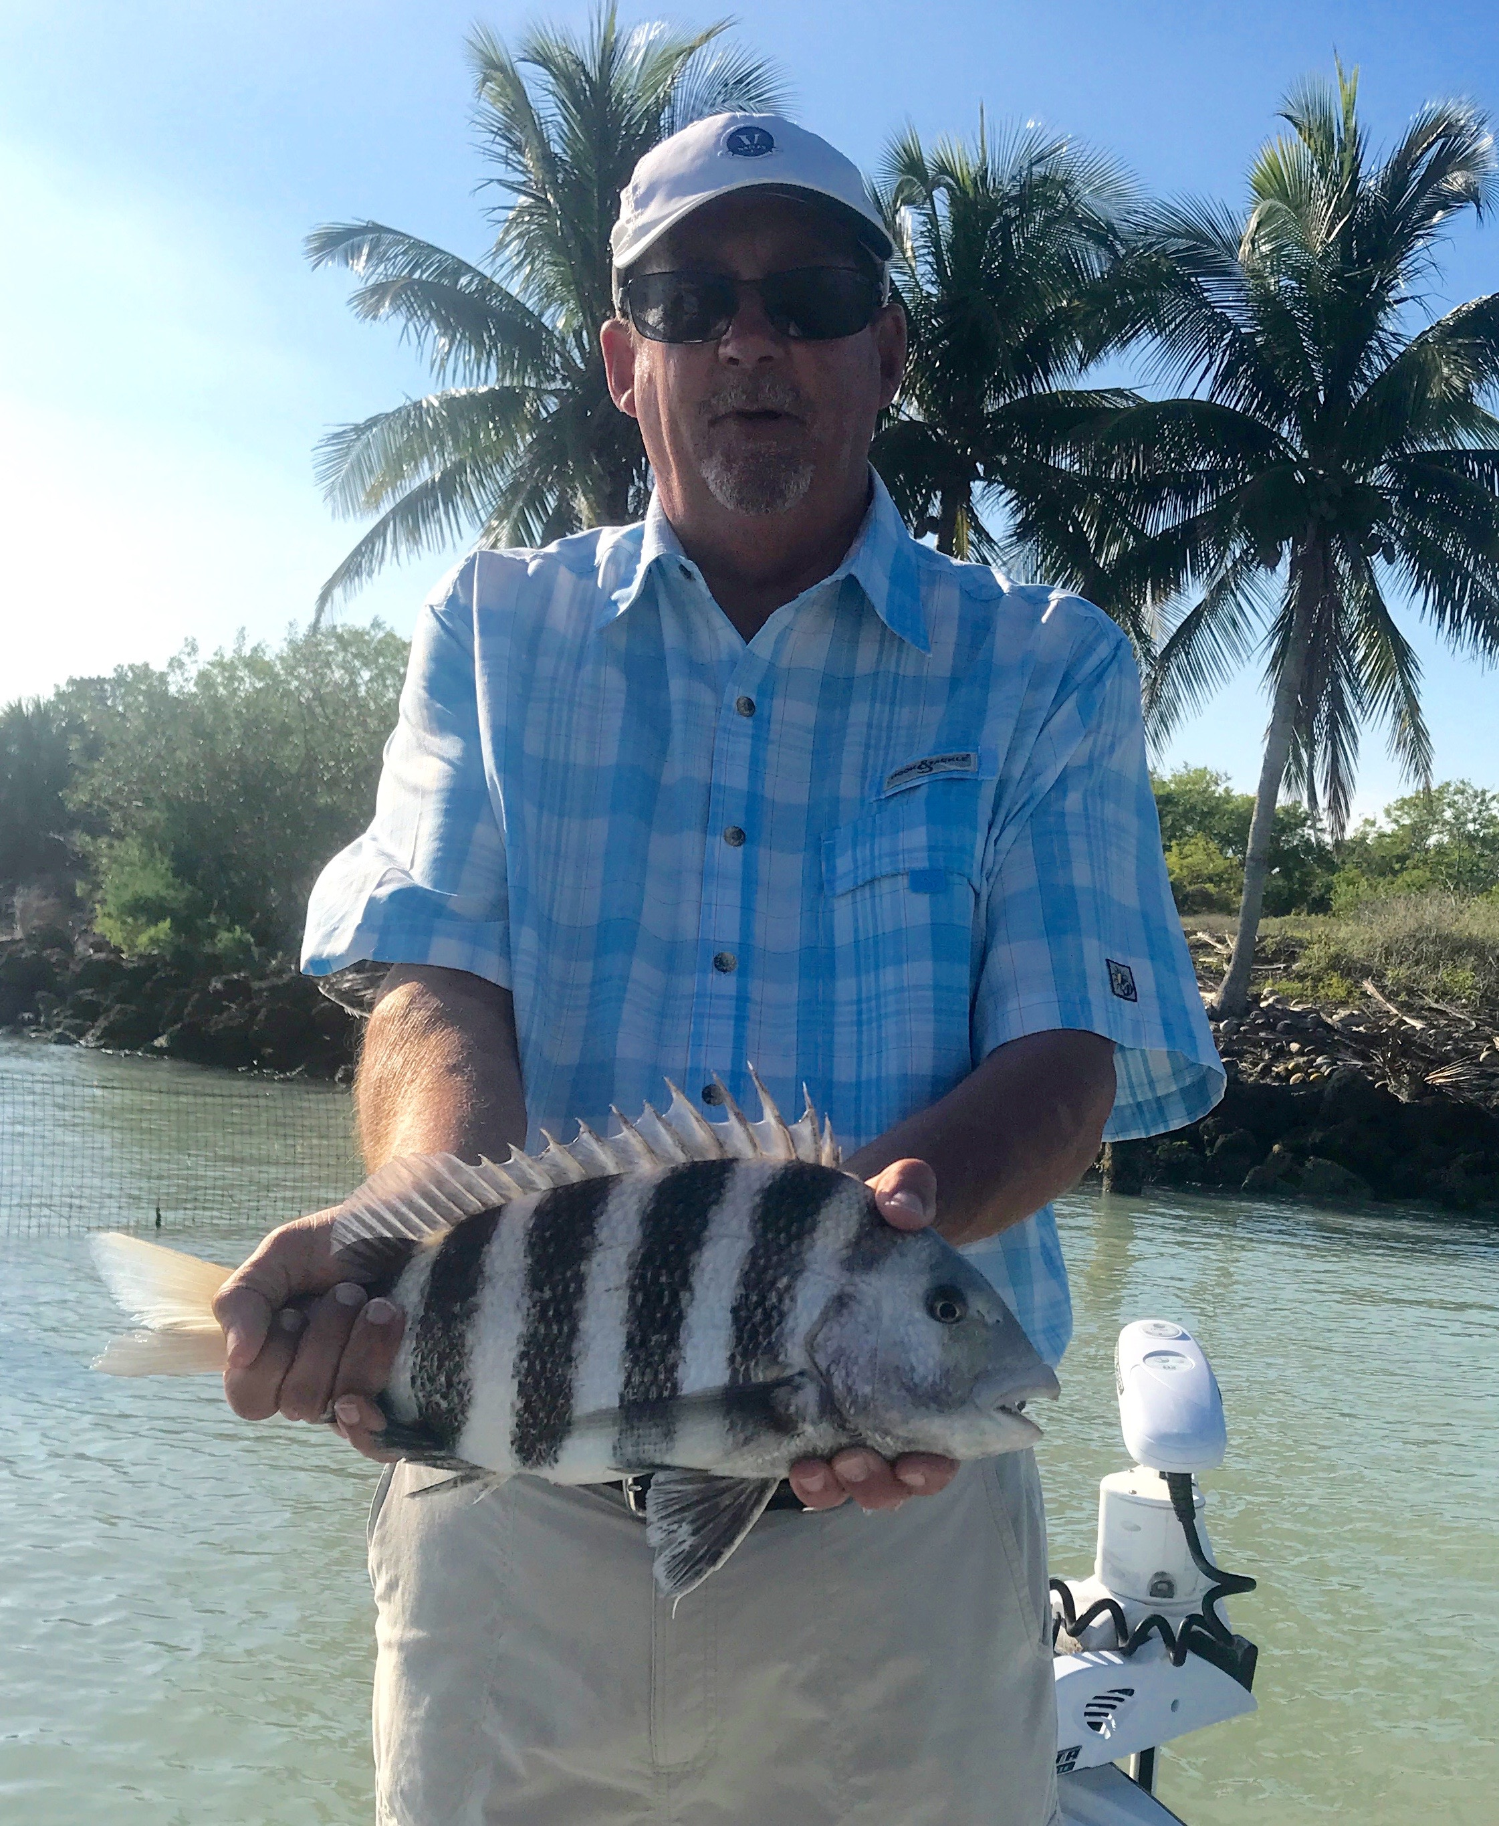

Picture: Nick Little with a 18 inch sheepshead caught while fishing with Capt Matt Mitchell this week.

Prime month for Sheepshead fishing

Even with our water temperature finally creeping back to 70 plus degrees this week the best action has still been on Sheepshead.
Putting in the extra time to go catch shiners simply has not started to pay off yet as it seems the fish are just not ready to eat them.

I figured once I had finally had shiners again I would be able to put my clients on some Snook after what has been months of catching sheepshead. Working sheltered deeper shorelines in the middle sound over the weekend I did get the Snook to respond a little bit to chummed live shiners. The Snook would pick up a shiner run with it and then drop it or more frustrating yet chase it around on the surface just long enough for a seagull to snatch the bait. It did feel good though to be throwing shiners again and this bite will fire up with a few more warm days.

Most trips this week I have been running north to favorite sheepshead spots and bouncing from dock to dock around the passes. Depending on the direction of the wind and tide one place seems to set up better than another. Sheepshead up to 18 inch where a common catch with some of the biggest ones of the week measuring right at the 20-inch mark. The abundance of these fish is refreshing as everyday I’ve been sending clients home with a zip-lock of fresh delicious fillets for dinner.

Most trips when targeting sheepshead there is a learning curve to successfully hooking these fish. The bite of these fish is different than any other fish as they nibble and never really inhale the bait. Getting the feel of when to set the hook only comes with time and practice. I gently lift the rod while feeling them nibble until the rod tip loads then a short quick pop to set the hook. Once they are hooked give them another pop to insure that the hook pieces the hard toothy mouth and they stay hooked. Though these fish can be frustrating to catch at first once you get you get the hang of it they are a blast to catch on light tackle.

