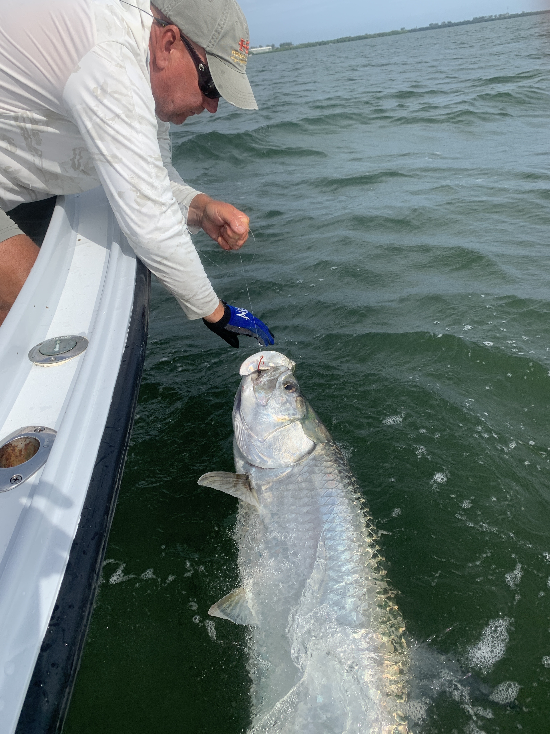

Pre Cristobal action

Pic: Virginia’s tarpon boat side before release

Tropical storm Cristobal brought lots of rains and strong winds before finally moving out of here. In the days before the slow moving weather maker moved through we managed to dodge the rain most days until a weekend wash out. Any time we have approaching weather it fires off fishing. The big change in barometric pressure triggers fish to eat. Add in some massive high tides generated by strong south winds and we had the perfect mangrove fishing set up.

Staying close to home most days we kept a eye to the sky and where able to dodge showers. The breezy overcast conditions made a welcome change from the excessive heat we have been dealing with. Most trips this week we targeted snook and redfish with success. During the lower tides the better bite came in the passes drifting live baits up close to the structure. As the water got up higher we switched our efforts to mangrove shorelines in the south eastern end of the sound.

Tarpon fishing this week was all about finding somewhere sheltered enough to be able to locate the fish. Until late in the week east winds made for a great set up on the northern beaches of Sanibel. Once located these beach fish ate both crabs and threadfin herring. As winds switched to the south with the approaching weather this was blown out. These beach fish will gradually reappear as conditions relax.

Later in the week I took long term client Gerald along with his wife Virginia on their first tarpon trip. Riding through all my favorite places in the bay we saw only a few rolling fish. Opting to set up and soak some baits I figured we would have a better shot at it. While anchored up in the choppy conditions within 10 minutes we had seen a few tarpon roll. Texting with other captains it seemed no one had located any good numbers of fish.

A tarpon bite happens so fast, one second your having a conversation then like the flip of a switch we were hurriedly clearing the other rods and giving chase as Virginia was hooked up. For the first few minutes this fish did not jump and really had us thinking it was a shark. As it came completely around the boat it went airborne only 30ft away. Virginia’s tarpon put on a great show jumping a half dozen times before finally coming boat side for a face grab and release. Congratulations on your first Tarpon Virginia.

