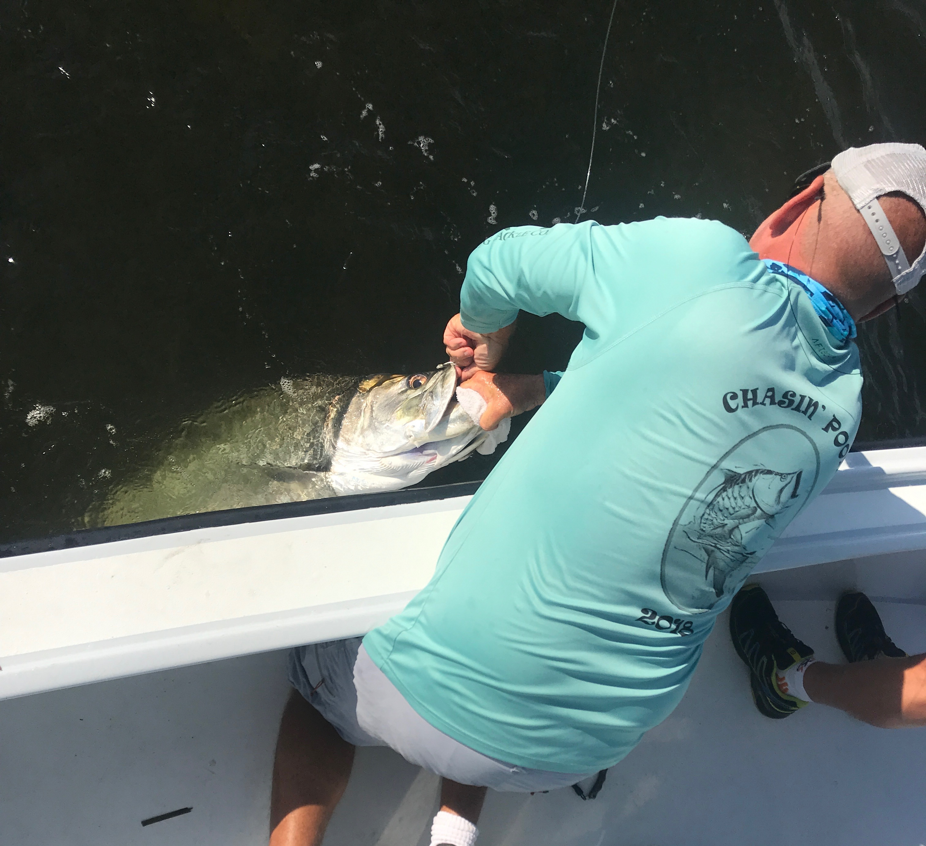

Practice extreme tarpon patience

Picture: Tarpon comes boat side before being released unharmed

With May Tarpon fishing now in full swing this week was a reminder of just how much the days conditions can make or break a tarpon trip. Strong winds can bring any hopes of a successful day to a grinding halt. Even in the few days following a strong blow the choppy sea’s and stirred up chalk colored water sticks around. Then as conditions gradually improve each day we slowly start seeing more and more Tarpon reappear.

For the past two weeks really strong windy cold fronts have blown through and completely made our Tarpon disappear for a few days. Having Tarpon trips scheduled during this time right after these cold fronts had many of us local guides running around with clients and never even locating a fish. This is so frustrating as for a whole week before these fronts Tarpon where in the same places day after day.

During windy days I’ve learned that its often better to just pick the last place you saw Tarpon before the weather event and set up. After these past two blows the eastern side of the sound was the only decent looking water around and also the only place to hide from an easterly wind. After setting up for a few hours post front we did manage to see a few rolling fish which gives everyone much more confidence you may have a chance of hooking one. The worse the weather is the smaller the playing field gets with only so many places to hide.

Tarpon are an amazing fish and like any other big game hunt you simply have to put in your time to get your shots. Picking one random day if your chasing your bucket list fish does not make much sense its better if you can go a few times over a week spreading out the days to improve your odds. Catching a Tarpon can require more patience than any other kind of fishing we do but with patience can come great rewards. Windy days after a cold can be the toughest days to be a guide as you know nothing will come easy.

