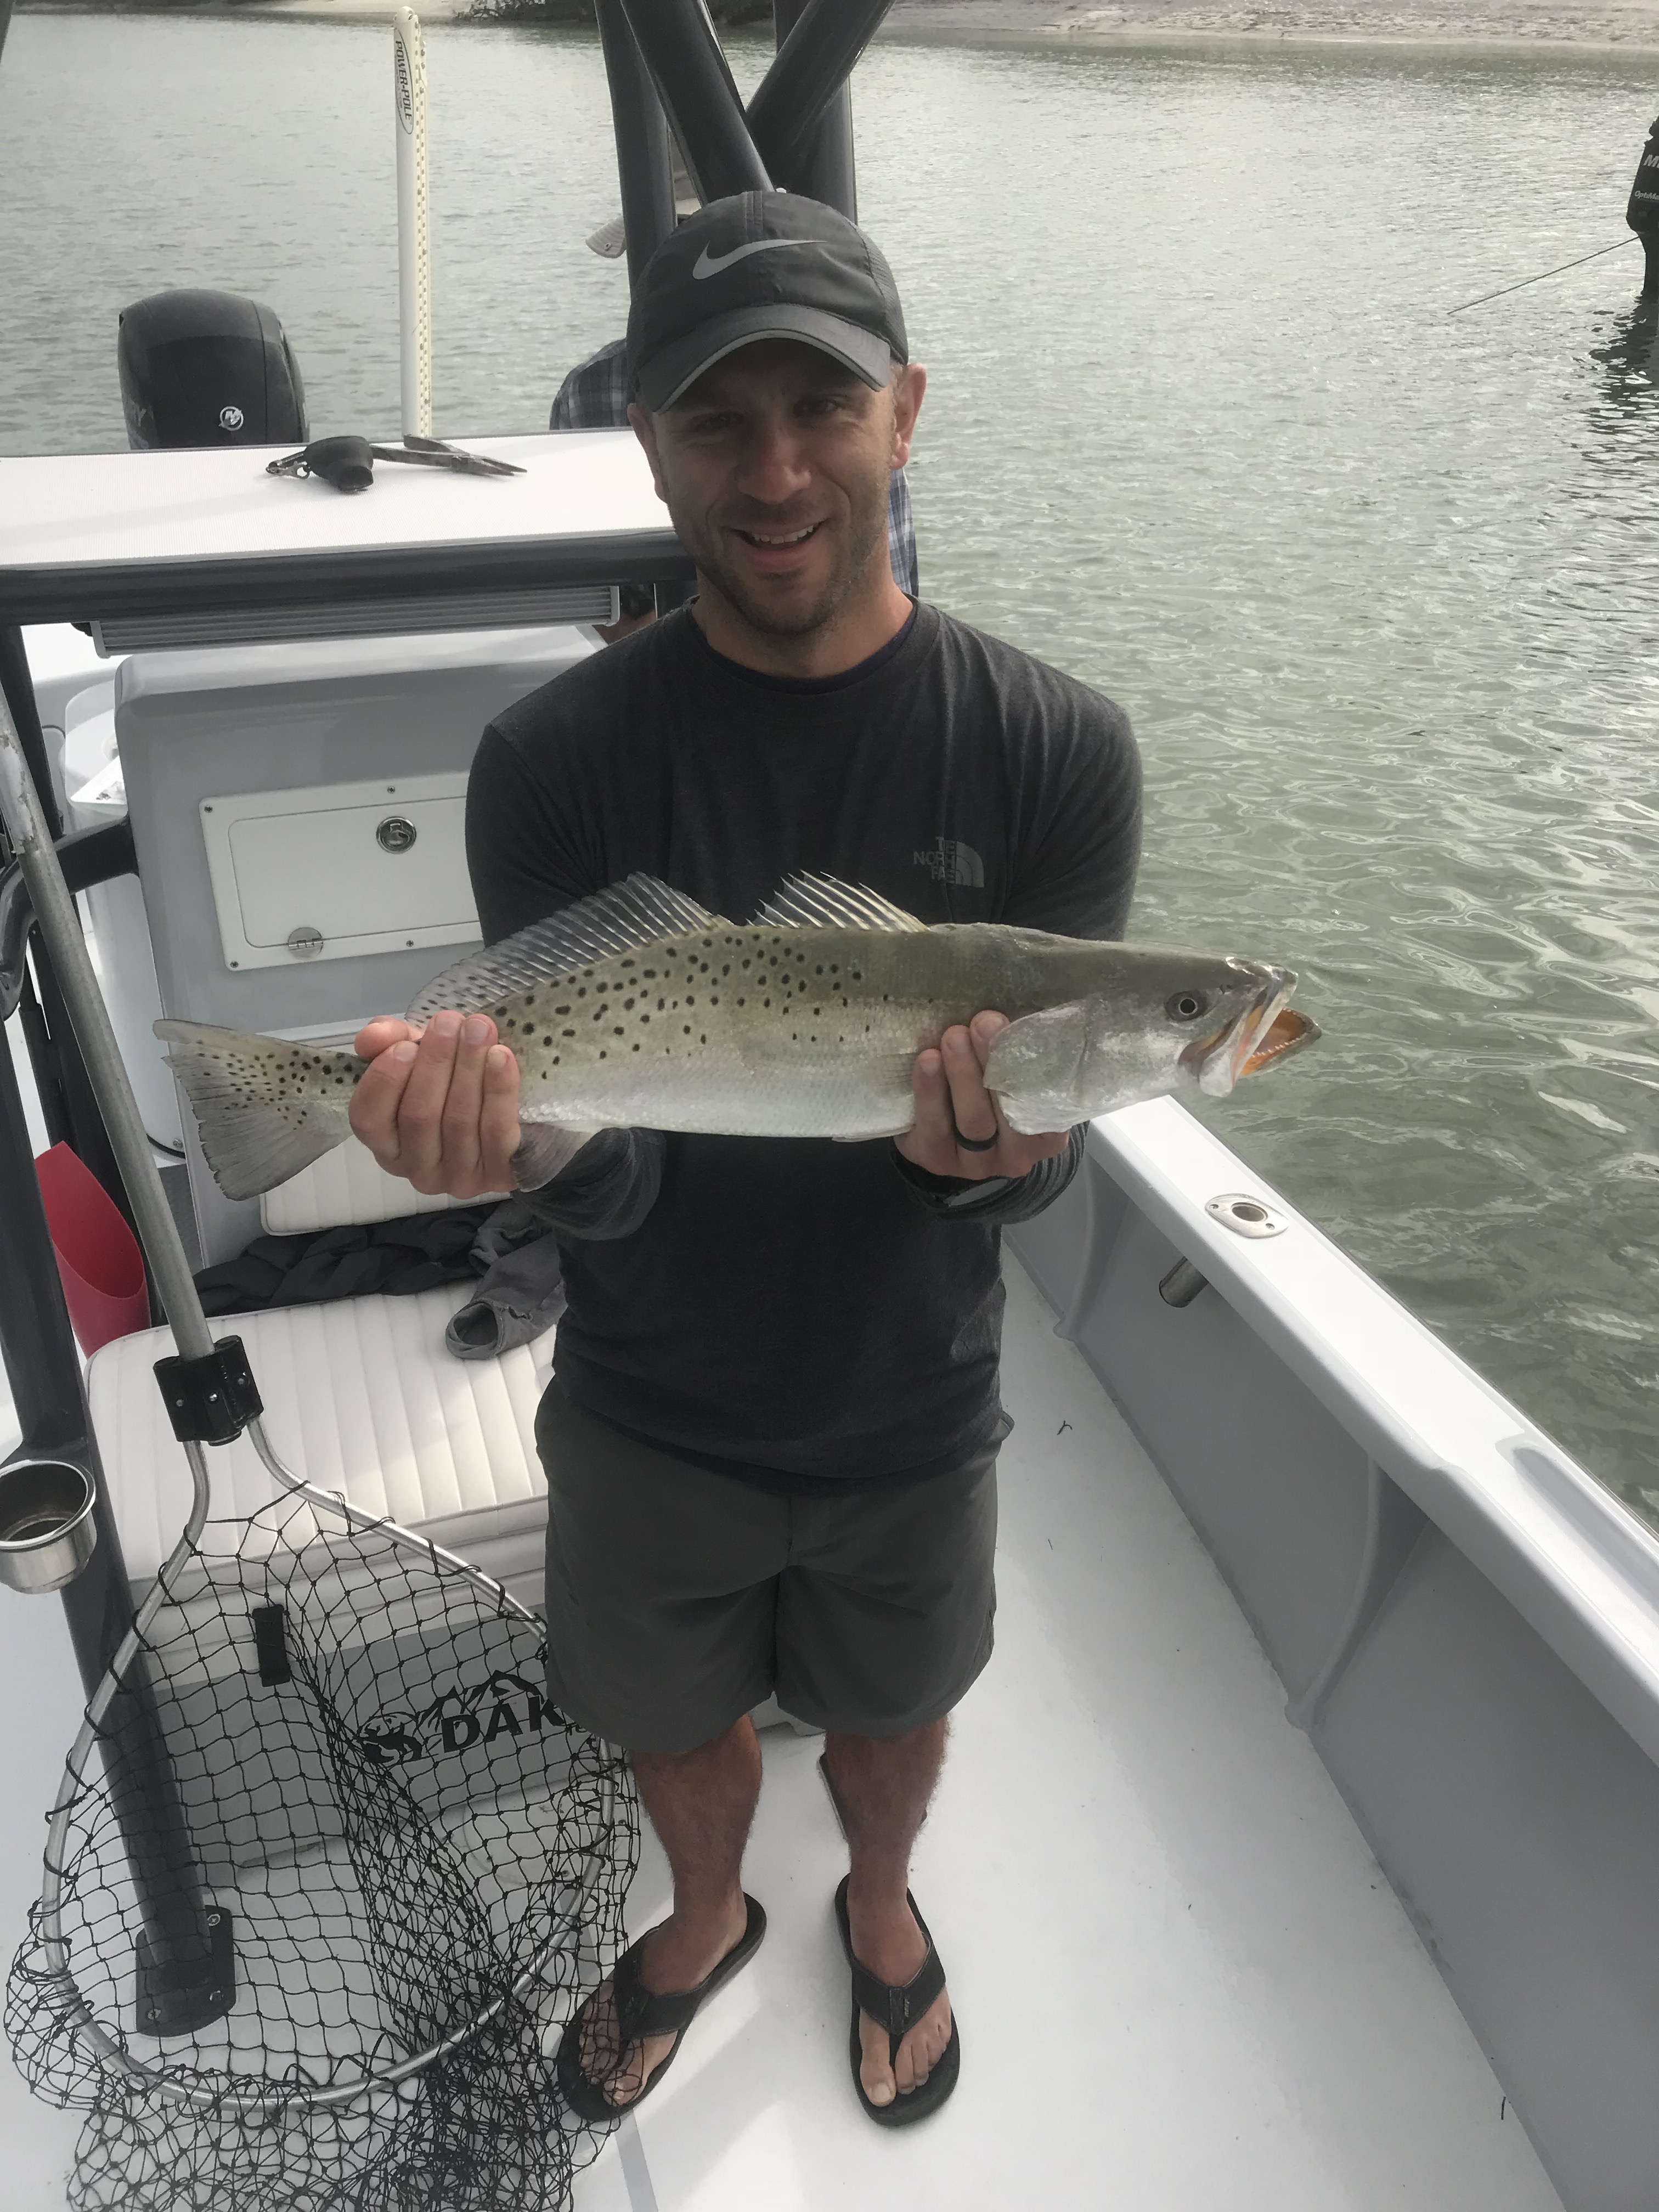

Picture: Big trout like this one are being caught in all the local passes

Pass fishing lights up

Fishing the passes this week was the best action around. Springtime warm water temperatures have pushed lots of Snook and trout of all sizes into our passes in massive numbers. During periods of clear water during the incoming tide its amazing how many Snook you can see stacked up around the structure or even straight down under the boat as large black patches of pre spawn Snook covering up the bottom. With our Snook fishery totally catch and release now until September and the fact that at times its possible to catch a Snook on almost every cast in the passes give these fish that little bit of extra care when releasing them as its spawning time. Not lifting them out of the water, using a de-hooking tool and avoiding using a landing net are all good for this incredible fishery.

This week we managed to consistently hook into some much larger Snook in the passes for the first time since last fall. Use bigger baits and heavier tackle if you want a chance at landing a real trophy over that magic 40 inch mark. Hooking into few of these giants on my regular 15# spinning tackle we simply got smoked. Seeing one of these big spawning female Snook break the surface before parting ways stays in your head for a while.

To target these big Snook in fast current requires at least 30# tackle to have any chance at all to turn these fish away from the structure. I describe this fishing to my clients as full contact and even when you are on your game using the larger tackle its tough to get one of these hard charging fish out into the open water let alone to the boat. My pass tackle for these big Snook is a shorter stout jigging style spinning rod with at least a 5500 spinning reel. Set the drag to exterminate and get ready for hand to hand combat. I rig with 50# leader, a sliding weight and a heavy duty gorilla style hook. Fishing with such a tight drag its common to straighten any regular hook when you put the heat to it.

Trout fishing in the passes has also been on fire with the slower periods of tide movement bringing the best action. Live shiners rigged with a split shot a foot or two up from the hook caught trout after trout ranging in size anywhere from 15-25 inches. These Trout are also spawning too so if you don’t plan on keeping them to eat a de-hooking device is a great tool to release these fish without even touching them.

Windy conditions again at times this week made Tarpon fishing a guessing game more than the sight fishing fishery we all enjoy. During calmer periods rolling and free jumping tarpon are both gulf side and all through the sound. Fosters point was one of the hot spots this week with cut bait fisherman doing really well.

Red tide has continued to lurk around Ft Myers beach and Bonita beach and although we have not had any fish kills in San Carlos Bay or Pine Island sound its made it more difficult than usual to catch the large threadfin herring we use for tarpon fishing. Most years past threadfins can be caught by making a couple of throws of a cast net on the causeway or on Gulf side channel markers. Threadfins are a fragile species and it appears they are one of the first species to vacate the area when there is any red tide at all present.

