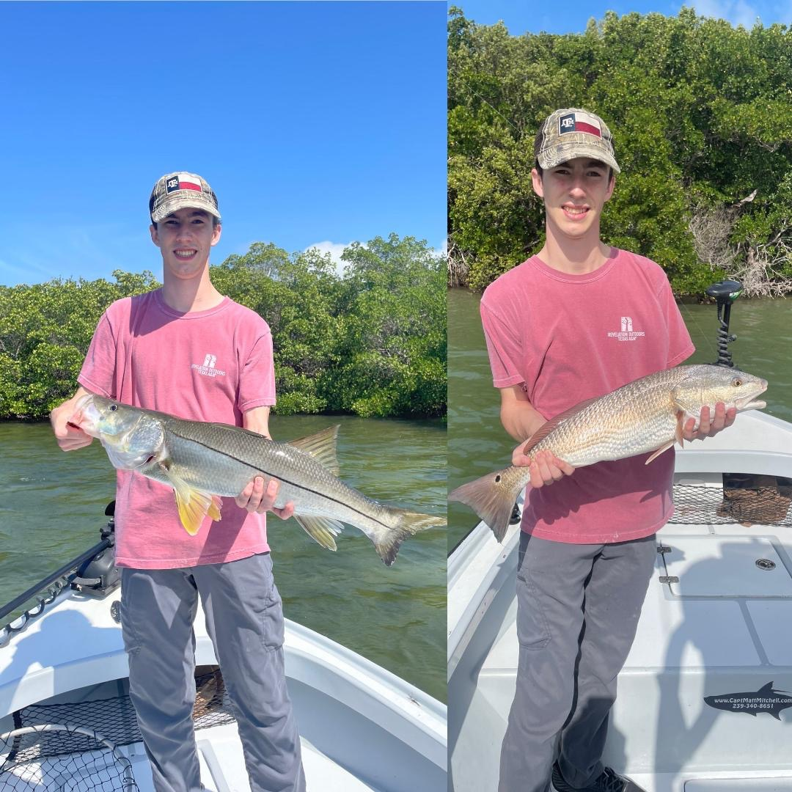

One last cold blast

Pic: Mike visiting from Texas had a amazing day on the water with Capt Matt Mitchell This week

Just when we think winter is done it never fails to deliver that one last mid-March cold front reminding us winter is not quite done. As usual the bite in the days before the arrival of the front was amazing with Snook, Redfish and trout all feeding. The last few days before the front we had strong south winds which always prove to be the best set up for a non-stop bite.

Gale and small craft warnings over the past weekend meant lots of cancellations during our busiest month of the year. After 2 days of not being on the water patterning the fish may take a few days until conditions get back to normal. Bait is the first thing that changes with the wind and cold water. After what has been a easy few weeks of catching shiners I’m expecting a little bit of a struggle for at least a few days. To supplement the shiners for a few days I plan on taking shrimp as insurance.

Pre front fishing despite slow tides was as good as it gets for March. Prevailing south winds gave us higher than normal tides and kept the water moving during what should have been lousy tide days. One thing that has been a surprise this past few months is the incredible rebound we have seen in our trout fishery. When filleting fish at Punta Rassa just about every boat has had limits of trout. This abundance of trout is a real sign of how much our water quality has improved in the past few years.

The best trout fishing for me over the past few weeks has come in the power line area of the sound. This area has lots of shallow healthy grass flats which are peppered with small areas of sand which is the perfect trout habitat. Live free lined shiners cast and slowly retrieved caught fish after fish with very few of these trout being less than the 15-inch minimum. Shrimp under a popping cork have also been getting it done in these same area’s though the average size of the trout has been a little smaller. Expect a mixed bag of Spanish Mackerel, Ladyfish and even some pompano in the mix.

Oyster bar fishing on the higher stages has been amazing for both Snook and Redfish. Live shiners caught snook after snook while set up on the windblown side of these bars. Most of these snook are in the 20–25-inch range. Now and again though a 30 inch plus snook will crash the party. Just about any set of oyster bars in the sound has held lots of snook. The key to this bite is high enough water. During clean clear water periods locating these bars is easy.

Getting back on the water after a strong cold front is always a challenge. Dirty water stirred up from the wind along with a 10 degree drop in water temperature will make the first few days a little tough. With no more cold fronts in sight hopefully that was it for winter and our conditions along with fishing action will quickly rebound.

