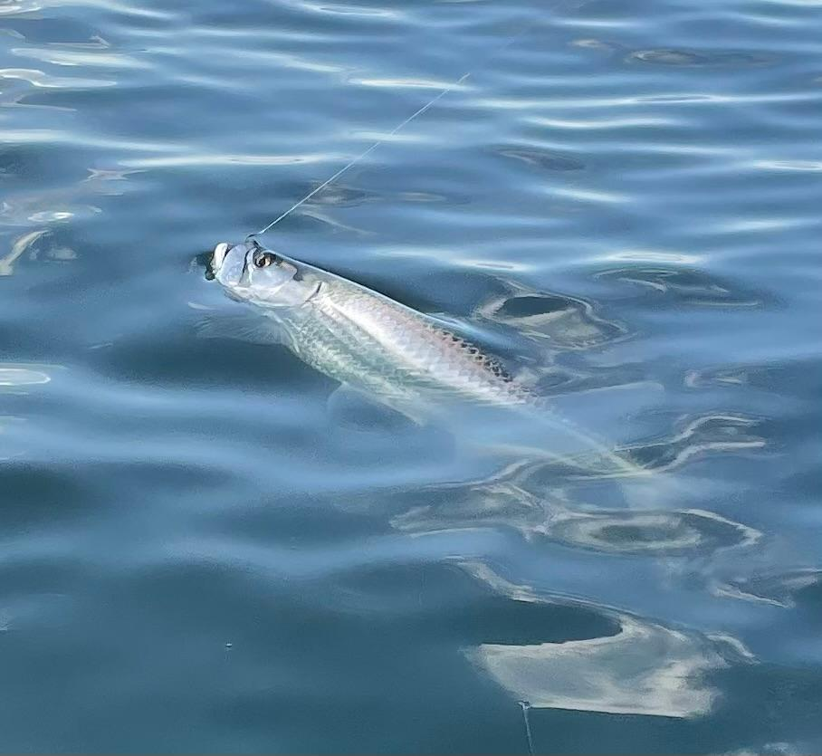

No place like home

Pic: A beach tarpon comes boat side

After being gone for most of September on vacation it always feels good to get home. There is no other place like SWFL. It seems no matter where ever I vacation there is always that excitement to come home and get back out on our waters. With a few days off after returning home that’s exactly what I did immediately getting out along the beaches and spending some time chasing tarpon.

Although this beach tarpon bite has yet to kick into high gear yet I’m finding a few rollers here and there. Locating feeding birds on bait has been the place to look. Ft Myers beach, Captiva and North Captiva have been the places to start the hunt. It’s just seemed everything is very spread out meaning both the bait and the tarpon. As water temperatures gradually cool the bait will ball up tighter. This bite will only get better with mid October through November being prime time.

My favourite way to target these Fall beach tarpon is to sight fish them. This starts by riding the beach until you locate birds on bait then drop the trolling motor. Slowly move through these areas while looking for rolling fish. Once you find them it’s all about predicting their movement and getting a bait out in front of them. My go to bait is a live pinfish under a float, unlike the Spring tarpon migration these fish will eat a well-presented bait more times than not.

Over the past week like everyone else I’ve been watching the painfully slow track of tropical storm Ian. Part of living on the coast is the scary probability of a direct hit by one of these potentially catastrophic storms. Good news for us as the track switches is bad news for another place in Florida. No matter where this storm makes landfall it will come close enough to us to cause big changes to our fishing for at least a few days. Storm surge, rain and potentially high winds will dirty up the water.

