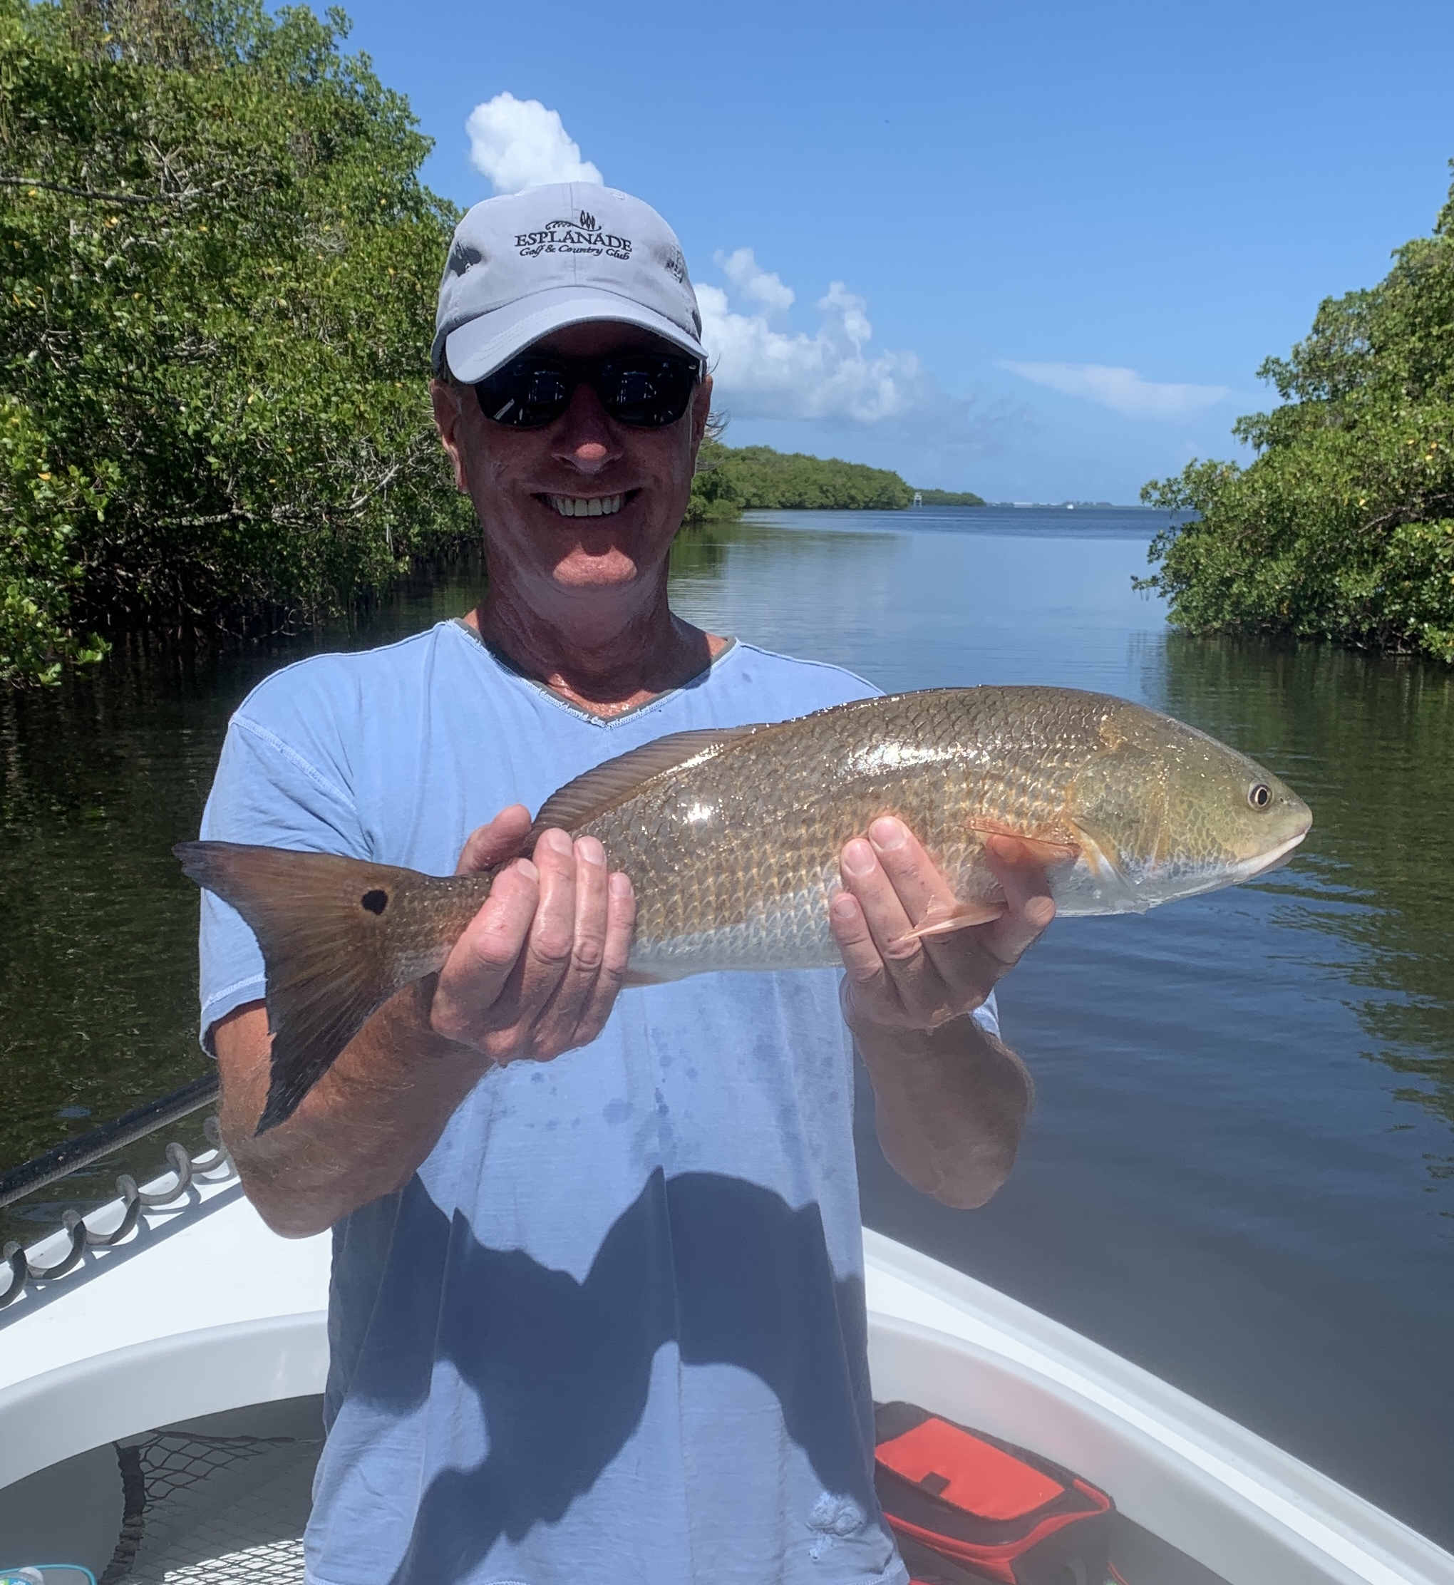

Mixed bag summer fishing

Pic: Danny with a redfish caught while fishing with Capt Matt Mitchell this week

Finally with no weather issues we managed to get in a full week of fishing letting our clients catch a great mixed bag of fish. Having a wide variety of both gear and baits let us take advantage of what the days conditions gave us. Pass fishing remained strong on the lower phases of the tide while action out on the deeper flats always produced a mixed bag of fish including trout, snapper, blacktip sharks and even some pompano. Going back in the mangroves and chumming with small shiners gave us a great bite on juvenile snook, jacks and hungry mangrove snapper.

Mangrove snapper fishing has really picked up as it always does this time every year. These tasty fish though found all year long get to be much bigger during our summer months. They are being caught almost anywhere throughout the sound though the passes and docks close to the passes have some of the largest concentrations. When targeting these tasty fish remember they have very good eyesight so the lighter the gear you can fish the more successful you will be. I often go all the way down to a 6ft long 15 or even 12 pound test fluorocarbon leader. Small light wire hooks from a #1 to a 2/0 are also a good choice. Baits for mangrove snapper include shiners, live shrimp and small pinfish. Chumming lots of the hatch bait that is around is a sure fire method to get them fired up too.

When flats fishing I’ve been drifting in the deeper water from 4-6ft. Look for area’s where the sand and grass are mixed. Fosters point flats, redlight shoal and Captiva rocks have been just a few of the better flats. There is no better was to locate fish in these area’s than by casting a soft plastic jig. When the water is clear like now a 1/4 oz jig head with a white paddle tail is my choice. Unlike live bait bobber fishing you can make really long casts to prospect the entire area. Another advantage of casting the jigs is that when you miss the bite you simply continue the retrieve and the baits not gone. This allows you multiple shots before you hook the fish without having to rebait. Once you locate the fish anchor up and enjoy. This is one time we often do much better on plastic’s than even a live bait.

With our summer rains in full swing getting back to the dock before mid afternoon has been a must. Getting caught out in one of these daily strong thunderstorms can be a dangerous or at least soaking wet proposition. The one real plus to these daily storms though is that it cools off the water just a few degree’s making the fish more active.

