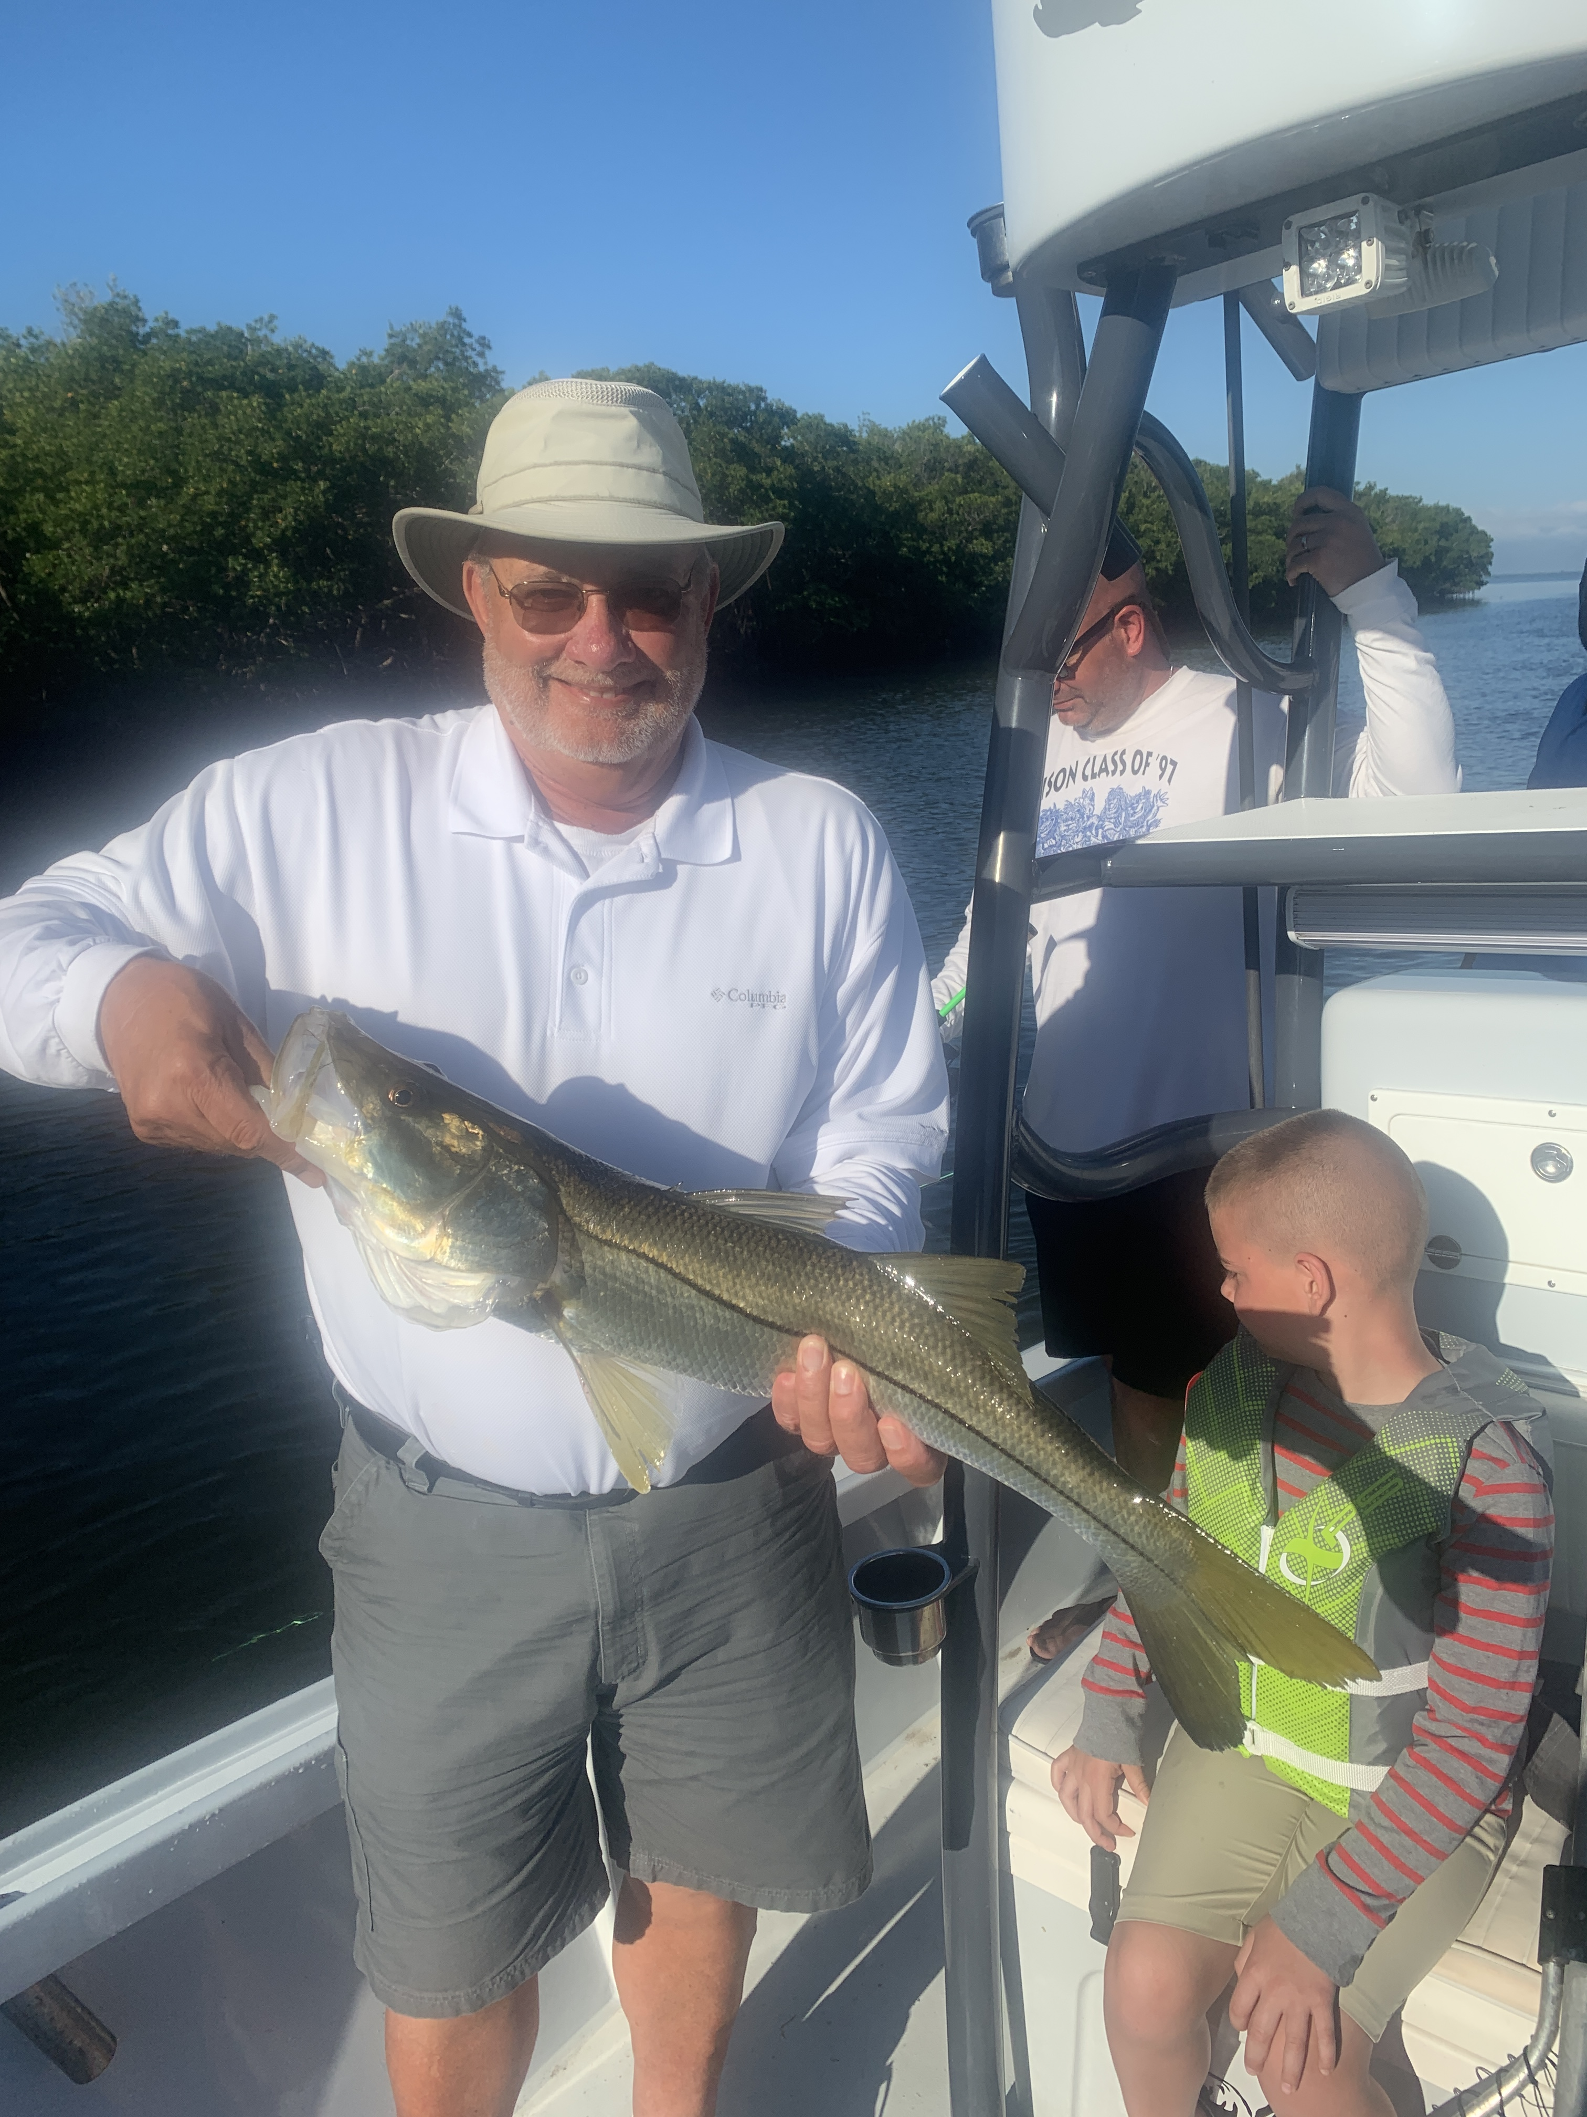

Picture: Ron from Ohio with a 31 inch Snook caught and released with Capt Matt Mitchell this week

March Snookin

What a amazing week of fishing this was. Even dealing with days of slow to no tide movement we caught and released lots of Snook. Now that the water temperature in the mid 70’s Snook are feeding hard after a few months of what can only be described s a cold water hibernation. If you caught a live well full of shiners it was hard to go wrong.

The one real key to this weeks fishing for me was staying on the eastern side of the sound in the clean clear water. This also has rung true for catching shiners. Water by the passes was milky, stirred up and seemed to hold very few Snook. Although several times this week the inside of the passes was loaded with feeding Mackerel and Ladyfish during the incoming tide as bait poured into the bay.

Being able to ride around on a tower to spot Snook in crystal clear water then set up and present a bait to them is about as good as it gets as a guide. Snook this week averaged in the mid 20-inch range with the largest brought to the boat measuring 31 inches. We did hook a few real monster Snook this week that partied ways after winning the battle to get to the barnacle encrusted mangrove roots.

Now our season is in full swing the boat traffic out on the bay is really busy. I always find it interesting as to where people set up and fish. Many of our well known trout spots throughout the bay have boats fishing them as they have in years past. Unfortunately, this winter has been different than any other winter I have fished. Places I could count on to get it done simply do not have any fish. If you are a trout fisherman life is tough for you. Luckily the Spanish Mackerel and Lady fish have shown up on many of the flats that traditionally had excellent trout fishing.

Clients looking for fillets this week took home Mangrove Snapper on most trips they have come as a bonus while catch and release Snook fishing. I’m certainly not a meat fisherman and going fishing is more about the whole experience rather than bringing home fillets. I often joke with clients if they are looking for groceries there are stores for that. Its a beautiful place we live get out on the water let it calm your soul.

