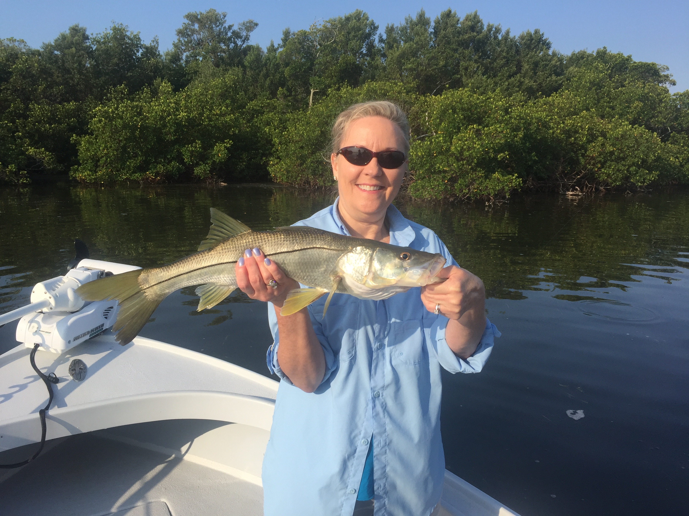

Pic: Kat White from Gainesville with a Snook caught while fishing with Capt Matt Mitchell

Mangrove Snapper bite is on

With the late July convection style heat on us, even stepping outside from the AC of the house or car instantly fogs your sunglasses. Getting out on the water early and getting done by noon has produced the best results with a mixed bag of species being caught on my charters all week. Snook, snapper, mackerel, jacks, trout and sharks have all part of the usual days catch. Clients that want fillets have been going home with limits of delicious mangrove snapper.

Docks, pilings and basically any under water structure in the sound has been holding lots of these keeper sized mangrove snapper. A long light leader and a small hook has brought the best results on these snapper. In clear water I have been rigging with as light as 12# test fluorocarbon and a #1 light wire hook. When using small shiners for bait at times this has been crazy fast paced action. Down sizing to light spinning gear to cast these small baits these fish fight hard and are a lot of fun to catch. Anywhere from the south end of Matlacha pass all the way up the sound these snapper and schooled up when you locate them.

Catch and release snook fishing while using these same small shiners has been a good bite too. Mangrove shorelines in and around our passes have been holding lots of 20-26 inch snook along with an occasional larger fish. When you find the little fry bait along a mangrove ort sandy shoreline these snook are close by. Despite what seems to be ugly brown water at closer inspection its amazing clear in certain area’s including the San Carlos Bay.

Popping cork fishing with small shiners in the southern sound and San Carlos Bay has been good action too on trout, ladyfish and jacks. Drift fishing during periods of light wind in 4-5ft of water has been busy action. Once you locate the fish by drifting drop the powerpole or anchor and whack em. The southern end of St James city even in the brown stained water has held some of the larger trout I have been catching anywhere. Chumming a few small shiners here and there has kept these fish feeding on the surface. Once the bite quits I’ve been drifting until I locate them again. Our big trout of the week measured 24 inches and was caught close to home off St James city

Green algae and red tide continue to be the main stories on the news again. In the sound we have been lucky enough that the green algae that is up in Cape Coral canals like a bad science fair project has not made its way out into the sound in any large amounts. Most of this green algae seems to be caught up in dead end canals from the cape coral bridge east where thankfully there is not enough water flow to move it out into the sound. At certain times we are seeing small chunks of it in San Carlos bay but its not anything like the shocking and sad pictures you see in these canals on the news reports. With the majority of cape coral not on city sewer and lots of fertilizer and yard waste going into those canals this algae will continue to bloom in the almost 90 degree water with or without Lake O releases. Water coming out of lake O is certainly a big part of this issue although a lot of the green algae problem starts much closer to home like in many back yards.

