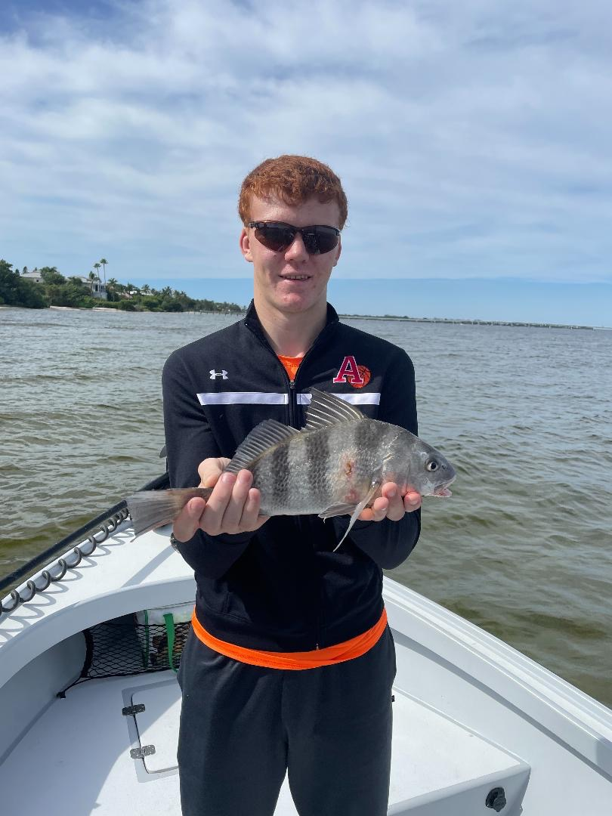

Pic: Both black drum and sheepshead love the cold water.

Low and slow during the cold

Water temperatures dipped into the mid 60’s for a couple of days after the last cold front. This chilly water meant switching it up to shrimp fishing for a few days until water temperatures slowly crept back to that magical 70-degree mark. Although I did manage to catch shiners even on the coldest days most of our action came on both live shrimp and chunks of shrimp for the two coldest days.

Area’s just inside the passes with swift moving current gave up the first keeper sheepshead of the season. Chunks of shrimp fished on a jig head also caught a winter variety of fish including black drum, rat redfish and even a few trout. This shrimp bite will continue all winter long with the best action coming immediately following a cold front and when the water is cold.

Out on the flats live shrimp also got it done while fishing popping cork rigs. Deeper holes and edges of the flats produced the better bite in 4-6ft though most of these trout are on the small side of the slot. If you are looking for non-stop action this flats bite is hard to beat as there are also lots of ladyfish and jacks in the mix. Start by drifting until you locate the fish then anchor up.

As water temperatures slowly crept back up to 70 we made that gradual change back to shiner fishing. Deeper mangrove channels all held lots of smaller snook along with some trout that ate free line shiners. Way back in the Ding creeks action was non-stop during the lower tide periods with both snook and jacks feeding hard. 50 plus fish days in these creeks was a pretty standard day out.

During the cooler mornings I found these snook out from the mangrove creeks soaking up the sun along the shallower shorelines. Dark bottom in skinny water is a great place for these fish to lay out and warm in the sun as they use it like a solar panel. These snook gave us some great sight fishing opportunities. Being able to watch a snook chase down and eat your bait in clear shallow water is as good as it gets.

With another major cool down forecast for this week expect the same pattern to play out yet again. Shrimp fishing will be most productive for a few days until water temperatures rebound to 70 degrees. The variety of species caught while shrimp fishing can be remarkable. Remember during low water temperatures fish small baits low and slow for success.

