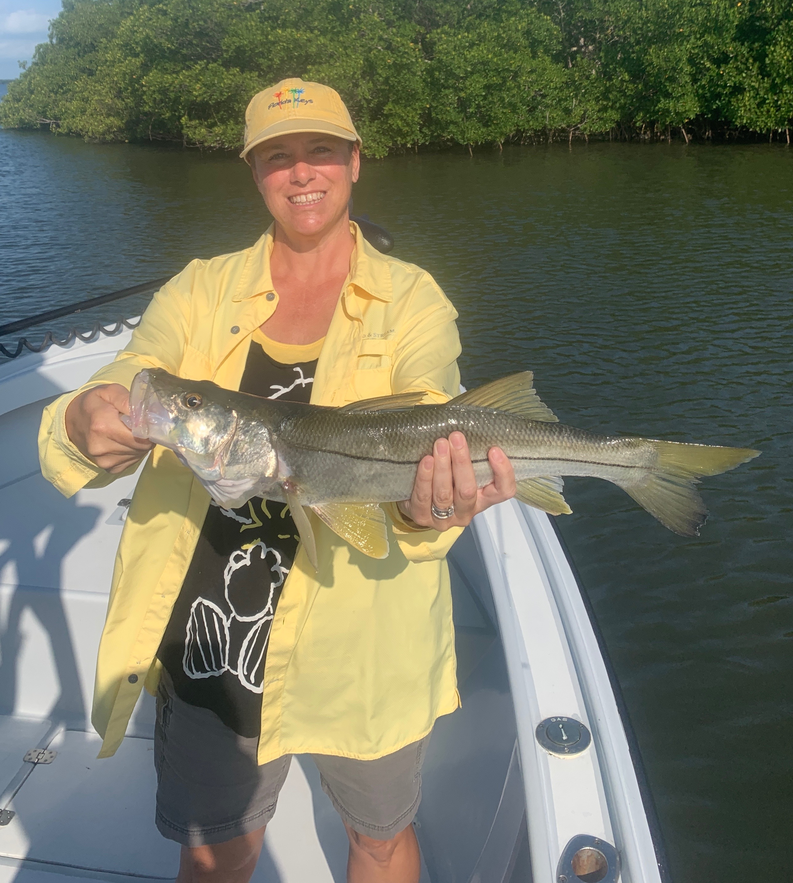

Lots of choices

Pic: Pam Murray with a snook caught this week with Capt Matt Mitchell

With so many choices of what to fish for its been hard to decide. A brief cool down for a few days along with strong winds did slow down the tarpon bite. Snook, redfish and Trout did not seem effected by the slight change of weather.

After the passing of a mild cold front last week it took a couple of days for tarpon to reappear in the sound. With so many fish around before the drop in temperature these fish simply vanished moving back offshore I suspect. Once water temperature in the sound warmed back up they gradually began to reappear. Early season deeper water spots from the causeway to the power lines are the first places they move back into. Once our morning temperatures are feeling warm and tropical again these fish will be spread out throughout the sound.

The most successful tarpon hook ups for me this week have come while soaking fresh cut silver mullet. We have hooked a few on live bait but often the bait gets dropped before the line ever comes tight. Having an assortment of baits is very important as you never know what a tarpon will want to eat from day to day.

Moving back into the four tide days has done wonders for the snook and redfish bite. I’ve been catching these fish on middle mangrove islands during the incoming tide. Pitching live shiners it does not take long to see if you picked the right shoreline. If your there more than 10 minutes without getting a bite its time to move. The shorelines and points with faster current have been the hot spots. Though we did not catch a ton of fish on any day all the fish have been quality.

Trout fishing has really rebounded over the past few months. Any trip we have targeted them we are catching a few around 20 inches along with lots of 14-16 inch fish. Water as clear as drinking water in the middle sound has made the perfect place to catch these trout. I like to fish the sand holes and grass along the many long sandbars and shoals on the eastern side of the sound. Making long casts with a live shrimp on a 1/4oz jig head is a sure way to catch a trout. Ladyfish, jacks and mackerel are all part of the mix.

Getting out on the water has been the only escape from the chaos of land. Once you return to the dock its back to the reality of spraying the boat down daily with sanitizer. This has become our new normal.

