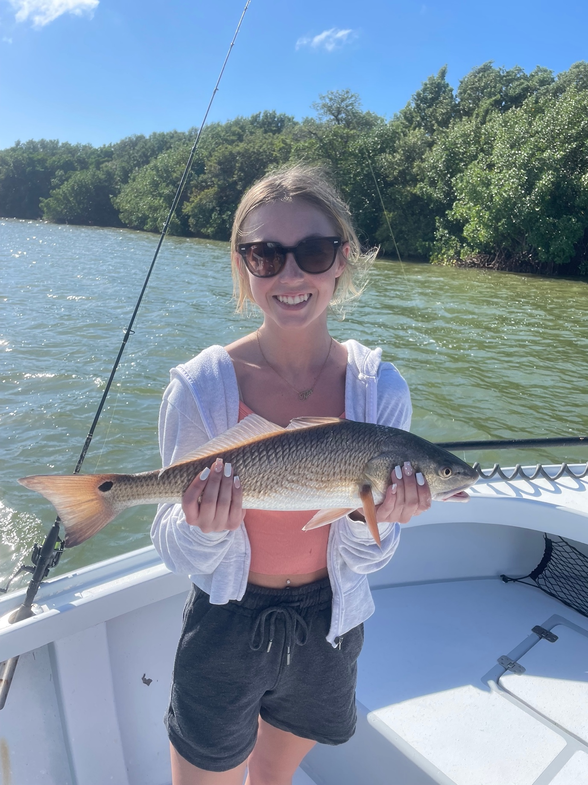

Just enjoy fishing!

Pic: Lydia from IN with a redfish that completed the slam for the days fishing.

Yet another week of amazing weather meant another week of non stop fishing. With December high temperatures in the 80’s for the entire month water temperatures have stayed in the all that can be described as that magical range. Catch and release snook fishing has been on fire with 30 plus fish trips being the normal.

With conditions being so perfect if anything the Snook are in a early Spring like pattern. I have been catching them basically anywhere from the passes to deep into the back country. One thing all the hot snook spots have had in common is moving tide. Seeing so many snook staged up around the passes is not a normal thing for the month of December.

Minus low tides and warm water are what dreams are made of for me. Throw in a blacked out live well full of shiners and my job is as much fun as can be. Along with the snook we are also catching redfish in the mix, our big one this week measured 32 inches. Larger trout have been more difficult to come by with most of the trout on the flats being less than the 15-inch minimum. Hungry schools of jacks having been popping up most places I target snook.

Bait is now being found out on the flats again instead of the deeper water of the causeway bridges where it usually winters. Water temperature again is the reason for this. Fingers crossed conditions continue on the warmer side as it just makes our fishing action so consistent.

With so many visitors from up north filling up my boats we are continually asked about what fish clients can take for a meal. Unfortunately, there is still not much available to harvest. With water temperatures so high our sheepshead bite has still not kicked off. Once you explain why we have the closure and then let them experience how good our fishing is the thought of dinner quickly goes away. What’s most important is the incredible rebound we have seen in our fishery in the past years thanks to both the better management of water quality along with the closure of Snook and Redfish.

