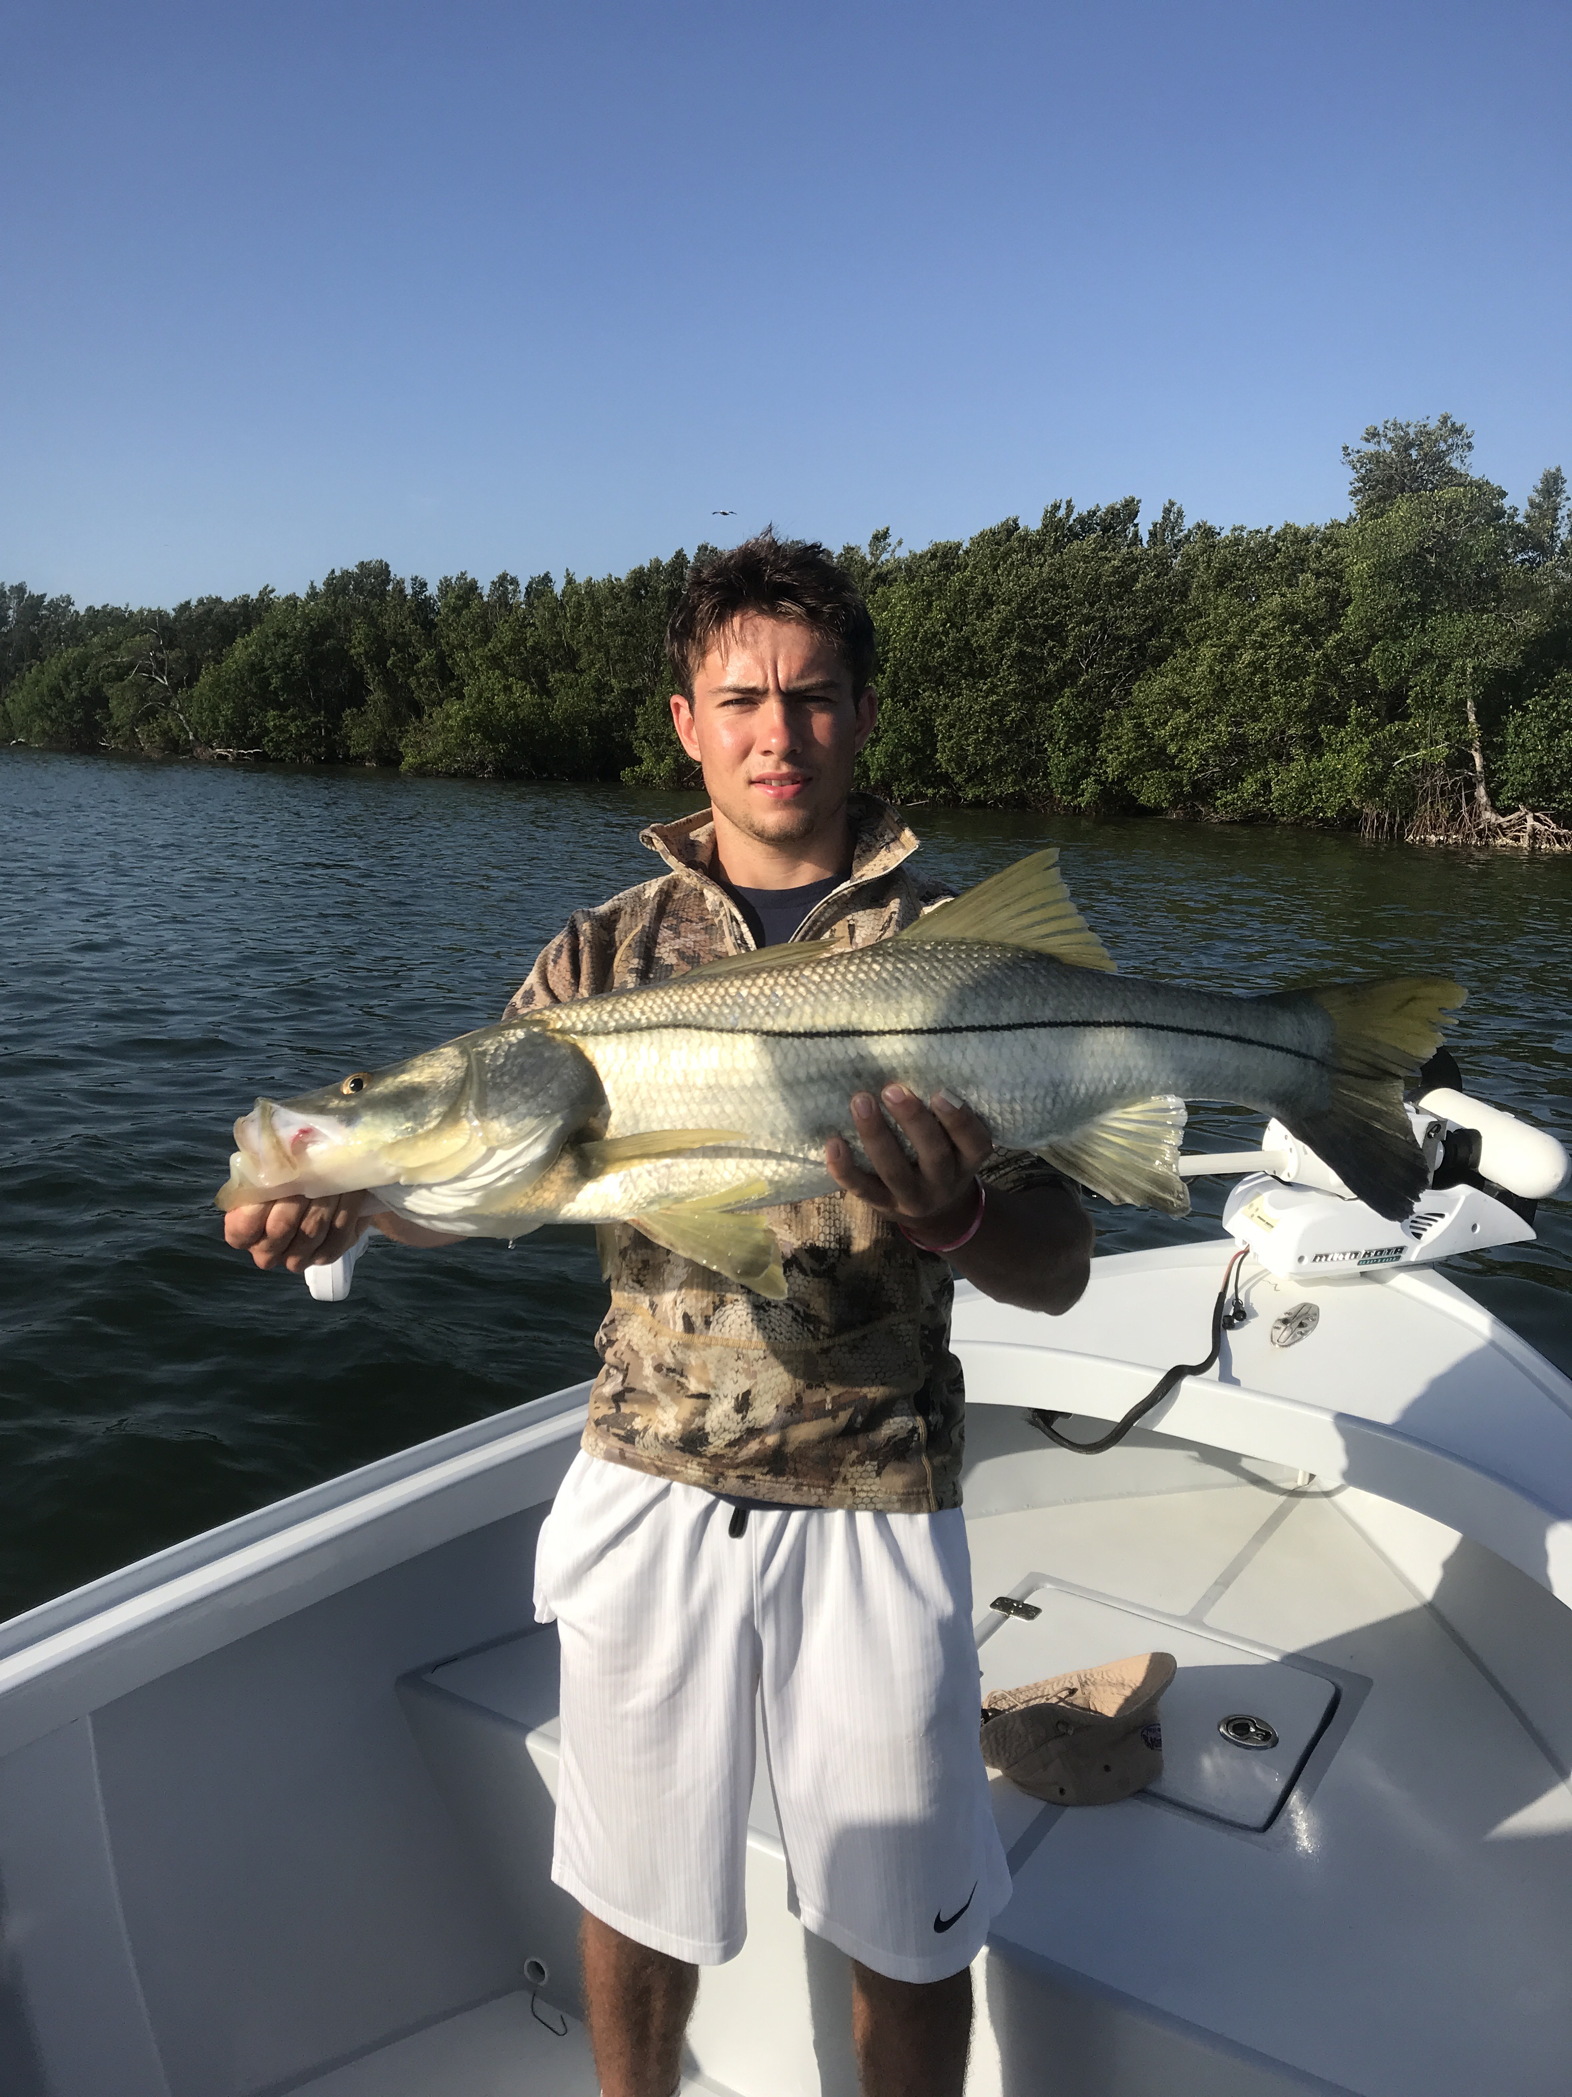

June Snook fest

Pic: George Pettegrew from Ohio with a 40-inch Snook caught while fishing with Capt Matt Mitchell this week.

Crazy action both on the beaches and in the passes continued this week with some of the most non-stop Snook fishing of the year. Mixed in with these Snook anglers looking for a meal also caught lots of Trout along with a few of the largest mangrove snapper we have seen so far this summer.

When fishing the passes it’s all about the tide. Moving water in all our passes means catch and release Snook along with all kinds of other species. Snook have now gathered in huge numbers in the passes for the annual spawn. When you find that right eddy where these fish are sat just out of the fast moving current it’s not unusual to catch a fish on almost every cast. Look for tiderips and current lines close to structure to enjoy this awesome action. Though most of these fish are the smaller males there are some giant females too.

When fishing the beaches its all about the wind with either a easterly wind direction or light winds making for calm and clear conditions and the best set up for fishing. Walking the beaches this month you will have great sight fishing opportunities with Snook cruising often right at your feet in the first trough between the sandbars. Along with these Snook on the beach expect to catch some large Trout mixed in with them too.

This past few weeks I have seen so many Tarpon both out and the beaches and in the sound than have seen the past few months. Any of the usual places from cabbage key south have all held just huge numbers of rolling happy Tarpon. The frustration level for anglers chasing the silver king has been very high most days with very few hooking a fish. One day early this week after sitting in rolling Tarpon throwing a variety of baits without a single bite I moved to a favourite trench in the northern sound. The very first cast on a crab we jumped a tarpon then within 20 minutes jumped another. As quick as both of these bites happened, the Tarpon threw the hook. It seemed no matter what type of bait you cast to these fish some day’s they just will not eat.

The largest Snook of the week on my boat came while fishing with George and Lucas visiting from Ohio. At the very first stop of the days trip George caught a 40-inch monster up against the mangroves. This big Snook ran all over before coming to the boat for a quick picture before being safely released. This was George’s personal best Snook and weighed close to 20 pounds.

