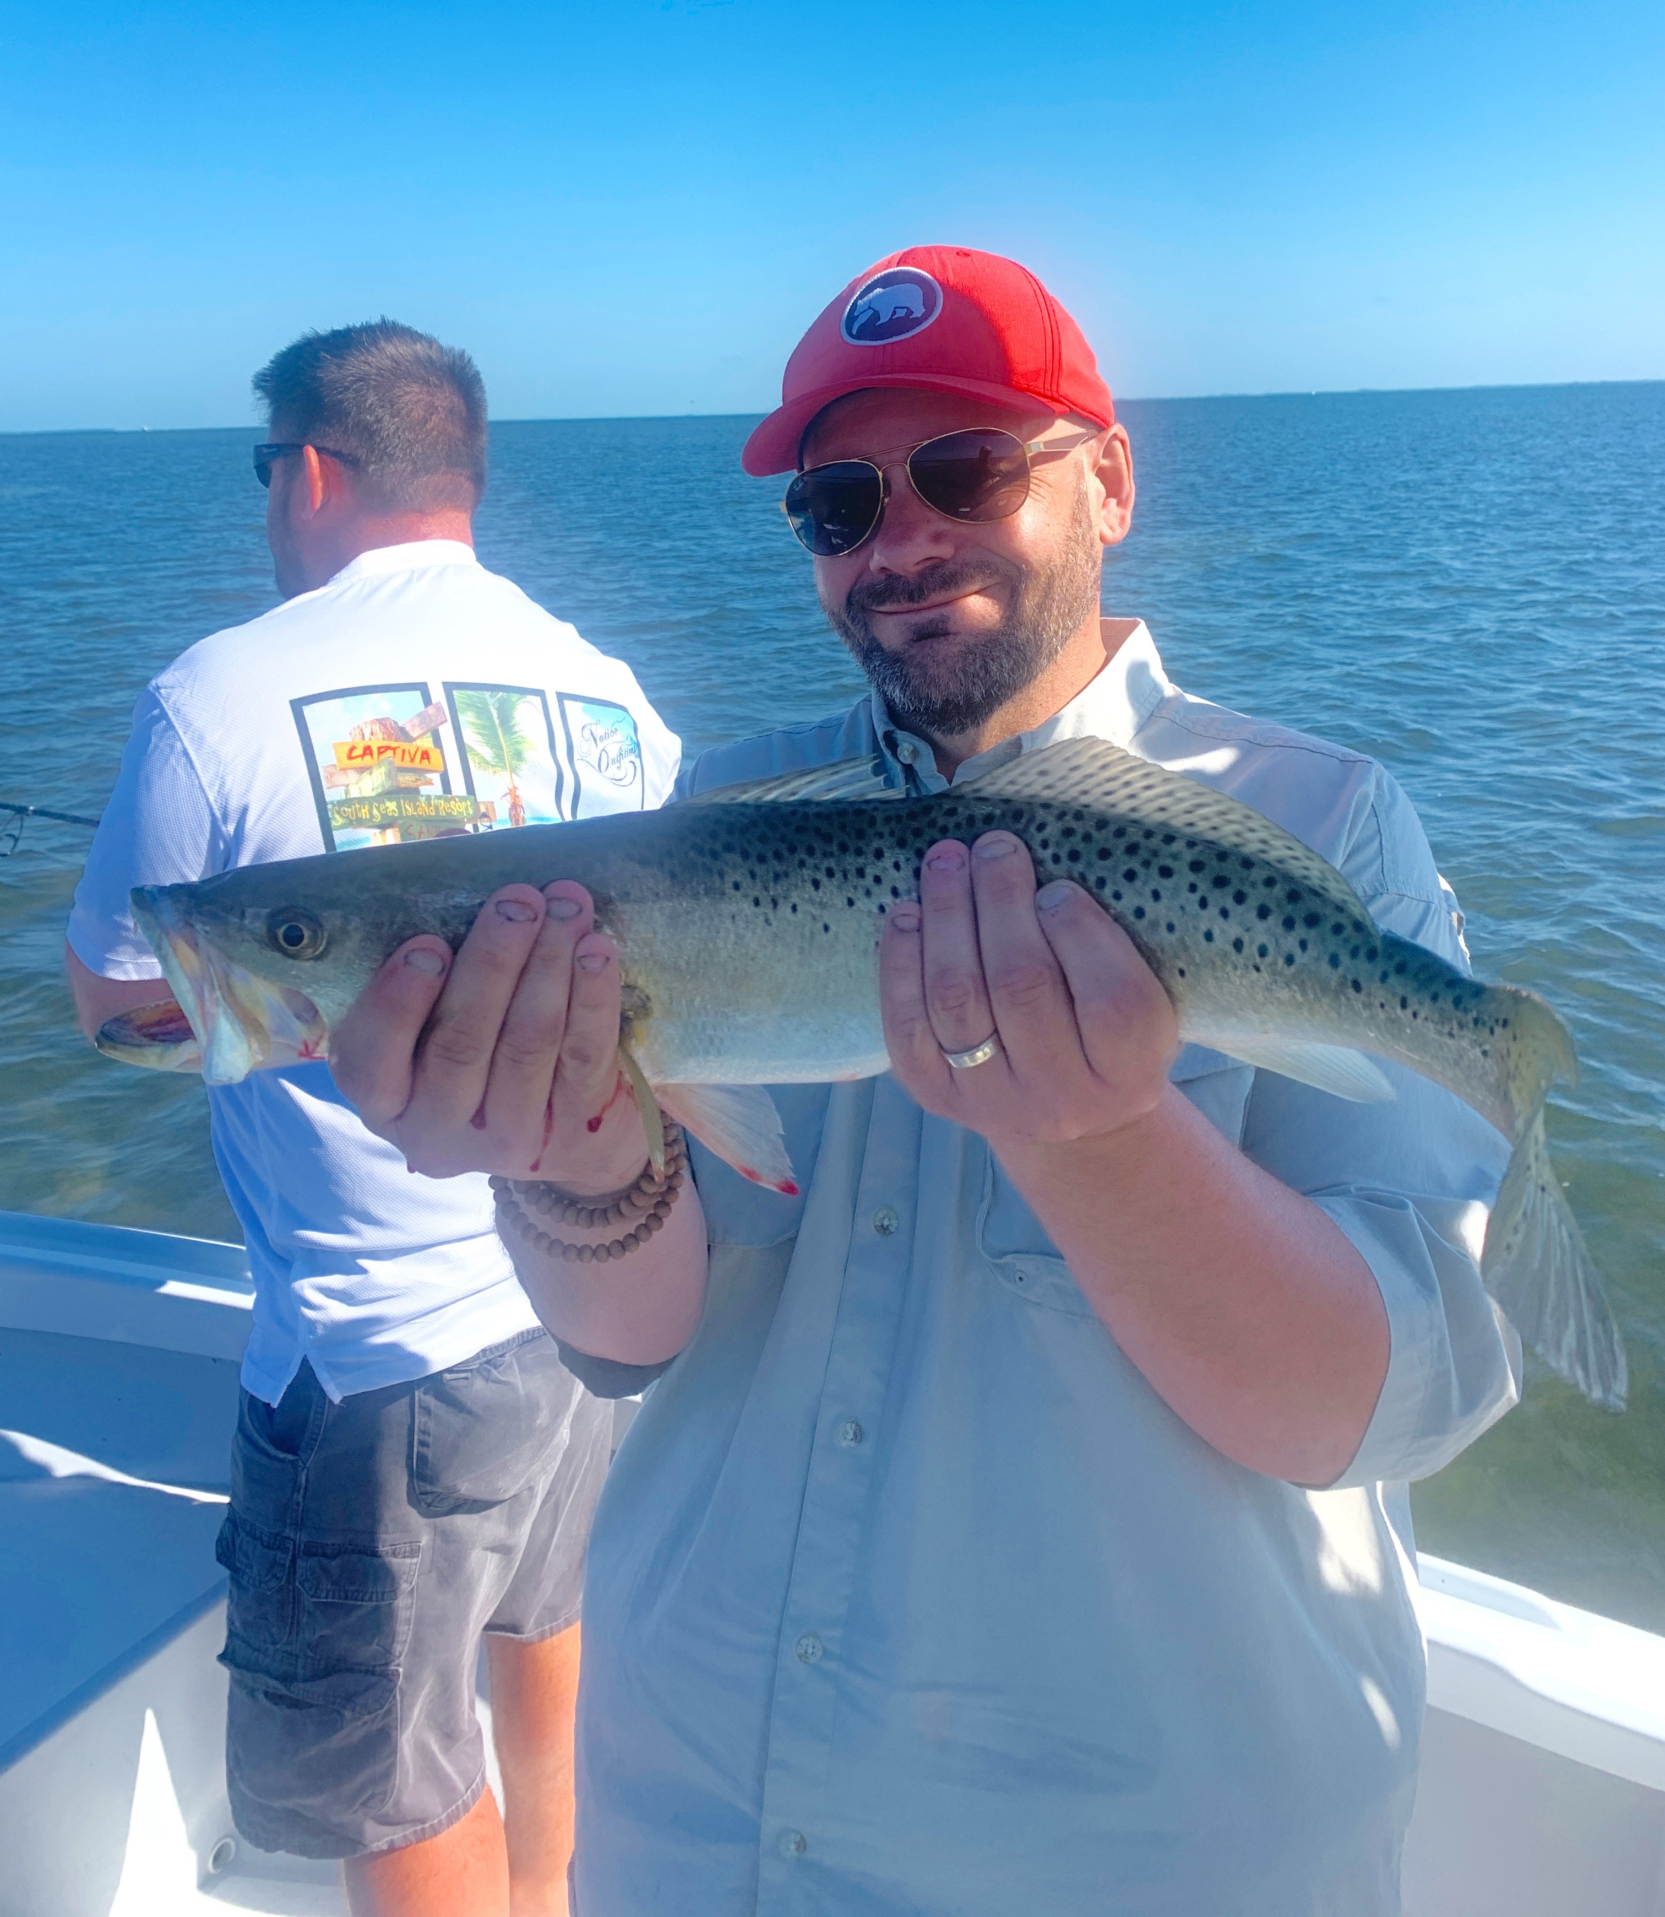

Guide life.

Pic: Stepfen with a gator trout caught while fishing with Capt Matt Mitchell this week.

Seems I’m always writing about the constantly changing weather conditions we experience while out on the water. Taking advantage of the good days while having places to duck and hide during the not so good periods is the life of a charter captain. Producing fish for clients is generally always much easier during those perfect days. Though being able to catch fish during the more often far from perfect windy or no tide days are what it takes to keep happy clients.

Never does any day quite go as planned. Days as a guide start early with the daily task of catching bait. Windy mornings can make this a challenge. How well we do on our trips is often decided with the amount of quality bait caught well before clients even board our boats. Plentiful bait means having enough to live chum and can fire up fish which some days don’t want to eat.

Bait catching is the morning coffee club of guides. We our usually anchored close together in tight knit groups. While chumming and throwing cast nets we discuss our catches along with stories of clients as we evolve our game plans for the days trips. Once loaded up with bait boats get cleaned tackle gets a quick once over making sure everything is ready to go before heading off to pick up.

Once on the water with our days trips, if things are going good, there is often very little communication. If you are struggling you initiate contact with other Captains to locate the fish. We are not in competition and are eager to put everyone on fish. Finding clients action comes much easier if you have multiple boats communicating. Having a tight network of other Captains on the water can be priceless on those tougher days.

Time spent on the water or as we say time served cannot be replaced. As fishing guides we take our experiences from the previous trips and return to where we caught fish. If conditions remain the same it’s often possible to return on the same stage of the tide and catch em day after day. When conditions change like wind direction, water temperature and tide its time to reach a little deeper in the memory bank to where you caught them during this same set up. When it comes right down to it I get paid for my gut instinct of where the fish will be.

