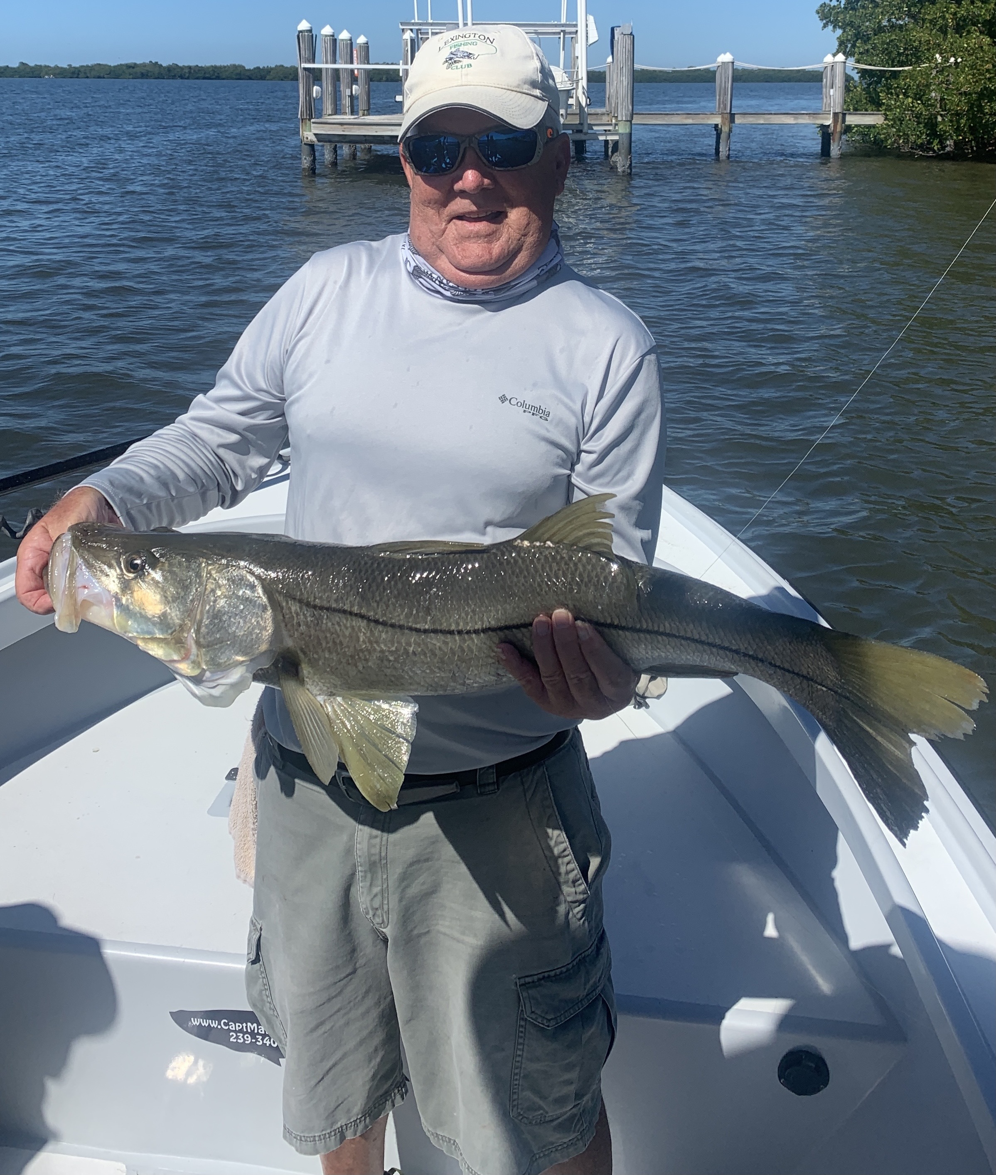

Got to love an early Spring

Pic: Bob Lauer from Lexington CC with a 36 inch Snook caught and released with Capt Matt Mitchell this week.

As we move into March it sure feels like winter has been over for a while. Although we had a few cold fronts most of last month was spent catching Snook and Redfish on shiners. The first confirmed tarpon catches have already happened, this is really early in the year. As water temperatures continue to climb tarpon will become more and more common. Fingers crossed we don’t get a strong cold front that will put this fishery on hold.

Our Snook fishing has never really slowed down this whole winter. During cooler periods I have been targeting them in deeper channels with fast moving current. Now things have warmed up the oyster bars throughout the sound have become a great choice during higher tide periods. Though most of the snook are from 18-24 inches we are also getting chances at some much larger models. Our big fish this week measured a respectable 36 inches and was caught on a St James City dock.

Out along the beaches has come to life with both fry bait and Spanish Mackerel as water temperatures are now in the mid 70’s. Look for diving birds and Mackerel hitting bait fish on the surface to get in on this fast paced action. Though I don’t find these fish very palatable they are a blast to catch and readily take artificial baits and flies. They can be caught both casting and trolling. For anglers just looking to bend a rod there may not be a easier species to target.

Over the past few weeks our shiners have moved from the bridges and spoil islands of the causeway and onto the flats. Basically the whole bar that runs from Chino Island north parallel with Pine island is a good place to find our bait of choice. Look for diving pelicans to point the way.
Shiners like grass in the 2-4ft range, area’s with large sand holes tend to hold only pinfish. Most mornings we chum these bait fish with a mix of salt water aquarium food and menhaden oil. Get a chum slick going and they will come to you or at least in range of a cast net. These magical little bait fish are key to most of our fishing and are the main food source of most game fish. As a guide having these baits is a must for a successful trip.

Back to that earlier question of when is the best time of year to fish: “Anytime you can!”

