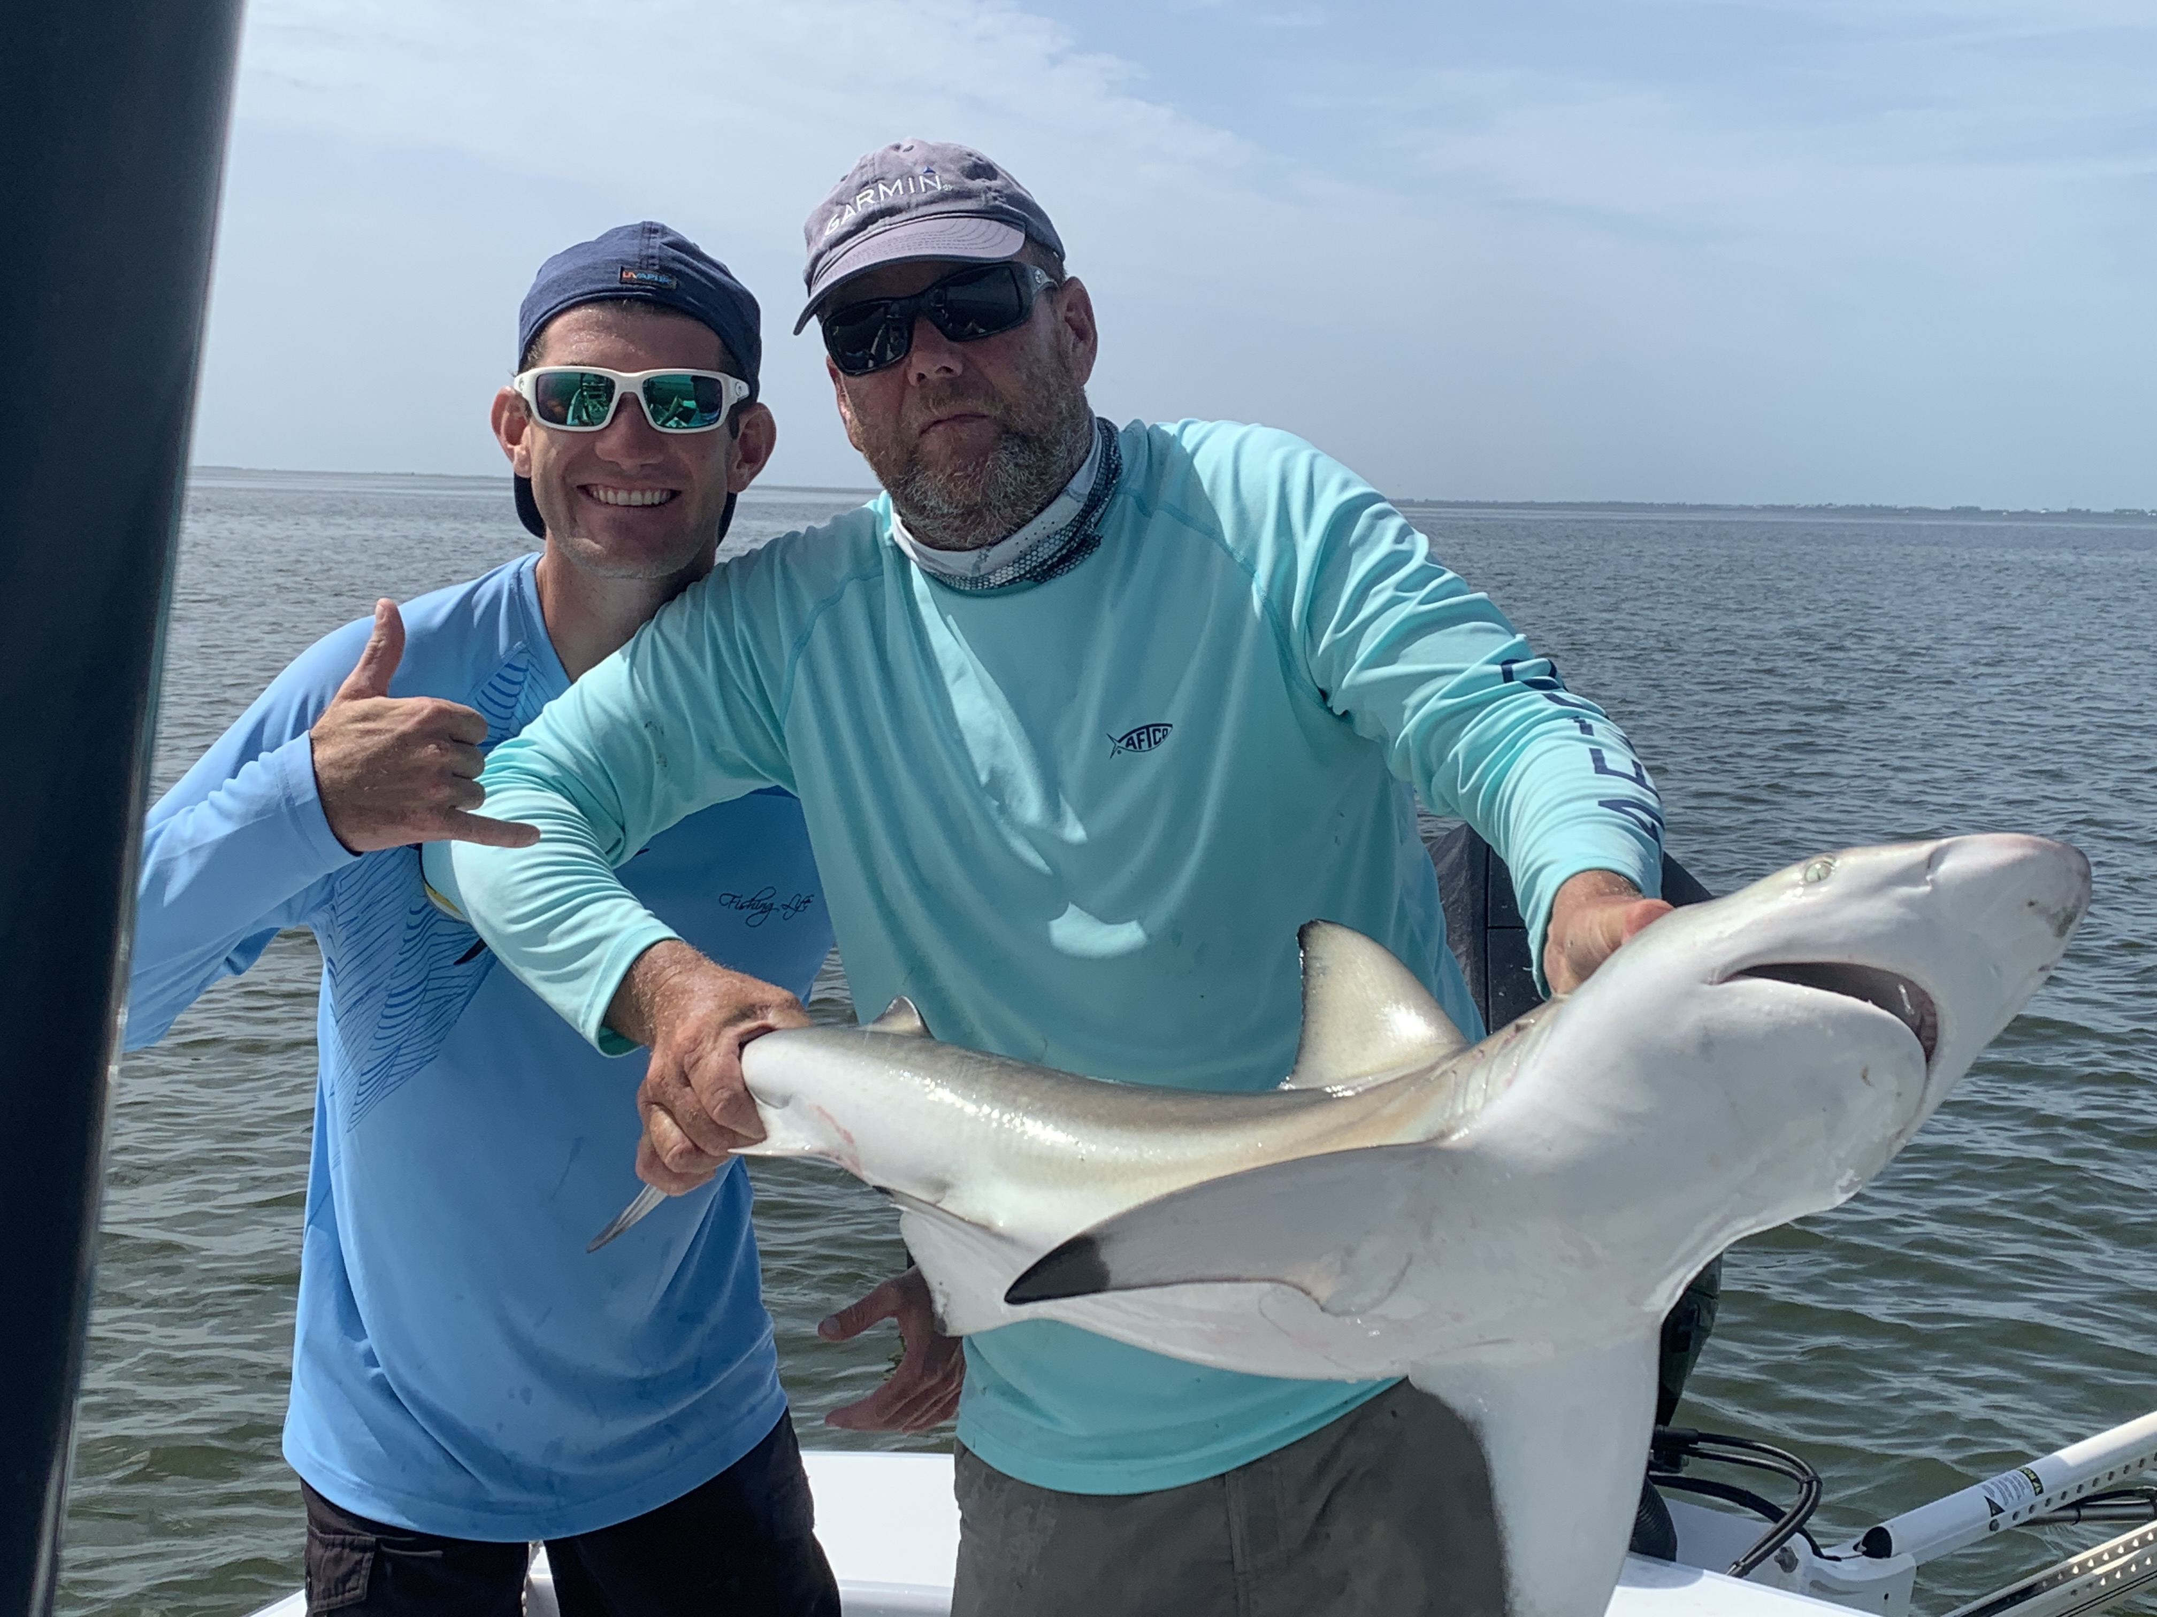

Fun family shark fishing

Pic: Blacktip sharks are very common and one of the more sporty varieties to catch

After a great week of fishing Memorial day weekend ended up being close to a wash out. Conditions right up until the weekend gave anglers some of the most consistent tarpon action we have seen in weeks. Snook, Redfish and Trout action in and around the passes has also been going off with the annual Snook spawn in full swing.

One of the less talked about and underappreciated fish we like to target are sharks. Sharks come in a variety of sizes and species and can be caught almost all year long. From right off the beaches to the back water channels sharks are abundant and just fun to catch. Deeper natural channels inside the passes and through the flats that have current are great places to get started.

When targeting Sharks my bait of choice is fresh mullet. I use medium heavy 30-50# spinning tackle that can hold a few hundred yards of line. Rig up with a 200# mono leader with crimps to attach a swivel at one end and a cut bait 12/0 circle hook at the other. When anchoring the boat for sharks I use a float buoy on my anchor. If we hook into a large one its easy to give chase before they dump the spool.

For bait large chunks or half a fresh mullet is my goto. I cast these baits down current and simply put the rod in the holder. They key to catching these fish on a circle hook is leave the rod in the holder until the fish swims off and the drag screams. Any fresh cut bait will work though mullet is easy to get from my local commercial fishermen.

All summer we do a lot of family fishing trips and kids just love to catch sharks. Many anglers have never done battle with any 5-6ft long fish that fights so hard. Unlike tarpon fishing catching multiple big fish on a trip is the normal. We catch a large variety of species including Blacktips, Lemons, Bulls and Spinners just to name a few.

