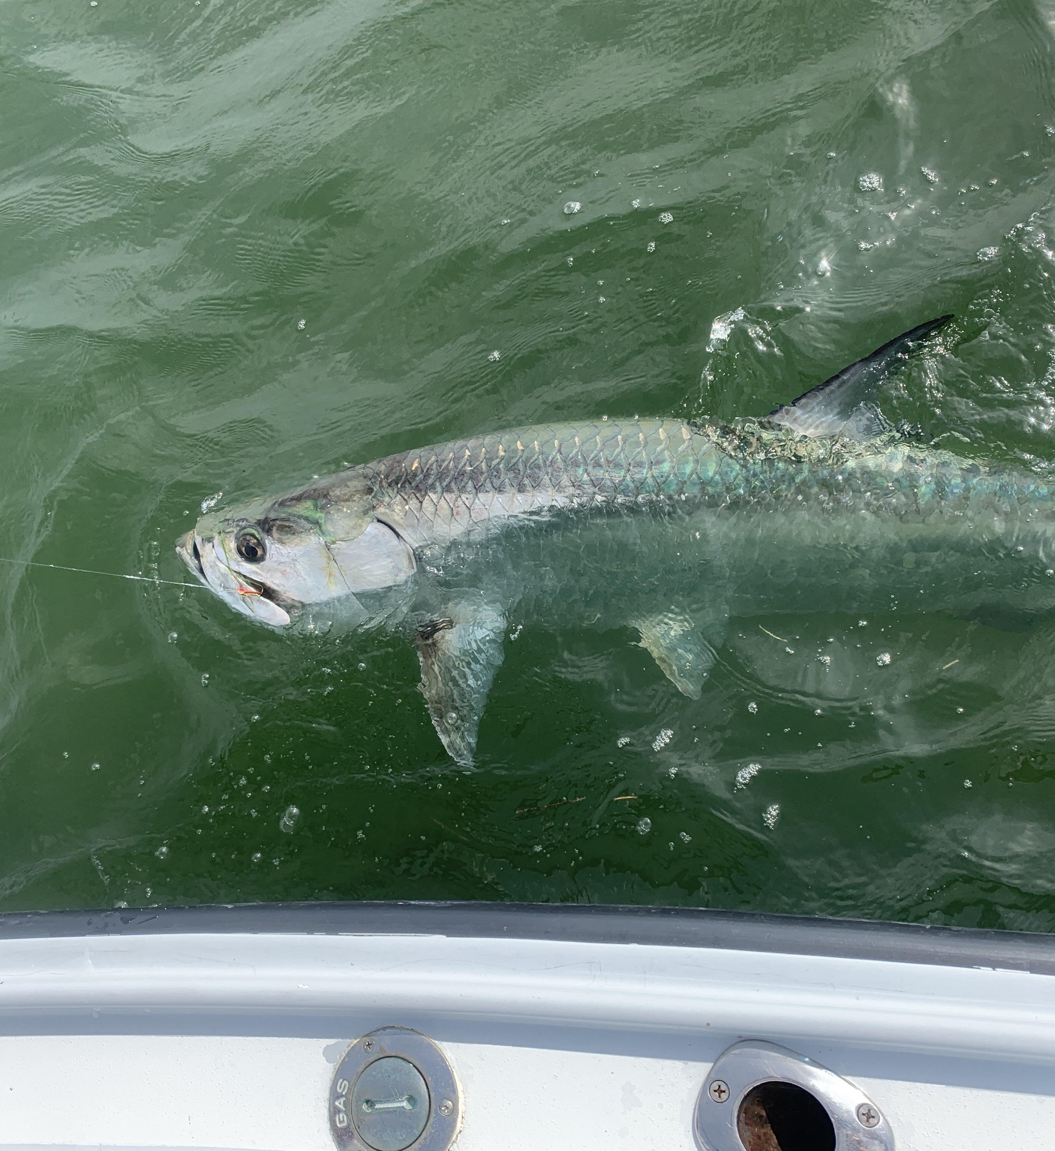

Picture: A beach tarpon caught and released this week

Follow the birds to the action

Our gradual change of season is now in full swing. Its not quite drastic enough yet to notice unless you're up early to enjoy that cooler air along with a significant drop in humidity. Feeding fish and birds working schools of small fry bait are appearing all over the sound and out on the beaches. The annual southerly bait migration of fall is just firing up. No matter if its Spring or Fall the change of season offers anglers some of the best fishing
opportunities of the year not only with our resident fish but all the migratory species following the bait buffet.

This week brought some fabulous catch and release snook fishing back in our mangrove creeks systems. Over the past few trips I’ve been checking out some of these favorite creeks with much success catching over 20 snook a trip. All though we haven't had any real giants back in these magical places pulling a snook out of this tight cover is as good as it gets. Watching snook explode on shiners then making a well placed cast resulted in instant hook ups or my favorite “instant gratification” Throw in a few redfish and some mangrove snapper and the creek trips i have been taking kept everyone smiling.

My favorite stage of the tide to fish most of these creeks is during the low water. The lower the tide gets the more bunched up these fish get. During higher water the fish just have to many places to get tucked up and be impossible to reach with a bait. As long as the water is moving it flows like a river in these narrow passages between the mangrove bays. Look for the fish to stage on the turns and bends or where the water rips making a eddy.

Out on the beaches when the wind has been out of the east I’ve been hunting tarpon. This week the best action came while running from Blind Pass north to Captiva pass and then again at the south end of Ft Myers beach. Birds and bait have shown the way to this amazing fishery. Everything out here revolves around the big schools of bait fish which are usually threadfin herring. The more feeding terns and pelicans the better the tarpon bite has been. Watching tarpon crash and roll through all this bait its just a matter of pitching a live pinfish rigged under a float to hook up.

