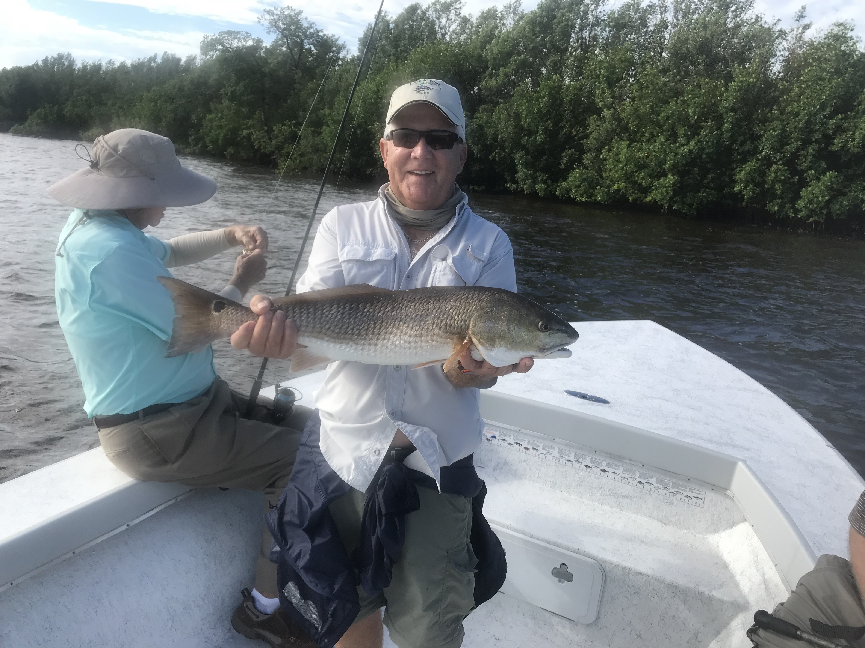

Picture: Bob Lauer from Lexington Country Club with a 26.5 redfish caught while fishing with Capt Matt Mitchell this week

Fishing cold fronts is all about timing.

With the first noticeable cold front of Fall forecast to pass through mid week the change of season is finally here. If this year is anything like past years once this first cool down happens we will get on a schedule of a cold front passing through every week to ten days. Fishing around cold fronts and learning how they effect the fishing can produce some awesome action along with some slower than usual fishing.

Timing is everything when it comes to fishing around cold fronts. A few days before a cold front arrives action will start to pick up. This bite really goes off giving anglers some of the most non stop action just as the wind comes around to the south dropping the barometric pressure just before the front passes. A few hours later on the back side of a cold front high pressure and strong north winds grind the bite to a halt. Fishing a few hours either side of the passing of a front will make the difference between a unforgettable day on the water and a day you just want to forget.

Redfish fishing picked up some this week with redfish of all sizes being caught all over the sound. During high tide periods oysters bars and mangrove shorelines where the places to be while on the lower tides the outside edges of sandbars and deeper natural channels held the fish. Once you located these redfish we caught several fish back to back. Many of the redfish this week where either over the 27 inch max or just under the 18 inch minimum. Finding a shoreline or oyster bar to fish where this weeks strong winds helped you by being at your back was the key. Buck key, Regla Island and Mackeever Keys in the southern sound all had Redfish on them this week although the places changed day to day depending on the wind direction and the phase of the tide.

Snook fishing was the most consistent fishing this week with lots of spots in the sound holding many many Snook. Chumming live shiners fired these fish up and for several days we returned to the same shorelines to catch snook after snook. While fishing some of these favorite snook hot spots it often does not take long for the dolphins to find you and run you off. Once the dolphins show up and start eating snook that your releasing its time to move on no matter how good this bite is. These dolphins really have this free meal thing dialed in so please do not encourage it by feeding them, its not only bad for our snook fishery its against the law to feed any wild animal.

Fishing with some of my regular clients Bob, Bill and Ed from Lexington Country Club one windy day this week we had a great day catching redfish, snook and a few other species. Although we only ended keeping one 26.5 inch redfish we caught two more Bull Redfish that where over the slot along with a few under the slot Reds plus about 30 snook. This kind of action along with a great variety of species is what our Fall fishing is all about.

