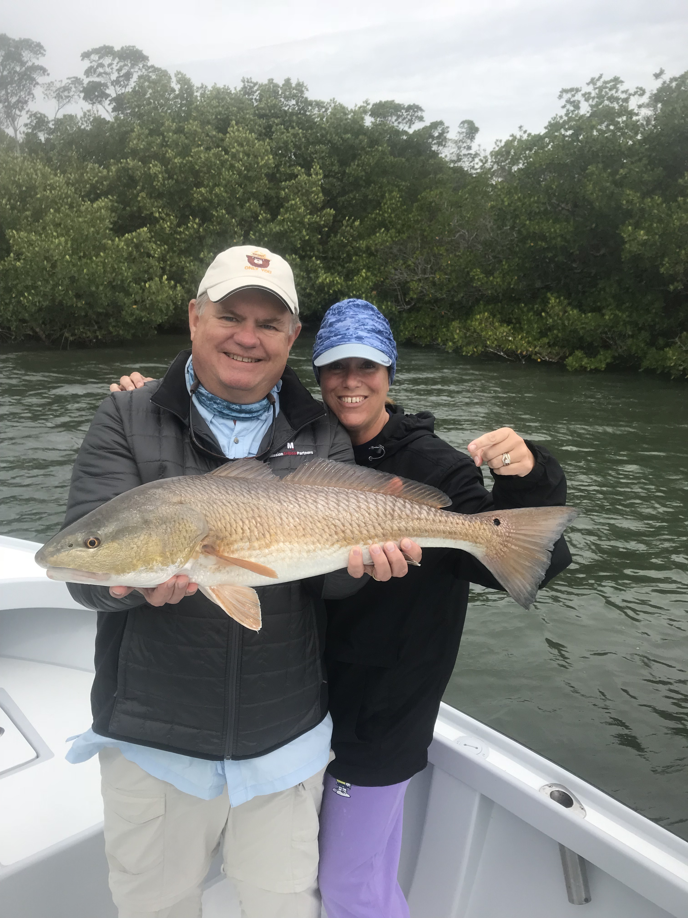
Picture: Pam and Kevin Murray with a 29 inch redfish caught and released with Capt Matt Mitchell this week.

Finally some Redfish rehab

So far March has felt more like winter than spring and our fishing has reflected that. Major temperature swings and strong winds have made staying on consistent fishing a challenge. I’ve been catching fish every trip although it has required often changing up the days target species to bend the rods. Add to that unpredictable weather and some of the worst non moving tide days we have seen for a long time and angling options where few.

During these non moving tide times any bit of current you could find seemed to make all the difference in the world. Fishing in the passes was a good choice as these where the only places that had any water movement at all. During windy periods if you could locate a shoreline or narrow cut that the wind moved the water through you where in the right place. Being extra patient you could always grind out a few fish in the passes when they just would not bite anywhere else.

My usual go to of winter fishing in the Ding Darling creek systems ground to a halt again this week. I had days of not seeing a single fish in the usually filled with life shallow clear water. All I can think of is that these creeks may have experienced some effects of red tide though not enough to cause a big fish kill just enough to make the fish relocate. Riding through these creeks and not even seeing a mullet jump or a Sheepshead push out of the channel is just freaky.

During the colder windy periods it was all about shrimp fishing again. Sheepshead and black drum became our fish of choice. Docks in and around the passes held good numbers of Sheepshead and put some meat in the cooler for my clients. Small chunks of shrimp fished close to barnacle crusted pilings and structure caught lots of these fish save the trip. Along with the Sheepshead you just never really know what you will catch dock fishing and this proved true with a few redfish, black drum and small gag grouper in the mix.

The 10 degree plus drop in our water temperature which came almost over night ground our Snook bite to a quick stop. Targeting Snook on shiners one afternoon this week post cold front with my clients who only wanted to catch Snook we went place to place looking at basically hundreds of Snook laid up in all the places they usually get during cold periods. We did manage to catch 5 under slot sized Snook though the action as expected was slow at best. A few warmer days or targeting them just before another cold front passes through these fish will feed.

The most memorable action of the week came while fishing for redfish on the eastern side of Captiva. With no moving water I picked a narrow creek mouth that the wind was funnelling into and we set up pitching tail hooked pinfish up under the trees. After a few minutes of nothing we then caught a 28 inch red followed up shortly by a 23 inch red then a 29 inch monster. We then worked other shorelines in the same area without success. This was the best redfish bite I have been on in weeks and was a much needed pick me up for me after what was all in all another tough week on the water

