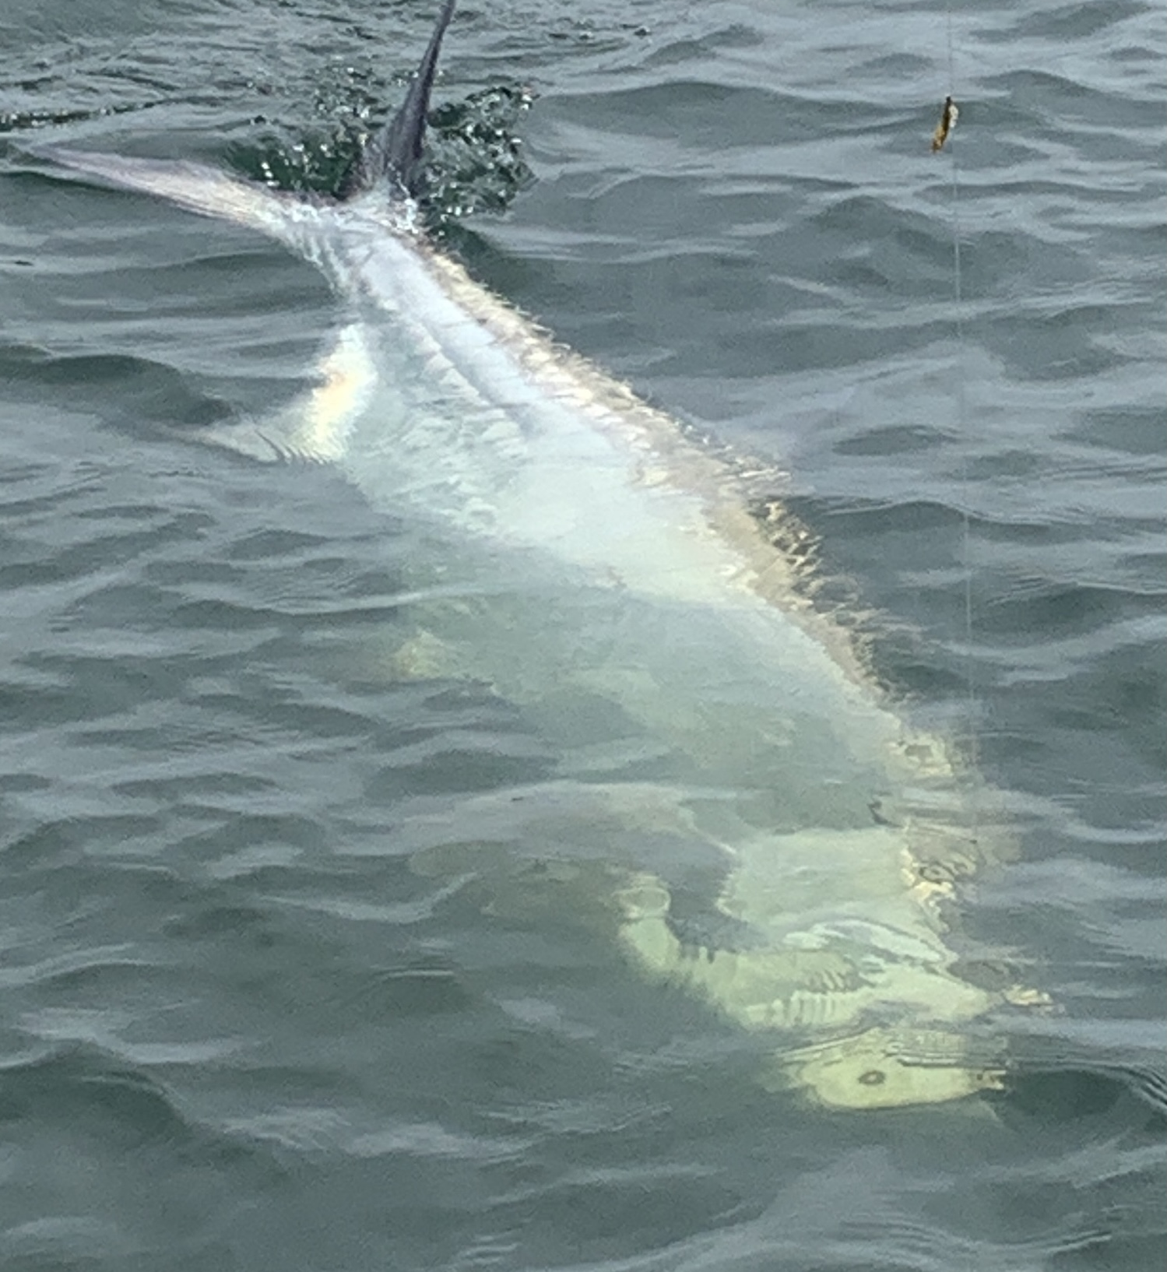

Pic: Despite not getting that perfect picture Gerald’s 1st tarpon put on quite a show.

Dog days of summer offer amazing fishing opportunities

For the next few months the daily pattern of sticky hot mornings turning into scorching mid day heat until afternoon thunderstorms cool everything off is upon us. What I enjoy most this time of year is being able to get out well before before sun up and share some of the best fishing action on the planet with my clients all before lunch time.

The first few hours after sunrise is that magical time on the water. The early bird gets the worm is very true. Fish are most active during these cooler water periods often shutting down in the heat of the afternoon,. Watching a sunrise as tarpon roll and gulp air in slick calm water is as good as it gets.

Catch and release Snook fishing is on fire all summer long with giant spawning females filling the passes and then roaming the beaches. Think big baits for big fish all summer with large pinfish and grunts catching some of the best snook of the year. For every large female snook in and around the passes there are another 100 males ranging in size from 20-26 inches. Strong morning tides will have these fish feeding on every bait that gets pushed by them. Drifting the passes will become the method of choice over the next few weeks.

This week I had the pleasure of getting my long time client and friend Gerald his bucket list tarpon on his 60th birthday. After a early start and sitting in hundreds of rolling fish without a bite I made a move south. Hopes were high as we watched a few tarpon surface. These fish had the right body language as they milled around slowly raised up.

After one tarpon pulled down his pinfish and with a swirl and flash just decided to let go time was ticking down on the mornings trip. Then bang, it happened one of the cut bait rods went off with the big tarpon jumping twice before we could get the rod out of the holder. After what turned out to be 45 minute slugfest as it towed the boat around Gerald got the estimated 120 pound fish close enough for a leader touch. Although we didn't get that magical in the water picture he is now hooked on tarpon fishing. Until you do battle with one of these fish you simply do not have any idea how strong they are. Congrats Gerald and Happy Birthday.

