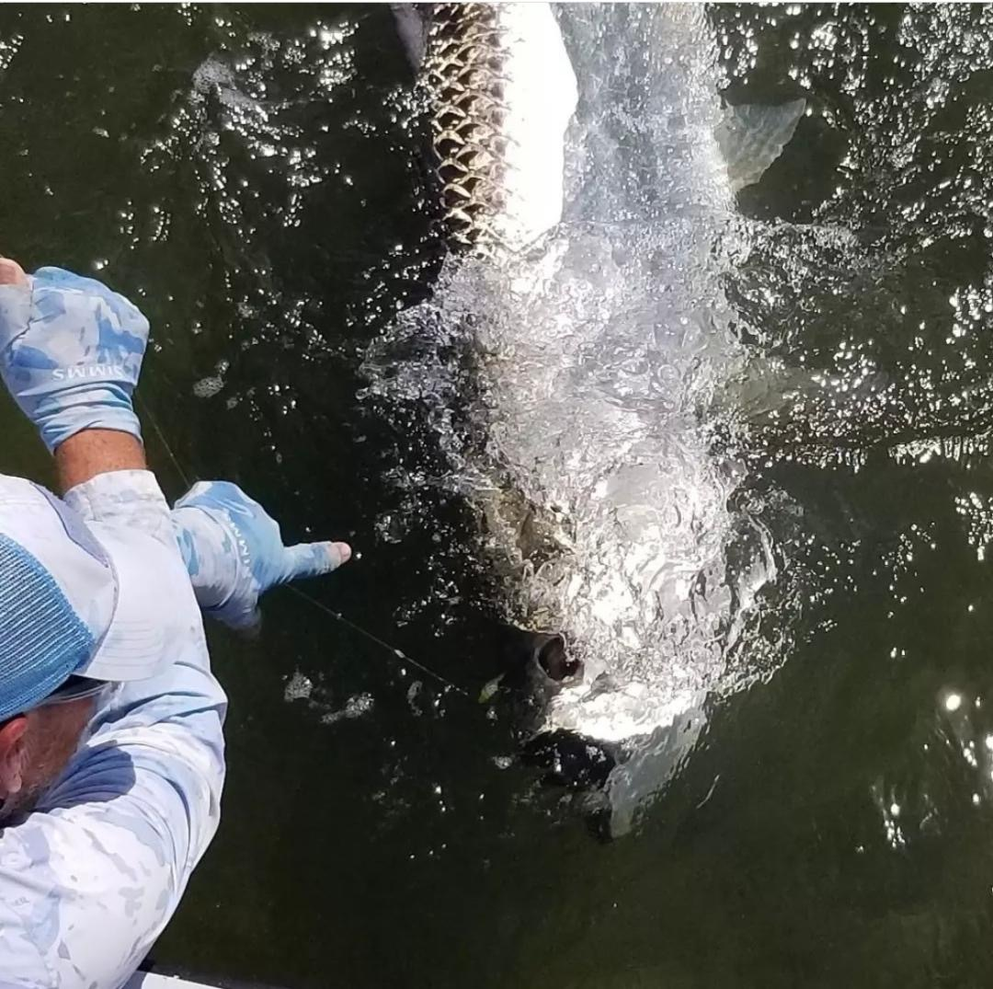

Conditions are so right

Pic: A tarpon boat side just before release caught while fishing with Capt Matt Mitchell this week.

What a difference a few days can make. After all that can be described as a windy tough tarpon week. Conditions finally came good for the long holiday weekend. Calm humid mornings meant lots of happy rolling tarpon. I concentrated my efforts in areas at the northern end of the sound from Redfish pass to Boca Grande and returned to these fish day after day. Most of the tarpon we found where on the bay side and within a mile or so of the passes as they rode the incoming tide into the sound.

When fishing over the busy holiday weekend it’s always a crazy time to be out on the water. The key was getting out super early and being done by mid-morning as boat traffic increased. Being to the fish just as the sun started to come up, we were greeted with tarpon as far as the eye could see. There are not many things in life that makes your heart race than being surrounded by rolling tarpon as you watch them fin and roll hoping one will eat your bait.

Once we had located the fish, I would watch the movement and then gently and quietly crawl up on the trolling motor to get in casting range. Despite having fish roll right next to the boat making a long cast with a live pinfish under a float is the most effective. Many times, these fish would appear behind or just too far out from the boat to get a bait to. The long downwind cast well out in front of the approaching fish was the presentation they wanted. The further out from the boat you can keep your bait the less chance the fish have of feeling you there. Clean clear water in the northern sound also made it possible to track these fish even while they were under water.

Over the past few seasons, I have tweaked my live bait set up from the standard 7/0 Trokar circle hook under a float to a custom weighted 7/0 Trokar circle hook. These hooks have just right amount of lead moulded right into the shank of the hook. This saves you from having to use a split shot which always seems to hang floating grass. This 1/8th oz of lead keeps the drifting bait down in the water column and in the strike zone. There is nothing as frustrating as watching a unweighted bait swim up on the surface to escape the approaching pod of tarpon. Skyline jigs is a local company based out of Port Charlotte and came out with this simple yet innovative solution for tarpon anglers. The weighted hooks are offered in a variety of weight so you can dial it in depending on how fast the current is moving and the size of your bait.

